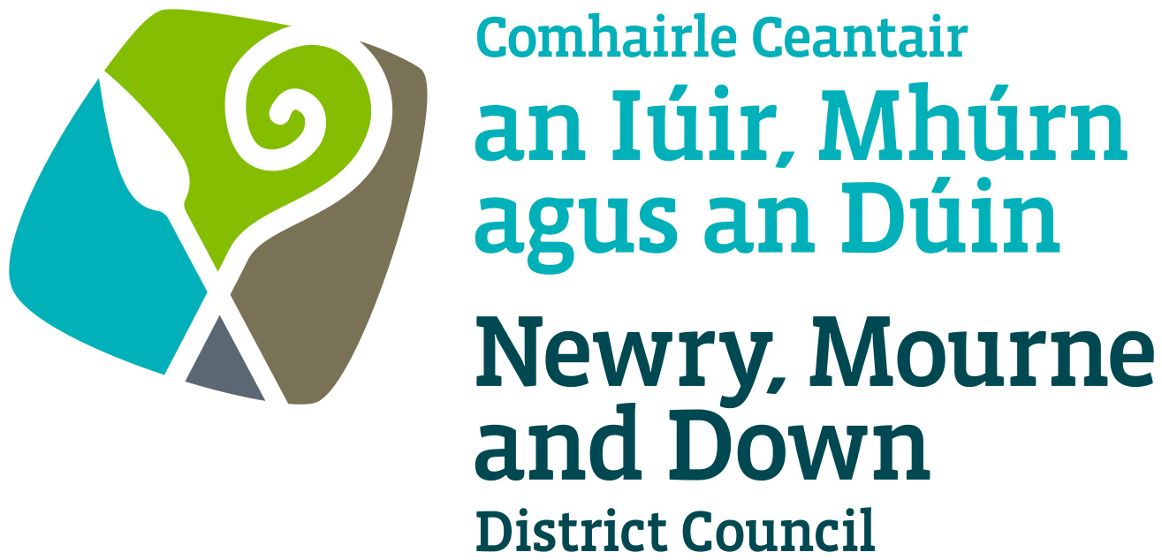 | How to prevent maggots in your bin  TAKE CARE OF YOUR WASTE  ADVICE SHEET

How to Avoid Flies & Maggots  There are many things that we can do to help prevent flies being attracted to and breeding in our bins.  All meat, fish and dairy waste should be wrapped and effectively secured to stop flies laying their eggs before rubbish is placed in the bin. Wrapping waste in newspaper provides a very effective barrier. However this is only one example of wrapping, use whichever method is best for you.  Don’t leave food out in the kitchen. Eat, cook and store food properly, or place it wrapped in the bin as soon as possible. However it is important to remember that flies may lay eggs on food even before it has reached the bin.  Dog faeces are also a common spot for flies to lay eggs. Dog owners can help to prevent maggots and flies in their bin by bagging and tying any faeces well before putting them in their bin.  To control flies further you could hang up an insecticidal strip in the kitchen, or store your bin a shaded area.  Looking After Your Bin  If you do get maggots you could pour a bleach solution and boiling water into your bin after it has been emptied. This will prevent maggots in the future clean and disinfect your bin well.  It is important to keep your bin clean and ensure that the lid is always properly closed. Wheelie bins are specifically designed to keep insects out once the bin lid is closed. If a bin is left open containing unwrapped food it is likely that flies will enter. | The Kitchen Bin  The easiest way to sort waste from recyclables is to separate as you go. Many people find it convenient to have 3 bins, one for food waste, one for recyclables and one for non-recyclable waste.  A kitchen caddy with a lid and liner is ideal for the temporary storage of food waste. It is important though, not to allow food waste to remain in this bin too long after they are full. Tie your caddy liners with a knot before placing them in your brown bin.  Material place into your kitchen-recycling bin should be clean dry and loose. There is no need to bag your recyclables.  It is recommended to clean and disinfect all bins at regular intervals.  The Life Cycle of the Fly  The common house fly, lays its eggs in rotting, moist material. They are attracted by the odours of decomposition. Some will feed, others will mate and some females will deposit their heavy loads of eggs. The major external factor affecting the life cycle of a fly is temperature. Maggots develop slower at lower temperatures and more rapidly at higher temperatures. In hot weather they can hatch within 8 to 20 hours. The maggots emerge from the eggs and they immediately feed on, and grow in, the material where the eggs were laid. These larvae are 3 to 9mm long and creamy white in colour.  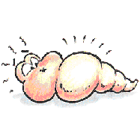When the maggots are full-grown, they crawl away to a dry, cool place near breeding material, and transform into the pupae stage. They emerge as adult flies and the cycle restarts. Six or more generations of fly eggs may hatch in a single summer, resulting in a large number of flies.

If you have any further queries please do not hesitate to contact us on | 028 30 31 32 33  recycling@nmandd.org

