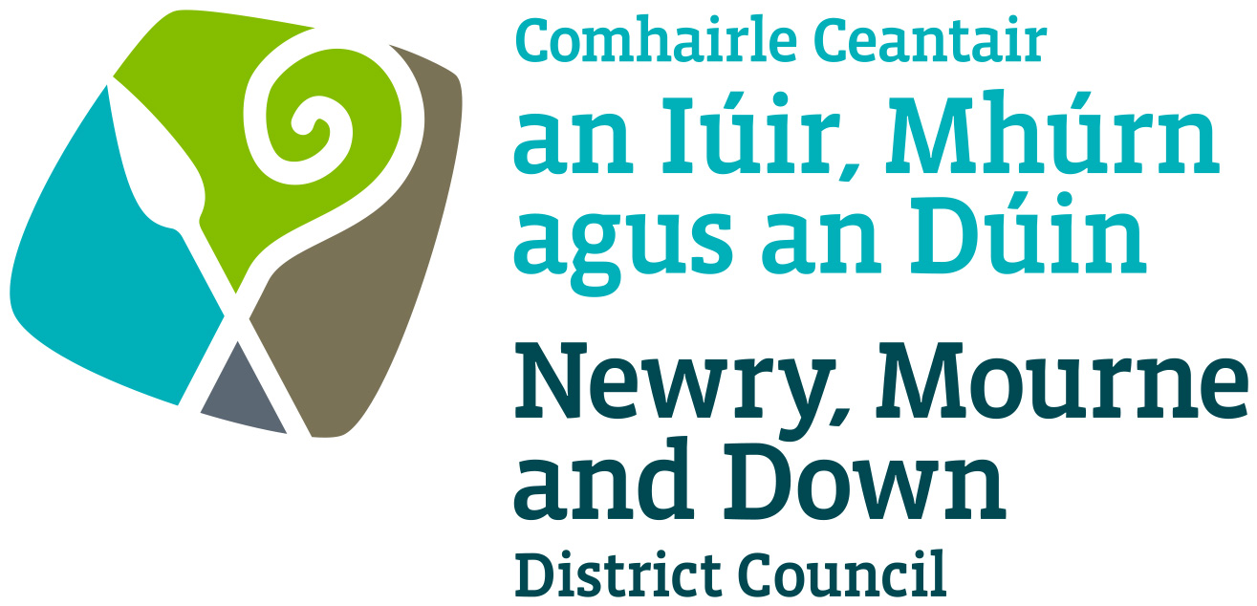

Local Development Plan
Preparatory Studies

Paper 9: Public Utilities

January 2017

Contents | Page No
Purpose & Content | 3
1.0 Introduction | 4
1.3 Main Stakeholders in Public Utility Provision | 4
2.0 Regional Policy Context | 5
2.2 The Regional Development Strategy 2035 (RDS) | 5
2.14 Planning Policy | 8
3.0 Newry, Mourne & Down Council Plans & Strategy | 9
3.1 Newry Mourne & Down District Corporate Plan 2015 - 2019 | 9
3.2 Newry, Mourne & Down Community Plan 2030 ‘Living Well Together’ | 9
3.7 Newry Mourne & Down Economic Regeneration & Investment Strategy | 10
4.0 Telecommunications & Broadband | 10
4.5 Broadband | 11
4.16 Mobile Data Coverage | 14
5.0 Energy Supply | 15
5.7 Renewable Energy | 17
5.11 Wind | 17
5.16 Solar (Photovoltaic) | 19
5.17 Hydro Electricity | 19
4.18 Tidal | 19
5.20 Heat | 20
5.21 Biomass | 20
5.22 Biogas | 20
5.26 Connections to Electricity Grid | 21
5.30 Natural Gas | 22
6.0 Waste Management | 24
6.2 Strategic Planning Policy Statement | 24
6.14 Waste Management Plan | 26
6.18 Waste Processing within Newry, Mourne & Down District Council | 27
7.0 Flood Risk, Drainage & Water Supply | 28
7.1 Flood Risk | 28
7.13 Drainage | 30
7.17 Sewage Facilities Waste Water Treatment Works (WWTW) | 32
7.25 Water Supply | 33
8.0 Conclusions | 34

APPENDICES

Appendix A: Housing Evaluation Framework

Appendix B: Wind Turbine Application Determinations within NM&D Between 2002 and 2015

Appendix C: Northern Ireland Electricity Heat Map

Appendix D: 1/100 Year Climate Change Floodmap Downpatrick

Appendix E: 1/100 Year Climate Change Floodmap Newcastle

Appendix F: 1/100 Year Climate Change Floodmap Newry

Appendix G: Waste Water Treatment Works Capacity in NM&D

Public Utilities

Purpose: To provide the Council with an overview of matters relating to public utilities and implications for land use in the Newry, Mourne & Down District Council area.

Content: The paper provides:

- The regional & local policy context for public utilities and key service providers in the District;
- An overview of the provision of public utilities in the District;
- An outline of the main proposals for public utilities.

- Introduction

1.1 The purpose of this paper is to inform members on the provision and spare capacity of public utilities up to 2030 in order to assist judgements on the allocation of housing growth and other development in the Local Development Plan. It sets out the regional context for public utilities and an examination of existing physical infrastructure of the new Council area. It examines initial responses from a number of Government Departments and statutory bodies, including the Council, who have a responsibility for the various public utilities in relation to future supply. This paper allows members to commence consideration of how public utilities can be addressed in the Plan within the context of the Regional Development Strategy (RDS) and the Strategic Planning Policy Statement (SPPS).
1.2 The provision of public utilities within the District is primarily the responsibility of a number of Government Departments and statutory bodies as well as the Council. The main utilities covered in this paper are:
- Telecommunications
- Energy Supply
- Waste Management
- Flood Risk, Drainage, Water Supply and Sewerage

1.3 The provision of public utilities involves a large number of stakeholders, including Government Departments, Statutory Bodies, Councils and the private sector, depending on the utility in question. The roles and responsibilities may be summarised as follows:

Public Utility | Flood Risk, Drainage and Water Supply
Organisation | Areas of Responsibility
Department for Infrastructure (DFI), Rivers Agency | Drainage and flood defence
Department of Agriculture, Environment & Rural Affairs (DAERA), NIEA Water Management Unit | Protection of the aquatic environment, through activities including monitoring water quality, controlling effluent discharges, taking action to combat or minimise the effects of pollution.
NI Water | Mains water and sewage treatment
Public Utility | Energy Supply including Renewable Energy
Organisation | Areas of Responsibility
Department for the Economy (DfE) | Regulatory role in relation to energy provision
Northern Ireland Electricity (NIE) | Electricity asset owner of the transmission and distribution infrastructure
Private sector | Energy supply
Public Utility | Telecommunications
Organisation | Areas of Responsibility
Ofcom | Regulatory role in relation to telecommunications provision
Department for the Economy (DfE) | Telecommunications Strategy
Private sector | Telecommunications supply
Public Utility | Recycling and waste management
Organisation | Areas of Responsibility
Department of Agriculture, Environment & Rural Affairs (DAERA) | Waste Management Strategy
Department of Agriculture, Environment & Rural Affairs (DAERA) NIEA | Permits, licences and exemptions
Councils | Waste management facilities and infrastructure
Private sector | Recycling and waste disposal

- Regional Policy Context

2.1 The Regional Policy context is provided by the Regional Development Strategy (RDS) 2035 and regional planning policy statements. This section highlights the RDS policy objectives in relation to telecommunications, energy supply, waste management and water, sewerage and flood risk. The relevant policies of the Strategic Planning Policy Statement (SPPS) and Planning Policy Statements (PPS) are set out under the relevant utility headings (sections 3.0, 4.0, 5.0 and 6.0).
The Regional Development Strategy 2035 (RDS)
2.2 The RDS sets out clear policy aims and objectives regarding public utilities when allocating housing growth and emphasises the importance of the relationship between the location of housing, jobs, facilities and services and infrastructure.
Telecommunications
2.3 Policy RG3 of the RDS recognises the need for an efficient telecommunications infrastructure to give Northern Ireland a competitive advantage. Northern Ireland’s core communication network is of high quality which is necessary for sustainable economic growth and investment. Therefore it is important to continually improve international and internal connectivity. The RDS 2035 envisages that next generation broadband services will be available to provide support for 85% of businesses.
2.4 Spatial Framework Guidance (SFG) 14 of the RDS also recognises that rural areas can be disadvantaged by their remote location in terms of access to essential services. Further innovation and advancements upon the existing rural telecommunication infrastructure will work to lessen this disadvantage.

The key policy aims of the RDS 2035 regarding telecommunications are:
- Invest in infrastructure to facilitate higher broadband speeds, whilst also considering the impact such infrastructure may have on the environment;
- Improve telecommunications services in rural areas to minimise the urban/rural divide;
- Increase the use of broadband; and
- Capitalise on direct international connectivity to support foreign direct investment and to provide a competitive edge.
Energy Supply including Renewable Energy
2.5 Policy RG5 of the RDS seeks to deliver a sustainable, reliable and secure energy supply to all sectors across the region. The development of new generation or distribution infrastructure will seek to avoid adverse environmental effects, particularly on or near protected sites.
The key policy aims of the RDS regarding renewable energy are:
- Increase the contribution of renewable energy sources, both onshore and offshore, to the overall energy mix;
- Strengthen the grid in order to support the increasing number of renewable electricity installations;
- Encourage new gas infrastructure including provision of natural gas to further enhance the provision of energy supply;
- Work with neighbours to provide competitive regional electricity and gas markets in the EU’s internal markets; and
- Develop smart grid initiatives to improve the responsiveness of the electricity grid to trends in customer demands.
Waste Management
2.6 Policy RG10 of the RDS is directed by the Waste Framework Directive (WFD) (2008/98/EC) which provides the overarching legislative framework. Article 4 of this Directive sets out a ‘Waste Hierarchy’ as a priority order for waste management. The primary purpose of the Waste Hierarchy is to minimise adverse environmental effects of waste and to increase resource efficiency in waste management and policy.
2.7 The Waste Hierarchy seeks to minimise the amount of waste brought to landfill through reducing, reusing and recycling waste. Waste disposal should only happen as a fifth and final option (Figure 1).
2.8 To manage waste sustainably RG10 promotes the use of the ‘proximity principle’ which emphasises the need to treat or dispose of waste as close as possible to the point of generation in an effort to minimise the negative effects of waste transportation.

Figure 1: Waste Hierarchy
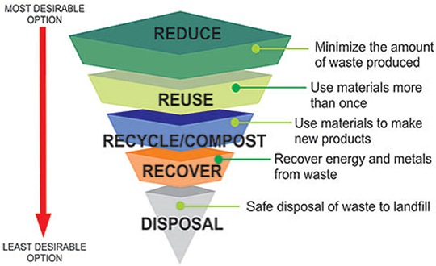
Water, sewerage and flood risk
2.9 Policy RG12 of the RDS promotes a more sustainable approach to the provision of water and sewerage services and flood risk management. Increased population, changes in household formation and climate change continue to put pressure on our water resources and drainage systems which may lead to discrepancies in water demand and availability as well as potential impacting on water quality. Planning for the provision of water and sewage infrastructure and treatment facilities is both a practical and environmental necessity for regional development.
2.10 The Housing Evaluation Framework (HEF) (Appendix A), a tool used to assist judgements on the allocation of housing growth, includes a ‘resource test’ which states that studies should be carried out to assess and detail physical infrastructure such as water, waste and sewage, including spare capacity. This is to ensure that the infrastructure is adequate to support the provision of future housing.
The key policy aims of the RDS regarding water and sewerage are:
- The integration of water and land use planning. Land use planning should be informed by current water and sewerage infrastructure and the capacity of that infrastructure to absorb future development. This will involve the planning authority working in conjunction with NI Water;
- Manage future water demand by reducing waste. To help manage future water demand in new developments, initiatives such as grey water recycling and rainwater harvesting should be promoted;
- Encourage sustainable surface water management. This will involve the encouragement of initiatives such as Sustainable Drainage Systems (SuDS) in significant development proposals. SuDS endeavour to use natural systems with low environmental impact (such as evapotranspiration) to dispose of dirty water and surface water in order to reduce the amount of water being released back into water courses.

2.11 In relation to development and flood risk, Policy RG8 of the RDS emphasises the need for mitigating the risk of flooding by avoiding those areas known to be at risk. This position is reflected in the HEF with the Environmental Capacity test including assessment of potential flood risk areas to guide the allocation of land for housing growth.
2.12 Furthermore, Policy RG1 of the RDS states that when allocating land for economic growth and employment, areas which are at risk of flooding should be avoided, where possible.
2.13 The RDS is complemented by the Strategic Planning Policy Statement (SPPS). The SPPS does not introduce any significant changes to any of the previous Planning Policy Statements (PPSs) which relate to the provision of public utilities, but helps to shorten and simplify the guidance for councils. The position in terms of the SPPS is summarised within the relevant subject area below.
Planning Policy

2.14 The following Planning Policy provides the planning policy context for the assessment and determination of utility developments and include:
- PPS 10 - Telecommunications
- PPS 11 - Planning and Waste Management
- PPS 15 - Planning and Flood Risk
- PPS 18 - Renewable Energy
- PPS 21 - Sustainable Development in the Countryside
- A Planning Strategy for Rural Northern Ireland

The key issues from these policy documents and guidance relevant for the LDP preparation include:
- Facilitating the continued development of telecommunications infrastructure but ensuring that visual and environmental impact is kept to a minimum;
- The Council may consult with telecommunications operators over the plan period to ascertain the extent of network coverage in plan area. The Council could consider the allocation of certain sites for the provision of tall masts to encourage site sharing;
- Promoting the development, in appropriate locations, of waste management facilities to meet need as identified by the Waste Management Plan;
- Consideration of the impact of existing or proposed waste management facilities when zoning land for development and ensuring incompatibility of adjacent land uses are avoided. The COMAH Directive (EU Directive 96/82/EC) requires development plans to ensure that appropriate distances are maintained between hazardous substances and residential areas of public use / open space;
- A presumption against development within designated floodplains;
- Promotion of development of renewable energy resources which will not negatively impact on the environment, landscape or amenity of nearby land uses;
- Careful consideration must be given to distinctive landscape areas when considering wind energy proposals;
- Integration of new electricity powerlines and cables into the existing landscape and townscape; and
- Development relying on non-mains sewage will only be acceptable were it does not create or add to a pollution problem.

3.0 Newry, Mourne & Down District Council Plans & Strategy
Newry, Mourne and Down District Council Corporate Plan 2015-2019
3.1 The Newry, Mourne and Down District Council Corporate Plan 2015-2019 sets out 8 strategic priorities to be delivered over the plan period. The advocation for increased broadband and mobile coverage has been identified as one of the key actions for the Council over the plan period.
Newry, Mourne & Down Community Plan 2030 ‘Living Well Together’
3.2 Community Planning came into operation on 1st April 2015 as part of the full implementation of local government reform. Community planning is a process led by a council in conjunction with partners and communities to develop and implement a shared vision for their area, a long term vision which relates to all aspects of community life and which also involves working together to plan and deliver better services which make a real difference to people's lives.
3.3 The Local Government Act introduces a statutory link between the community plan and a council’s local development plan, in that the preparation of the LDP must take account of the Community Plan. It is intended that the LDP will be the spatial reflection of the Community Plan and that the two should work in tandem towards the same vision for a council area and its communities and set the long term social, economic and environmental objectives for an area.
3.4 The community Plan is to be the overarching strategic plan for integrated planning and delivering of services in Newry Mourne and Down. It provides a framework for the strategies and plans the Council will put in place to contribute towards the outcomes in the community plan and it is based on a detailed analysis of future risks and opportunities for Newry, Mourne & Down.
3.5 With regard to Public Utility provision, a key outcome for the draft Community Plan is that all people in the Newry, Mourne & Down District get a good start in life and fulfil their lifelong potential. The level of connectivity within the District has been identified as an indicator for achieving this outcome with the level of broadband connectivity a key measure.
3.6 A clean and quality sustainable environment has also been identified as a key outcome and the use of renewable energy sources e.g. wind, sun will be central to delivery of this which will be discussed in detail in section 5.0
Newry, Mourne and Down Economic, Regeneration & Investment Strategy
3.7 The Newry, Mourne and Down Economic, Regeneration & Investment Strategy sets out the vision to make the area a vibrant, dynamic and connected region for investment, tourism and culture. Rural Development and Regeneration has been identified as one of the strategy’s five key themes.
3.8 In order to meet the strategic priority of improving infrastructure across rural areas for the needs of rural communities, rural services and rural businesses, the Council will review existing broadband research and data to identify current provision and support broadband research & data with consultation with relevant bodies to identify all infrastructural needs and requirements within the rural areas.
3.9 The Council will work with Government Departments and statutory bodies to encourage and support the delivery of initiatives across the region which will seek to improve rural infrastructure in order to meet the requirements of rural communities, rural services, and rural businesses.
4.0 Telecommunications & Broadband
4.1 Modern telecommunications are an essential and beneficial element of everyday living for the people of and visitors to this District. It is important to continue to support investment in high quality communications infrastructure which plays a vital role in our social and economic well-being. Northern Ireland’s core telecommunications network is recognised as world class with a high quality communications infrastructure considered essential for sustainable economic growth.
4.2 Whilst the development of high quality telecommunications infrastructure is essential for continued economic growth it is necessary to minimise the impact on the environment as set out in the SPPS and PPS 10. The SPPS states that the LDP should bring forward policies which set out the detailed criteria for consideration of new telecommunications development in the local area including siting, design and impact upon visual amenity. To inform plan preparation, the Council may consult with telecommunications operators, and other relevant stakeholders, in relation to the anticipated extent of the network coverage required over the plan period. In certain circumstances and, subject to technical limitations on location and siting, the LDP may allocate specific sites for major new telecommunications development.
4.3 The Council should take account of the potential effects of new telecommunications development, and any necessary enabling works, on visual amenity and environmentally sensitive features and locations. New masts should only be considered where site sharing is not feasible or offers an improved environmental solution. Operators will be encouraged to site share wherever possible.
4.4 Until the new Plan Strategy for the whole District has been adopted, elements of PPS 10 remain in place however; if there is a conflict between the SPPS and PPS 10, the SPPS should be accorded greater weight in the assessment of individual planning applications.
Broadband
4.5 The broadband market in Northern Ireland is fully privatised with the principal domestic and business provider being British Telecom (BT) with other providers such as Plusnet, EE, SKY, Talk Talk, Virgin Media, FUEL Business and XLN. Northern Ireland currently enjoys the best fixed line broadband infrastructure in the UK although there are some rural areas which still have limited connectivity.
4.6 Broadband speed is the time it takes to send data to and from your computer and is measured in megabits per second (Mbps, Mbit/s or just Mb). Currently, the speeds available in the UK range from 17Mbps to 76Mbps (Megabits per second) from BT and most other providers (many use BT's network) or from Virgin Media, which has its own independent network with speeds of 50Mbps, 100Mb or 200Mb.
4.7 Fast internet connections allows the user to move freely around the web with minimal delays for downloading, uploading, moving between sites etc. A slow connection can lead to longer download times, buffering etc. The average urban and rural broadband download speed in the UK is currently 31.3Mbps and 11.6 Mbps respectively compared to 32.5 Mbps and 18Mbps in Northern Ireland.
4.8 The broadband speeds available are influenced by location, as fibre broadband is still in the rollout phase and the networks don’t yet cover the whole country.
Table 1: Broadband availability in Newry, Mourne & Down
 | Newry & Mourne | Down | NI
Average sync speed (Mbit/s) | 17.1% | 18.9 | 18.3%
Percentage getting less than 2Mbit/s | 18.20% | 15.30% | 15.6%
Superfast Broadband availability | 95.90% | 94.50% | 93.8%
Broadband take up: | 65.8% (of which 23.80% is superfast) | 67.60% (Of which 26.40% is superfast) | 63.9%
Average data use | 28.1 GB/Connection/Month | 26.9 GB/Connection/Month | 28.9%
Source: http://maps.ofcom.org.uk/broadband/ (figures as of 2013)
4.9 In accordance with the aims of the RDS and the SPPS, it is vital to ensure that we continue to improve the broadband network in order to ensure that businesses remain competitive and that rural communities do not feel cut off or isolated.
4.10 The UK Government intends to introduce a new Universal Service Obligation (USO) that should give everybody the legal right to request a broadband connection capable of delivering a minimum speed of 10Mbps (Megabits per second) by 2020. As detailed below this District does not compare favourably with other Councils. It should be noted however that as the superfast broadband rollout programme nears completion, these figures should see improvements
Figure 2: The Percentage of premises unable to get 2, 5 and 10 Mbit/s by local authority area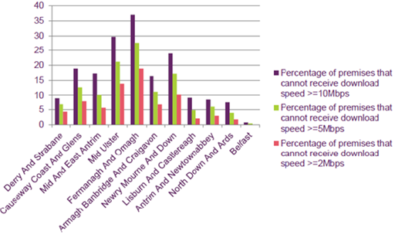
Source Ofcom NI Report Dec 2015
4.11 There have been numerous improvements to the broadband network which have taken place in recent years and the District has benefited from these:
Broadband Improvement Project
4.12 This project is designed to provide for the first time, improve or increase broadband services in certain areas. Work began in February of 2015 and it is envisaged that work will finish at the end of 2017. Work has already taken place to improve or provide broadband in the following areas within the Newry, Mourne & Down District;

Ardglass | Ballykinler | Ballynahinch | Ballyward
Bessbrook | Crossgar | Crossmaglen | Downpatrick
Forkhill | Jerrettspass | Keady | Kilkeel
Killeavy | Maghera | Mayobridge | Newry
Newtownhamilton | Rostrevor | Saintfield | Seaforde
Strangford
Source: www.nidirect.gov.uk/broadband-improvement-project
Northern Ireland Broadband Fund
4.13 This was a £1.9m fund which was set aside to help support projects which aimed to improve broadband across Northern Ireland. In Newry, Mourne & Down, the following projects benefitted from this fund:
a) Installation of Fibre To The Cabinet (FTTC) technology to cabinets in the Crossmaglen, Downpatrick, Forkhill, and Newtownhamilton exchange areas; and
b) Installation of a WiMAX Fixed Wireless Access Network in the District.
4.14 The installation of apparatus to improve the Broadband network will usually constitute Permitted Development under Part 18 of the Schedule to the Planning (General Permitted Development) Order (Northern Ireland) 2015. As such, it is not envisaged that the planning process will have an impact on the provision of such development.
Next Generation Broadband Project
4.15 This project aimed at delivering improved broadband services to small and medium sized enterprises across Northern Ireland. This project is now in its operational phase in that fibre deployment has been completed to all 1,265 telecommunication cabinets across Northern Ireland including Newry, Mourne & Down. Following this project BT completed fibre upgrades to a further 783 cabinets across NI under its own Next Generation Access (NGA) programme. Almost 2,500 cabinets are now fibre enabled with more than 90% of premises in Northern Ireland connected to an enabled cabinet.

Table 2: Broadband Improvement Schemes in N.Ireland
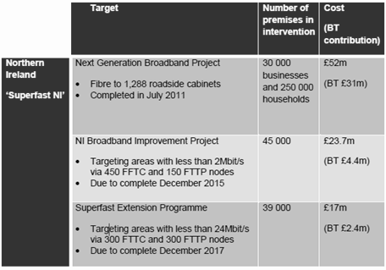
Source: Ofcom Connected Nations 2015 – Northern Ireland Report
Mobile Data Coverage
4.16 Table 3 below sets out the availability of 2G and 3G data coverage in the District as broken down by the historic LGD areas. 3G is the most common type of mobile broadband connection but 4G broadband connectivity is more recent and is the fastest mobile connection available.
Table 3: Mobile Data Coverage 2013
 | Area | Geographical Coverage (no reliable signal) | Geographical coverage (all operators) | Premises coverage (no reliable signal) | Premises coverage (all operators)
3G Mobile Data Coverage | Newry and Mourne | 21.60% | 8.20% | 12.40% | 31.30%
 | Down | 5.60% | 10.90% | 6.10% | 17.20%
2G Mobile Data Coverage | Newry and Mourne | 24.40% | 44.70% | 13.80% | 61.30%
 | Down | 1.20% | 72.20% | 0.60% | 69.80%
Source: http://maps.ofcom.org.uk/mobile-services/mobile-services-data-3G/
4.17 The roll out of 4G coverage in Newry, Mourne & Down has commenced by the three main providers EE, O2 and Vodafone. Although there has been good progress to date, the development of 4G coverage across the district remains on-going.
4.18 Moving forward, it is for the Council to decide if they wish to adopt policies for telecommunications development which are in line with existing policy or if they want to develop a more restrictive policy, for example, having regard for the visual impact of telecommunications infrastructure. To a lesser extent than in the past, concerns amongst some concerning potential health implications also exist, however these concerns remain unfounded.
4.20 Having evaluated the information available in respect of telecommunications, the options for the council are to:
- Adopt policies which are in line with existing planning policy contained within Planning Policy Statement 10 (PPS 10) Telecommunications;
- Develop a more restrictive policy, having regard to concerns over potential health implications, visual and/or environmental impact on the landscape;
- Develop an approach which promotes the development of telecommunications infrastructure whilst also paying close attention to the impact such development will have. This may mean for example, that certain areas are designated at local policies plan stage as areas where no telecommunications development will be permitted in order to protect sensitive landscapes, provided there is not a recognised ‘Not Spot’ at that location i.e. no telecommunication coverage at all. Any such policy changes would be brought through the introduction of Countryside Policy Areas.

5.0 Energy Supply
5.1 The SPPS reinforces the aims of the RDS 2035 in that it seeks to increase the contribution that renewable energy can make to overall energy supply. The policy objectives are to ensure that the environmental, landscape, visual and amenity impacts associated with or arising from renewable energy development are adequately addressed; ensure adequate protection of the region’s built, natural, and cultural heritage features; and facilitate the integration of renewable energy technology into the design, siting and layout of new development and promote greater application of the principles of Passive Solar Design. In relation to electricity lines, current operational policy within the Planning Strategy for Rural Northern Ireland indicates a preference for underground lines to minimise the visual intrusion of overhead lines.
5.2 In preparing the LDP, the Council should formulate policies and proposals which support a range of renewable energy infrastructure whilst still taking into account the above mentioned policy objectives.
5.3 Energy in the District is primarily produced by the use of fossil fuels from the three fossil fuel generating plants in Northern Ireland. These plants supply electricity to a wholesale electricity market for the whole island of Ireland known as the Single Electricity Market (SEM). The SEM is served by the North South Interconnector. In addition the Moyle interconnector links Northern Ireland to the electricity grid in Britain which brings additional competition to the electricity generation market.
Figure 3: NI Transmission System
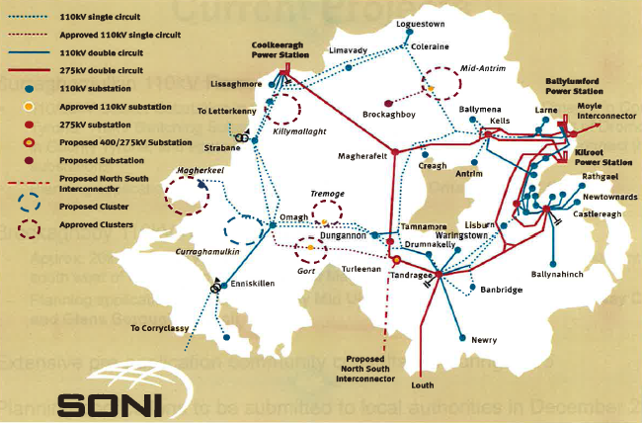
Source: Soni
5.4 SONI is responsible for the safe, secure, efficient and reliable operation of the high voltage electricity system in Northern Ireland. SONI works in cooperation with asset owner NIE to develop the grid infrastructure. This is needed to support competition in energy, to promote economic growth and to facilitate renewable energy. No substantial SONI projects have been proposed within this District, SONI however has stated it will engage with SOLACE and Local Authorities to ensure future Developments are considered within the Council’s Local Development Plan.
5.5 To underpin economic growth in the District, it is necessary to have a modern and sustainable economic infrastructure including robust electricity connections. Whilst electricity supply in the Council area and NI as a whole is not an issue, the upsurge in the number of renewable energy developments, particularly wind turbines seeking to connect to the electricity grid, has highlighted that grid reinforcement is required to facilitate the growth of renewable energy generation. Newry, Mourne & Down’s geographical location presents opportunities to create physical links to the electricity network for the Republic of Ireland.
5.6 The SPPS is clear that overhead power lines should avoid areas of landscape sensitivity including Areas of Outstanding Natural Beauty (AONB’s).
Renewable Energy
5.7 The European Commission’s Renewable Energy Directive (2009/28/EC) establishes overall policy for the production and promotion of energy from renewable sources in the EU and specifies national renewable energy targets for each country. The Strategic Energy Framework (DETI 2010) states that Northern Ireland will seek to achieve 40% of electricity consumption from renewable sources by 2020. In line with this, the Northern Ireland Executive in their Programme for Government 2011-2015 (PFG) set a target that by 2015, 20% of all electricity would be generated from renewable sources.
5.8 For the 12 month period April 2015 to March 2016, 25.4% of total electricity consumption in Northern Ireland was generated from renewable sources located in Northern Ireland. This represents an increase of 5.5 % on the previous 12 month period (April 2014 to March 2015). In the 12 month period ending June 2009, some 8.1% of the total electricity consumption in Northern Ireland was generated from renewable sources (Source Department for the Economy). This figure outlines significant growth in the renewable sector over recent years, between the twelve month period ending June 2009 and the twelve month period ending April 2015, there has been a rise of around 142% in average renewable generation volumes. Therefore continued development of renewable energy resources is vital to facilitating the delivery of international and national commitments on both greenhouse gas emissions and renewable energy and progress towards the current PFG objective of living and working sustainably and protecting the environment.
5.9 New private forms of renewable energy development are likely to increase in use in the Newry, Mourne and Down area over the plan period and will require connection to the electricity network.
5.10 The main sources of renewable energy are the wind, the sun (solar), moving water (hydropower), heat extracted from the air, ground, water (including geothermal energy), biomass (wood, biodegradable waste and energy crops) and gas (bio and landfill). The key issues regarding each of these energy sources are discussed below:
Wind
5.11 Electricity generated by onshore wind farms is the most established, large scale source of renewable energy in NI. Over the 12 month period April 2015 to March 2016, 90% of all renewable electricity generated within Northern Ireland was generated from wind (see figure 4).
5.12 At present there are no operational wind farms in the Newry, Mourne and Down area, this is in stark contrast to the rest of Northern Ireland where 126 windfarms have been approved. There has however been 321 individual wind turbines of varying sizes approved across the District, these figures are for between 2002 and 2015 (See map Appendix B).
Figure 4: Renewable electricity generation by type of generation April 2015 to March 2016
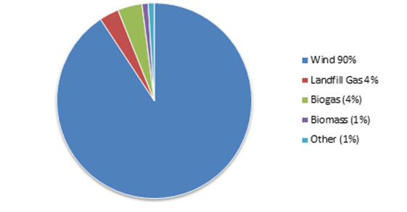
Other includes Hydro, Tidal, Combined Heat & Power and Photovoltaic (PV)

Source: Department for Economy

5.13 Public attitude towards wind energy development is changing. Newry, Mourne and Down District contains some of the most scenic landscapes including the AONB areas surrounding Slieve Gullion, the Mournes, Slieve Croob, Strangford and Lecale which encompass 55% of the District. There are concerns regarding the proliferation of single turbines and resulting visual intrusion, safety and the increasing size and massing of turbines and interference through noise and flicker.
5.14 Having evaluated the information available in respect of wind energy, the options for the Council are to:
- Adopt policies which are in line with existing planning policy contained within Planning Policy Statement 18 (PPS 18) Renewable Energy and the Best Practice Guidance to PPS18;
- Develop a more restrictive policy, having regard to concerns relating to impacts on AONBs and sensitive landscapes, bio-diversity and tourism;
- Adopt a policy position that recognises the value of wind energy development but provides policy which gives greater weight to environmentally sensitive areas and greater protection to neighbouring amenity. Any such policy changes would be brought through the introduction of Countryside Policy Areas.

5.15 As outlined earlier, Northern Ireland is on course to meet the targets of 40% of electricity consumed from renewable sources by 2020 set out by the Strategic Energy Framework and has met the 20% target set out in the 2011-15 PFG by the NI Executive. Consequently, a more restrictive policy may hinder the progress made thus far and reverse the positive trends experienced to date. By adopting option 3, the Council would be able to continue to support renewable wind energy development whilst also safeguarding areas which are considered to be of particular scenic value and also reducing potential impacts on neighbouring properties. The impact of onshore Wind Turbine applications will be considered further in the Landscape Character and Rural Pressure Analysis Papers.
Solar (Photovoltaic)
5.16 Active solar photovoltaic (PV) technologies generate electricity from daylight. The most common form of device is a solar panel or module typically 0.5 to 1 m2 in size, dark in colour and having low reflective properties. Although roof mounted is most common, modules can be mounted on sides of buildings, or on free standing support structures on the ground. A number of modules are usually connected together in an array to produce the required output, which can vary from a domestic scale panel on e.g. residential buildings / farms of just a few square metres to several hundred square metre industrial scale panels. In most cases involving dwelling houses, providing the building is not listed or in a conservation area and the installation complies with the relevant constraints, PV will be ‘permitted development’ and a planning application will not be required. Passive Solar Design (PSD) is an environmentally benign approach to ensure that domestic scale buildings capture maximum light and heat from the sun whilst being positioned in the landform to act as a buffer against the worst of the elements. As of 1st April 2015 55 solar applications have been processed within the District area of which 54 have been approved. One example of a larger solar application is the approved application for a 5.1MW Photovoltaic solar farm at Tullynaskeagh Road, Downpatrick. It should be noted that the number of operational panels is likely to be much higher as some panels may qualify as permitted development and therefore did not require a planning application. To date, operational planning policy regarding solar power has not raised any particular key issues.
Hydro Electricity
5.17 Water flowing from a higher to a lower level drives a turbine which produces mechanical energy. This mechanical energy is usually turned into electrical energy by a generator. There are no large scale hydroelectric schemes in the District although recently there has been an upsurge in planning applications for small scale schemes, particularly in the Newry and South Armagh area. Hydro developments anticipated will generally small in scale and subject to design, ecological and fisheries considerations being carefully assessed this type of renewable energy development is unlikely to cause significant concern.
Tidal
5.18 Tidal power or tidal energy is a form of hydropower that converts the energy obtained from tides into useful forms of power, mainly electricity. Although not yet widely used, tidal power has potential for future electricity generation. Tides are more predictable than wind energy and solar power. Among sources of renewable energy, tidal power has traditionally suffered from relatively high cost and limited availability of sites with sufficiently high tidal ranges or flow velocities, thus constricting its total availability. However technological developments and improvements, both in design (e.g. dynamic tidal power, tidal lagoons) and turbine technology (e.g. new axial turbines, cross flow turbines), indicate that the total availability of tidal power may be much higher than previously assumed, and that economic and environmental costs may be brought down to competitive levels.
5.19 SeaGen is the world's first large scale commercial tidal stream generator. It was four times more powerful than any other tidal stream generator in the world at the time of installation. The first SeaGen generator was installed in Strangford Narrows between Strangford and Portaferry in April 2008 and was connected to the grid in July 2008. It generated 1.2 MW for between 18 and 20 hours a day while the tides are forced in and out of Strangford Lough through the Narrows. Strangford Lough was also the site of the very first known tide mill in the world, the Nendrum Monastery mill where remains dating from 787 have been excavated. At present there are no new approvals for tidal energy within the District.
Heat
5.20 Ground source heat pumps operate by circulating water (or another fluid) through pipes buried in the ground. The water temperature in the pipes is lower than the surrounding ground and so it warms up slightly. This low grade heat is transferred to a heat pump, which raises the temperature to around 50°C. Water source heat pumps operate in a similar way, with the pipes being submerged in water. Air source heat pumps extract heat in the air and use a fan to draw air over coils that extract energy. Air-source heat pumps can be located in the roof space or on the side of a building. They are similar in appearance to air conditioning boxes. To date, existing operational policy has not raised any significant issues with these types of renewable energy developments subject to careful planning consideration including archaeological implications.
Biomass

5.21 Biomass fuels, including wood and energy crops, can be utilised to provide energy either by combustion or fermentation / digestion technologies.
There are currently three main categories of biomass plant:
- Plant designed primarily for the production of electricity;
- Combined heat and power plant (CHP); and
- Plant designed for the production of heat.

Biogas
5.22 Biogas typically refers to a mixture of different gases produced by the breakdown of organic matter in the absence of oxygen. Biogas can be produced from raw materials such as agricultural waste, manure, municipal waste, plant material, sewage, green waste or food waste. Biogas is a renewable energy source and in many cases exerts a very small carbon footprint.
5.23 Emissions and waste products from biomass energy production include airborne emissions, emissions to watercourses and ash. Anaerobic digestion (AD) is a process which bacteria break down organic material in the absence of oxygen to produce a methane rich biogas. This can be combusted to generate electricity. Thermal processes can also be used extract energy from waste. These processes use a high temperature to release the chemical energy in the fuel. Planning issues from these renewable energy developments that require consideration include:

- Visual intrusion-the plant is an industrial feature with a chimney;
- Noise from plant and traffic operations;
- Any effects on health, local ecology or conservation from the plant and air / waterborne emissions; and
- Traffic to and from the site in order to transport biomass fuel and subsequent by-products.

5.24 Landfill gas is produced by wet organic waste decomposing under anaerobic conditions which then releases a biogas. The waste is covered and mechanically compressed by the weight of the material that is deposited above. This material prevents oxygen exposure thus allowing anaerobic microbes to thrive. This gas builds up and is slowly released into the atmosphere if the site has not been engineered to capture the gas. If the site has been engineered appropriately however, this gas can be burned and used to generate energy.
5.25 Having evaluated the information available in respect of biomass development, the options for the council are to:

- Adopt policies which are in line with existing planning policy within Planning Policy Statement 18 (PPS 18) and the related Best Practice Guidance to PPS18 and within Planning Policy Statement 11 (PPS 11) Planning and Waste Management in the case of biomass from waste.
- Develop a more restrictive policy, having regard to concerns over environmental impact, visual impact and amenity impact.

Connections to Electricity Grid

5.26 The electricity network in NI is facing an unprecedented demand for the connection of renewable generation. The total amount of renewable generation already connected to the network is 729MW, with a further 455MW committed to connect. Renewable energy connection is very reliant on the existing infrastructure. However at present the transmission and distribution networks cannot provide, on an unrestricted basis, for all of this connected renewable generation.

5.27 Since the introduction of increased Renewable Obligation Certificate (ROC) incentives for small scale generation in April 2010, there has been a large increase in the amount of small scale generation either connected to, or committed to connect to the 11kV network. NIE have produced an 11kV network heat map (February 2015) to provide guidance on capability of the 11kV network to accept further small scale generation (see Appendix C). This heat map identifies where investment is currently required. This map is a simple visual representation however it displays that in the Newry, Mourne & Down District Plan Area locations such as Lecale, Slieve Croob and Newtownhamilton are already at saturation point.

5.28 The existing energy infrastructure needs to be overhauled to ensure it will be fit for purpose. This includes strengthening the grid and developing smart grid initiatives. The upgrading of the electricity grid will involve more overhead powerlines and power installations. The following table provides details of the various projects presently underway or planned in NI to aid renewables integration into the electricity network:

Short Term Plan (STP)
Increasing capacity of existing 110kV network by using Dynamic Line Rating techniques combined with selective up-rating- Work Completed.
Medium Term Plan (MTP)
Series of individual projects designed to reinforce 110kV network to increase capacity & remove bottlenecks-Work on-going.
Renewable Integration Development Plan (RIDP) & Network 25
The RIDP has identified the issues which will arise due to the connection of renewable generation (in the north and west of NI) & in 2013 the project had arrived at a preferred overall scheme option. The scheme involves new extra high voltage, 275 and 110 kV infrastructure and the uprating of some existing circuits. However, phase 4 of the RIDP is now focused on the preparation of a transmission plan for the whole of NI (Network 25) supported by an associated Strategic Environmental Assessment.
Generation Cluster Infrastructure
To facilitate the connection of renewable generation to the grid NIE will ‘cluster’ their arrangements for the connection of generators (generally onshore wind farms) so that generators will share transmission network infrastructure as far as possible. Clustered connections generally involve the construction of a 110/33kV substation, connection to the 110kV network & individual 33kV generation connections. There are to be at least 7 cluster substations developed before 2020.
New North South Interconnector (NSI)
The proposed new interconnector will require the construction of a new 275/400kV substation & a new 400kV overhead line between Turleenan (Dungannon) and Woodland (Meath). A planning application was submitted in December 2009, the Environment Minister referred the application to the Planning Appeals Commission (PAC) and a Public Inquiry commenced in March 2012. An updated planning application, relating specifically to the works associated with the construction of overhead lines & towers was submitted to DOE in April 2013. Following a period of public consultation, this application has been returned to the PAC for recommencement of the Inquiry.

5.29 It must be noted that in terms of the current planned and ongoing projects within Northern Ireland detailed within the RIDP & Network 25 along with the general Cluster Infrastructure, none of these works fall within this Council area.
Natural Gas
5.30 Natural gas was first introduced to Northern Ireland via the Scotland to Northern Ireland gas pipeline in 1996. Initially, natural gas was made available to customers in Greater Belfast, the immediate surrounding area and Larne where the gas distribution network has been developed by Phoenix Natural Gas (PNG). By the end of 2014, natural gas was available to circa 307,000 properties in this area, with around 182,000 actually connected to natural gas.
5.31 Firmus Energy (Firmus) is engaged in work to develop the natural gas market outside Greater Belfast along the routes of the North-West gas transmission pipeline (completed November 2004) and the South-North gas transmission pipeline (completed October 2006). This work involves rolling out the gas distribution network in the 10 towns and cities across Northern Ireland including Newry, the others include Derry, Limavady, Ballymena, Ballymoney, Coleraine, Craigavon, Antrim, Banbridge and Armagh. To date, Firmus has connected around 25,000 customers in the 10 towns area, including taking natural gas to some additional urban areas, such as Warrenpoint.
5.32 In December 2015, the Utility Regulator approved an extension of Phoenix Gas’ gas conveyance licence to East Down. This proposed extension encompasses 13 new towns for development and requires capital expenditure in excess of £58m and will make gas available to around 27,000 properties. Settlements within the District to be served by the extension include Ballynahinch, Drumaness, Saintfield, Downpatrick, Castlewellan, Newcastle and Dundrum.
Figure 5: Proposed Licence Extension Map for Phoenix Gas
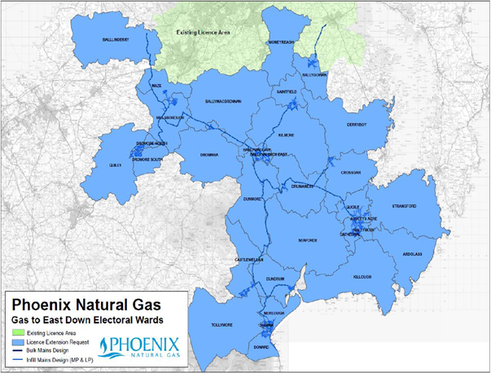
Source: Utility Regulator

6.0 Waste Management

6.1 The policy framework for the delivery of Waste Framework Directive is set out in the 2013 Revised Waste Management Strategy, containing actions and targets to meet the EU Directive and related Programme for Government targets. It sets targets of achieving a recycling rate of 50% of household waste by 2020 (EU Directive target) and a recycling rate of 45% of household waste by 2025 (PfG Target). Local Authority collected municipal waste has a recycling rate target of 60% by 2020. The document also sets out a number of proposals in relation to reducing the amount of food waste sent to landfill in Northern Ireland. By encouraging more people ‘to reduce, re-use and recycle’ and ‘let’s recycle more’, steady progress is being made in limiting the amount of waste sent to landfill.

Strategic Planning Policy Statement

6.2 The SPPS supports wider government policy and in line with the RDS, promotes the 5 step Waste Hierarchy and the proximity principle. It sets three policy objectives for waste management:
- Promote development of waste management and recycling facilities in appropriate locations;
- Ensure that detrimental effects on people, the environment, and local amenity associated with waste management facilities (e.g. pollution) are avoided or minimised; and
- Secure appropriate restoration of proposed waste management sites for agreed after-use.

6.3 Council should set out policies and proposals in the LDP that support the above-mentioned aims and policy objectives, tailored to the local circumstances of the plan area.
6.4 The Council must assess the likely extent of future waste management facilities for the plan area. Specific sites for the development of waste management facilities should be identified in the LDP together with key site requirements. The COMAH Directive (EU Directive 96/82/EC) requires development plans to ensure that appropriate distances are maintained between hazardous substances and residential areas of public use/open space.
6.5 Sites and proposals for waste collection and treatment facilities must meet one or more of the following locational criteria:

- It is located within an industrial or port area of a character appropriate to the development;
- It is suitably located within an active or worked out hard rock quarry or on the site of an existing or former waste management facilities including a land fill site;
- It brings previously developed, derelict or contaminated land back into productive use or where existing or redundant buildings can be utilised;
- In the case of civic amenity facilities, the site is conveniently located in terms of access to service a neighbourhood or settlement whilst avoiding unacceptable adverse impact on the character, environmental quality and amenities of the local area; or
- It is suitably located in the countryside, it involves the reuse of existing buildings or is on land within or adjacent to existing building groups. Alternatively where it is demonstrated that new buildings/plant are needed these must have an acceptable visual and environmental impact.

6.6 In the case of a regional scale waste collection or treatment facility, its location should relate closely to and benefit from easy access to key transport corridors and where practicable make use of the alternative transport modes of rail and water.
6.7 LDPs should also identify the need for appropriate waste management facilities within new development. A presumption in favour of waste collection and treatment facilities, and waste disposal (land filling and land raising) will apply where a need for such development is identified through the Waste Management Strategy and the relevant Waste Management Plan (WMP). In the case of Waste Water Treatment Works, need must be demonstrated to the satisfaction of the Department or relevant authority.
6.8 In all circumstances particular attention should be given to the potential impacts of existing and approved waste management facilities on neighbouring areas and the need to separate incompatible land uses.
6.9 Following the Publication of the SPPS, until such times as a Plan Strategy for the whole of the Council area has been adopted; planning authorities will apply existing policy contained within Planning Policy Statement 11 (PPS 11): Planning and Waste Management together with the SPPS. Any relevant supplementary and best practice guidance will also continue to apply. Any conflict between the SPPS and any policy retained under the transitional arrangements must be resolved in the favour of the provisions of the SPPS.
6.10 Where a council adopts its Plan Strategy, existing policy retained under the transitional arrangements shall cease to have effect in the district of that council and shall not be material from that date, whether the planning application has been received before or after that date.
6.11 PPS 11 promotes the development, in appropriate locations, of waste management facilities to meet need as identified in the WMP. Consideration of the impact of existing or proposed waste management facilities should also be given when zoning land for development and ensuring incompatibility of adjacent land uses is avoided.
Arc 21
6.12 Newry, Mourne & Down Council falls within the Arc 21 region. Arc 21 is an umbrella waste management group for 6 councils in the east of Northern Ireland. Arc21's aim is to encourage households and businesses to 'Reduce, Re-use and Recycle' as much as possible, and deliver new waste infrastructure facilities to manage waste efficiently and in an environmentally-friendly manner. At present Arc 21's region accounts for 54% of all Northern Ireland's municipal waste, 518,000 tonnes per annum
6.13 Under the provisions of the Waste and Contaminated Land (Northern Ireland) Order 1997 it is the responsibility of the district councils to prepare a WMP for the forward planning of waste management requirements for collecting, recovering, treating and disposing of controlled waste within the region.
Waste Management Plan

6.14 A revision of the Waste Management Plan for the Arc 21 region was determined by the Department of the Environment in September 2015. The Plan provides a framework for waste management provision and a regional network of facilities for all controlled wastes within the Arc 21 region. It establishes the overall need for waste management capacity and details the proposed arrangements to deal with the wastes produced in a sustainable manner.

Figure 6:
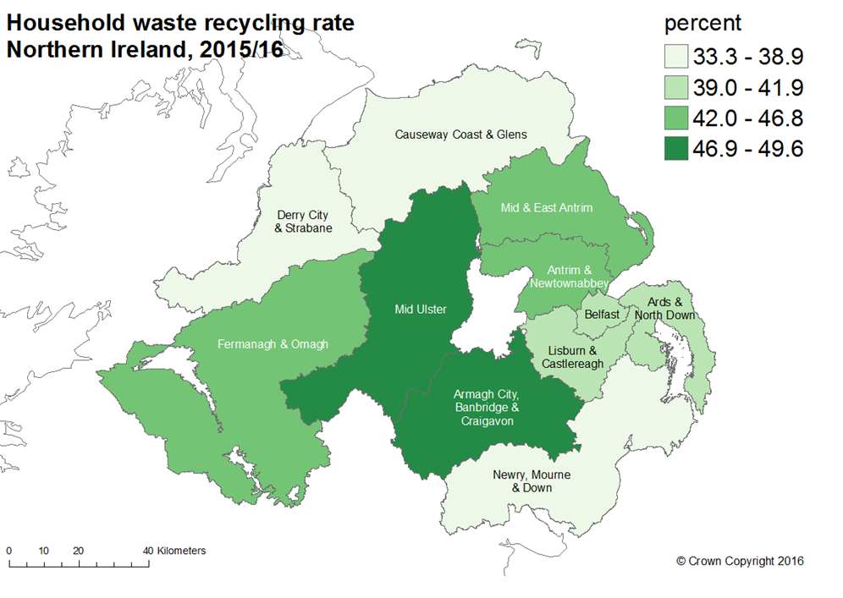
Source: NIEA NI Local Authority Collected Municipal Waste Management Statistics

6.15 The Arc 21 objectives have been set in the context of the following four principles of sustainable development:

- Social progress which meets the needs of everyone;
- Effective protection of the environment;
- Prudent use of natural resources; and
- Maintenance of high and stable levels of economic growth and employment.

6.16 The principle objective of the Plan is therefore to identify options for managing waste within the Arc 21 region which draws the correct balance between:

- The provision and maintenance of sufficient capacity to deal with the waste produced;
- Meeting strategic targets for recycling and recovery, and potentially for reduction;
- The protection of the environment for present and future generations; and
- Optimising resource utilisation in the Arc 21 region.

6.17 Application of the Waste Hierarchy to minimise waste production and policies to educate the public, industry and young people in particular, in effective resource use and reuse, recycling and composting is facilitated through the provision of ‘bring facilities’, bottle banks and civic amenity sites which are the responsibility of the Council.

Waste Processing within Newry, Mourne & Down District Council

6.18 In 2015/16 the Newry, Mourne & Down District Council area amassed 84,459 tonnes of municipal waste of which a total of 30,643 (36.3%) tonnes was sent for preparation for reuse, dry recycling and composting. A further 23,932 tonnes (28.3%) was sent for waste energy recovery and 29,762 (35.2%) was sent to landfill.

6.19 The two main landfill sites within the district at Aughnagon and Drumnakelly ceased to be used for the purpose of household waste on April 2015 and May 2016 respectively. Currently ‘Black Bin’ waste within the district is collected by the council and transferred to private operator for sorting of material appropriate for ‘Refuse Derived Fuel’ and recovery of recyclable and biodegradable material. Planning permission has been granted at the Councils landfill site at Drumnakelly for a proposed Waste Transfer Station. ‘Blue Bin’ waste within the District is also transferred to private operators in Newry and Mallusk for processing. Commercial waste disposal is the responsibility of the waste generator and commercial facilities exist in both Kilkeel and Bessbrook.

6.20 Newry, Mourne and Down District also has 10 recycling centres located across the District. These centres are located in the following settlements listed below:

Ballynahinch
Castlewellan
Downpatrick
Newry
Bessbrook
Kilkeel
Newtownhamilton
Crossmaglen
Warrenpoint
Hilltown

Outline planning permission has been granted for a more modern facility at Killough Road Downpatrick with a reserved matters application currently under consideration.

6.21 At present there is no envisaged need for additional or expansion of existing Council operated waste facilities within the District however this will be monitored and updated as the Development Plan progresses. It should also be noted that the recycling and use of waste for energy production is a growth area in the private sector and it is highly likely that during the Development Plan period there will be applications for facilities from the private sector.

7.0 Flood Risk, Drainage, Water Supply and Sewerage
Flood Risk

7.1 The EU “Floods Directive” (2007/060/EC) came into force on the 26th November 2007 and aims to establish a framework that will contribute to reducing the impact of flooding on communities and the environment. Compliance with this Directive is the responsibility of the Rivers Agency which is part of the Department for Infrastructure (DFI) and they have begun implementing the directive by establishing flood risk and hazard maps which were published in 2013.

7.2 The EU Floods Directive confirms that development can exacerbate flood risk and states that the planning authority has a crucial role to play in managing development so as to reduce the risks and impacts of flooding. The Directive highlights the fundamental importance of preventing or restricting new development in flood prone areas.

Under the Floods Directive, flood risk is managed by:

Prevention: avoiding construction of houses and industries in flood-prone areas; by adapting future developments to the risk of flooding; and by promoting appropriate land-use, agricultural and forestry practices.
Protection: taking measures, both structural and non-structural, to reduce the likelihood and impact of floods.
Preparedness: informing the public about flood risk and what to do in the event of a flood.

7.3 The SPPS states that the preparation of a LDP affords the opportunity to engage with relevant government departments with responsibility for various aspects of flood risk management thereby fostering a necessary joined up approach to addressing flooding issues. Typically, this will involve considerable engagement with Rivers Agency and the use of the most up to date information on flood risk which will usually be contained in the Strategic Flood Maps. This joined up approach should also be extended to neighbouring councils in circumstances where flooding and flood risk crosses administrative boundaries.

7.4 The SPPS also states that LDPs should take account not only of current flood risk but also the likelihood of flood risk in the future and should not allocate land for development which may be prone to flooding.

7.5 Until the new Plan Strategy is adopted, PPS 15 (Planning and Flood Risk) is to be applied alongside the SPPS. PPS 15 operates a presumption against development within designated flood plains, unless the development is of regional importance or it falls into a pre-defined list of categories such as:

- A replacement building;
- An essential operational development such as utilities infrastructure;
- Sport and recreational uses;
- Minerals development; or
- Seasonal development which will not increase flood risk

7.6 With specific reference to flooding in each river basin, in December 2015 DARD (now DFI) published specific Flood Risk Management Plans (FRMPs) for the three River Basin areas in Northern Ireland. Two of these Plans cover this District, the Neagh Bann River Basin Flood Risk Management Plan and the North East River Basin Flood Risk Management Plan.

7.7 Flood Risk Management Plans (FRMPs) are a key requirement of the Floods Directive (Directive 2007/60/EC on the assessment and management of flood risks) and are aimed at reducing the potential adverse consequences of significant floods on human health, economic activity, cultural heritage and the environment. The FRMPs are coordinated at the River Basin District level to align with the Water Framework Directive’s River Basin Management Plans and focus on managing the flood risk in the twenty Significant Flood Risk Areas (SFRAs) identified through the Preliminary Flood Risk Assessment (PFRA) for Northern Ireland that was completed by the Department in December 2011. Within this District, the FRMP’s encompass the settlements of Newry, Warrenpoint, Newcastle and Downpatrick. Areas identified for further study include Rostrevor, Ballynahinch and Drumaness. In practice, the FRMP’s provide the information and evidence necessary to support risk management decision making. The Plans also help promote greater awareness and understanding of the risks of flooding amongst the public, Government Departments, Councils and other organizations. The Council should ensure that the new LDP is compatible with these FRMP’s.

7.8 Rivers Agency Planning Advisory Unit also advises on the flooding potential for individual sites which are the subject of specific planning applications and where flooding is likely to occur. The Planning Advisory Unit will advise on any development where there is a potential to the proposed development or property elsewhere caused by the proposed development. The SPPS will not permit development within the flood plains of rivers or the sea unless it meets prescribed exceptional circumstances.

If not controlled in the correct way, development can increase flood risk by:

a) Using up land which is required for flood relief pondage;
b) Allowing new development to take place on land which is in danger of flooding and therefore posing a threat to the safety of that new development;
c) Increasing the volume of water which is entering a particular watercourse in the form of sewage or industrial effluent runoff.

7.9 When preparing local policies as part of the LDP process, the Council will seek to ensure that land which has been identified as being at risk of flooding is not zoned for certain types of development such as housing or industry. Such zoning would eradicate the natural function of such land as a flood relief pondage area.

Rivers Agency will be able to advise on the suitability of land for development with respect to flood risk. This includes:

• The Extent of Flood Risk.
• The Mitigation of flood risk.
• Sustainable Drainage Systems.
• Resistance measures against flooding.
• Resilience measures to reduce the impact after flooding occurs.

7.10 The LDP should take account of the “Climate Change” Flood maps (Appendix D-F) as well as the information contained in the Strategic and Hazard Flood Maps to establish land zonings.

7.11 There are no current works or definitive proposals for Flood Defence Schemes or Improvements to existing Flood Defence Schemes planned within the District. There are however, a number of possible schemes currently being considered at Design Stage including:

- Newcastle, Shimna River;
- Mayobridge Flood Alleviation Scheme;
- Annsborough Flood Alleviation Scheme (Phase 2).

7.12 There is also a Feasibility Study currently on-going regarding the Newry, Greenbank Sea Defence Upgrade and a Flood Study of Newry currently being undertaken. It should be noted that subject to viability, flood alleviation schemes can take several years from identification of the requirement through to completion of work. All proposed works are subject to the availability of resources and competing priorities.
Drainage
7.13 In March 2016, the Department for Infrastructure (DfI) published a long term strategy entitled Sustainable Water: A Long-Term Water Strategy for Northern Ireland (2015-2040) on the best way forward for managing the water sector in Northern Ireland.
The Strategy highlights that planning policies should promote sustainable water and sewerage services by making appropriate space in development plans for water and sewerage infrastructure. Future local development plans should make provision for both waste water treatment facilities and sustainable drainage systems.
The Strategy identifies four key sections:
• Drinking Water Supply and Demand
• Flood Risk Management and Drainage
• Environmental Protection and Improvement
• Water and Sewage Services
7.14 Each of these sections sets out aims, policies and actions to achieve Sustainable Water within the lifetime of the Strategy, some of which have been identified to be implemented through the Local Development Plans (LDP), including:
• Make space for surface water management in LDPs – e.g. when zoning suitable land, large surface water drainage schemes such as lakes, wetlands and wet woodland could be created to meet the future drainage needs of the proposed development in an area.
• LDP policy could require, either generally or for specific zonings, that schemes are put in place at design stage so as to minimise surface water runoff. It is preferable that a range of Sustainable Drainage System (SuDS) solutions be employed as these are more sustainable and often less costly than using traditional piped infrastructure. They also offer multiple benefits such as recreation and amenity provision. Examples of such are green roofs, permeable paving, soakaways, ponds and wetlands. The Diagram below shows how Sustainable Drainage Systems work (see figure 7).
7.16 Taking account of this information, the Council may, when preparing the LDP and local planning policies, try to ensure that the following objectives are realised;

- Ensure the LDP is compatible with and complements the Flood Risk Management Plans published by DFI Rivers Agency.
- Avoid zoning land for habitable development which has been identified as being at risk of flooding, either on the Strategic / Hazard / Climate Change Flood Maps.
- Formulate planning policy which makes drainage a key element of design and which promotes the use of SuDS.

Figure 7: Sustainable Drainage Systems
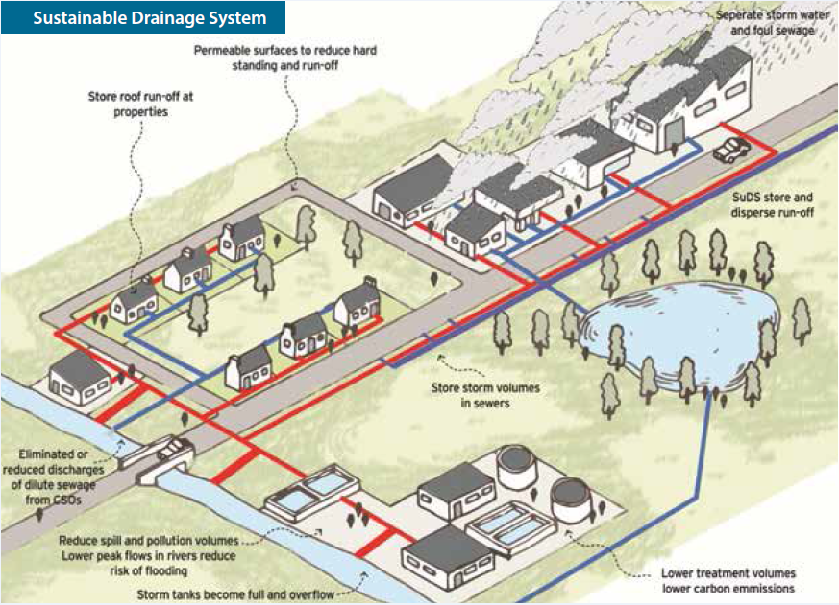
Source DRD: Sustainable Water

Sewerage Facilities – Waste Water Treatment Works (WWTW)

7.17 The provision of sewage treatment facilities across the District is also the responsibility of NI Water.

7.18 The RDS proposes that Newry, Mourne and Down District Council will need approximately 10,900 new houses from 2012 - 2025 so it is important to bear in mind the impact that this housing need will have on the existing sewage network capacity. Most houses are connected to the existing sewage network, under the SPPS, in all circumstances proposals for development must meet planning and environmental considerations including those for drainage and sewerage.

7.19 Single houses in the countryside rely on septic tanks, it should be noted that Policy CTY 16 of PPS 21 states that planning permission will only be granted for developments relying on non-mains sewerage where the applicant can demonstrate that this will not create or add to a pollution problem.

7.20 When preparing the LDP, the potential capacity of the existing sewage infrastructure in an area will have a bearing on the amount and location of new development and whether or not land is zoned for new development. An indication as to the available capacities (headroom) of existing waste water treatment works (WWTW) within the Council area was supplied by NI Water in December 2015 and will be updated through the plan process. The information provided (see appendix G) at this stage is limited to those settlements served by public treatment facilities serving population equivalents of greater than 50.

7.21 The information provided to date highlights that the following settlements as having no remaining capacity (headroom) within the business period 2015-2021:

Drumaness
Dundrum (Upgrade of this WWTW during 2015-2021)
Ballymaderphy
Glassdrumman (Armagh)
Glen Villas
Lurganare
Oliver Plunkett Park

7.22 NI Water maintains all works through a capital maintenance programme and further seeks to address quality and development issues through an enhancement programme which is delivered on a prioritised basis across Northern Ireland within allocated funding. This information will need to be kept under review to ensure an accurate picture of the extent of any constraint placed on development.

7.23 Proximity to existing WWTW will also be a factor in considering the location of new development land as part of the LDP. When selecting land for development, it is generally desirable to avoid land near established treatment works as these can cause nuisance. Guidelines established between DOE Planning and NI Water set out what can be considered acceptable distances between development and WWTWs. For example, a WWTW with a design equivalent population of 5,000 should not be within 300m of inhabited development.

7.24 Taking account of this information, the Council may, when preparing the LDP and local planning policies, try to ensure that the following objectives are realised;

- Ensure that development land is zoned in areas where the ‘headroom capacity’ of existing WWTWs is such that development can be supported by sewerage infrastructure; and
- Avoid zoning land for habitable development in close proximity to existing WWTWs.

Water Supply
7.25 The responsibility for the provision of water supply across the District is the responsibility of NI Water.
7.26 NI Water has indicated that it does not envisage any substantive issues that will impinge upon new development. This will be confirmed in a brief statement along with some additional context on on-going programme of Network strengthening and resilience improvements. Where there are instances of planned investment on major capital works e.g. water treatment works upgrade this will be highlighted within the response.
Reservoirs
7.27 The Reservoirs Act (Northern Ireland) 2015 aims to ensure that the existing 130-150 reservoirs in Northern Ireland are managed and operated to minimise any risk of flooding due to an uncontrolled release of water resulting from dam failure and therefore protecting people, the environment, cultural heritage and economic activity. It will impose management and maintenance requirements on owners and managers of reservoirs with a volume in excess of 10,000 cubic metres. To facilitate the management of such reservoirs, Rivers Agency has prepared reservoir inundation maps. Where development is proposed in close proximity to a reservoir, the developer will be required to submit a detailed flood risk assessment to show how the development will not be at risk of flooding from the nearby reservoir. Consequently, when preparing the LDP the Council may not wish to allocate land for development close to existing reservoirs. To do so would be to require the developer to carry out a flood risk assessment, thus complicating the planning application process.
8.0 Conclusions
8.1 This paper has provided an overview of utility provision within Newry, Mourne & Down and has looked the existing provision and spare capacity of public utilities over the plan period until 2030. Utility provision in the Local Development Plan must take account of the regional planning framework set out by the RDS and the SPPS to assist judgements on the allocation of housing growth and to ensure that sufficient land is allocated to meet the anticipated needs of the community. The provision of public utilities within the plan area is primarily the responsibility of a number of Government Departments and statutory bodies as well as the District Councils; however the private sector is playing an increasingly important role. In terms of the role of the LDP it is therefore important to recognise that external providers have their own long term strategies and investment plans subject to budget constraint.
8.2 The LDP will not designate or zone specific sites for public utilities. However in accordance with regional and operational planning policy it will seek to locate new developments which maximise the efficient use of existing utility infrastructure whilst keeping the environmental impact to a minimum.
8.3 Where proposals to develop new or replace existing public utilities are known, these should be identified in the Plan. Where provision of an existing public utilities is limited and there are no known plans to upgrade during the plan period, development may be constrained as a result of this.
Thus the key elements of any strategy relating to the following themes are identified as follows:
8.4 Telecommunications
- Develop an approach which promotes the development of telecommunications infrastructure whilst also paying close attention to the impact such development will have. This may mean for example, that certain areas are designated at local policies plan stage as areas where no telecommunications development will be permitted in order to protect sensitive landscapes, provided there is not a recognised ‘Not Spot’ at that location i.e. no telecommunication coverage at all. Any such policy changes would be brought through the introduction of Countryside Policy Areas.
8.5 Recycling and Waste Management
- Facilitate the implementation of the Waste Management Plan when formulating Plan Strategy and Local Policies Plan.
8.6 Flood Risk, Drainage and Water Supply
- Ensure that development land is zoned in areas where the “headroom capacity” of existing Waste Water Treatment Works is such that development can be supported by sewerage infrastructure.
- Avoid zoning land for habitable development in close proximity to existing WWTWs.
- Local development plans should be compatible with and compliment the Flood Risk Management Plans published by DFI Rivers Agency.
- Avoid zoning land for habitable development which has been identified as being at risk of flooding, either on the Strategic / Hazard / Climate Change Flood Maps.
- Formulate planning policy which makes drainage a key element of design and which promotes the use of SuDS.

8.7 Energy Supply and Renewables
- Adopt a policy position that recognises the value of wind energy development but provides policy which gives greater weight to environmentally sensitive areas and greater protection to neighbouring amenity. Any such policy changes would be brought through the introduction of Countryside Policy Areas.
- In relation to biomass development, adoption of current planning policy would ensure continued support for such development while ensuring potential impacts are minimised.

Appendices

Appendix A – Housing Evaluation Framework
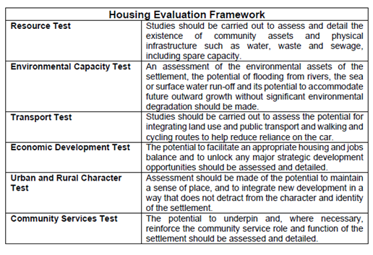

Appendix B – Wind Turbine Application Determinations within NM&D Between 2002 and 2015
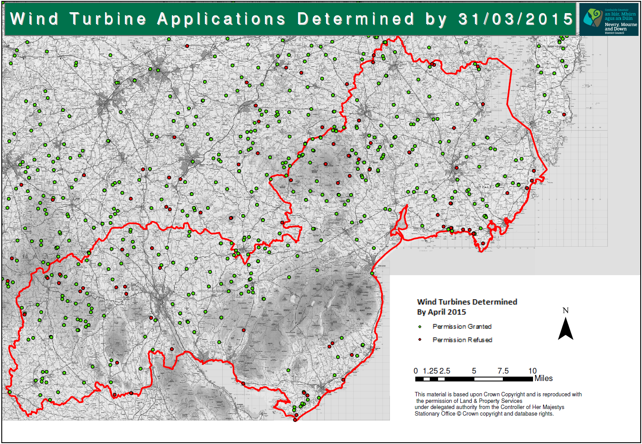
Appendix C – NIE Heatmap
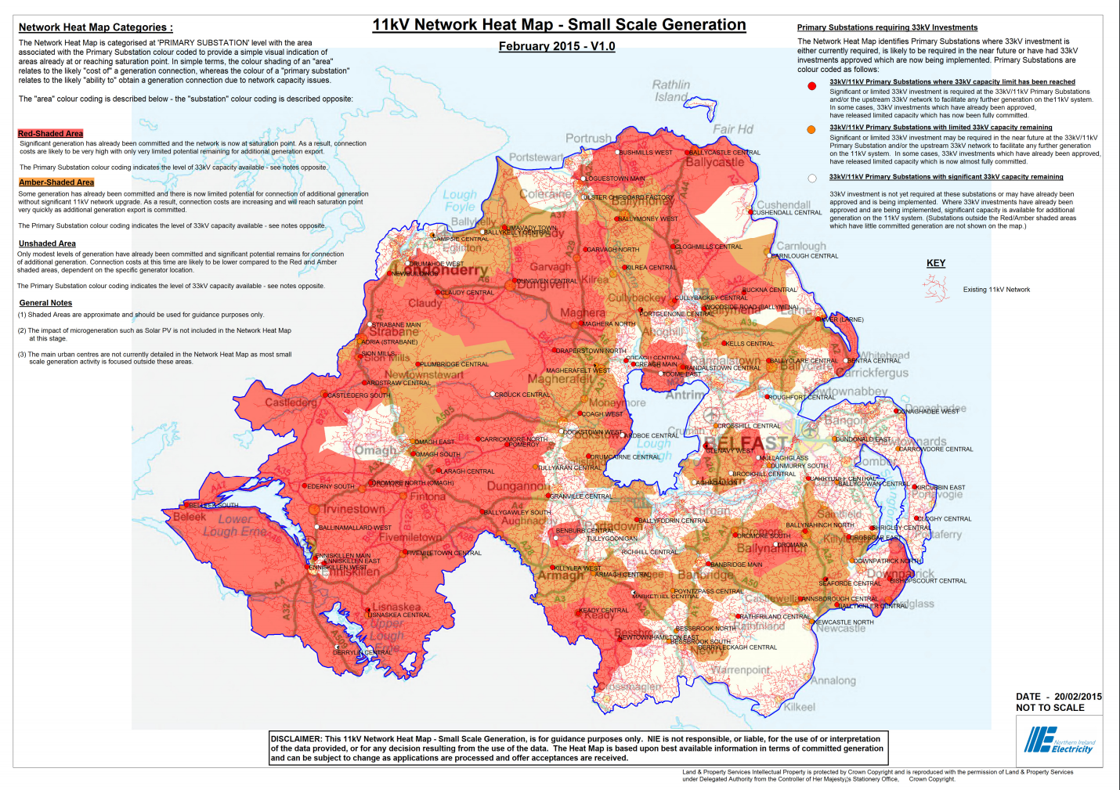
Source: http://www.nienetworks.co.uk/documents/Generation/SSG_HeatMap_200215_V1.aspx

Appendix D - 1/100 year Climate Change Floodmap: Downpatrick
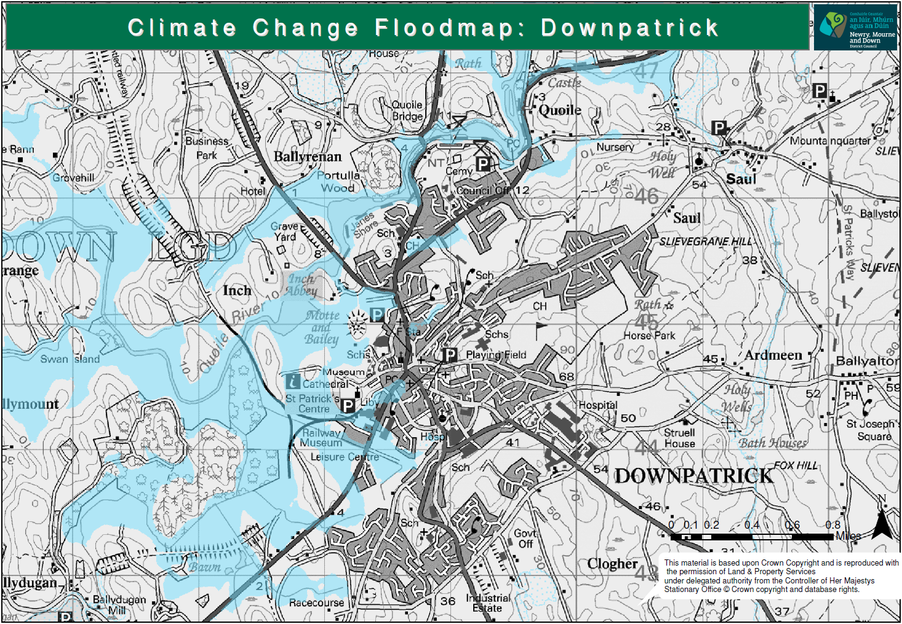

Appendix E - 1/100 Year Climate Change Floodmap: Newcastle
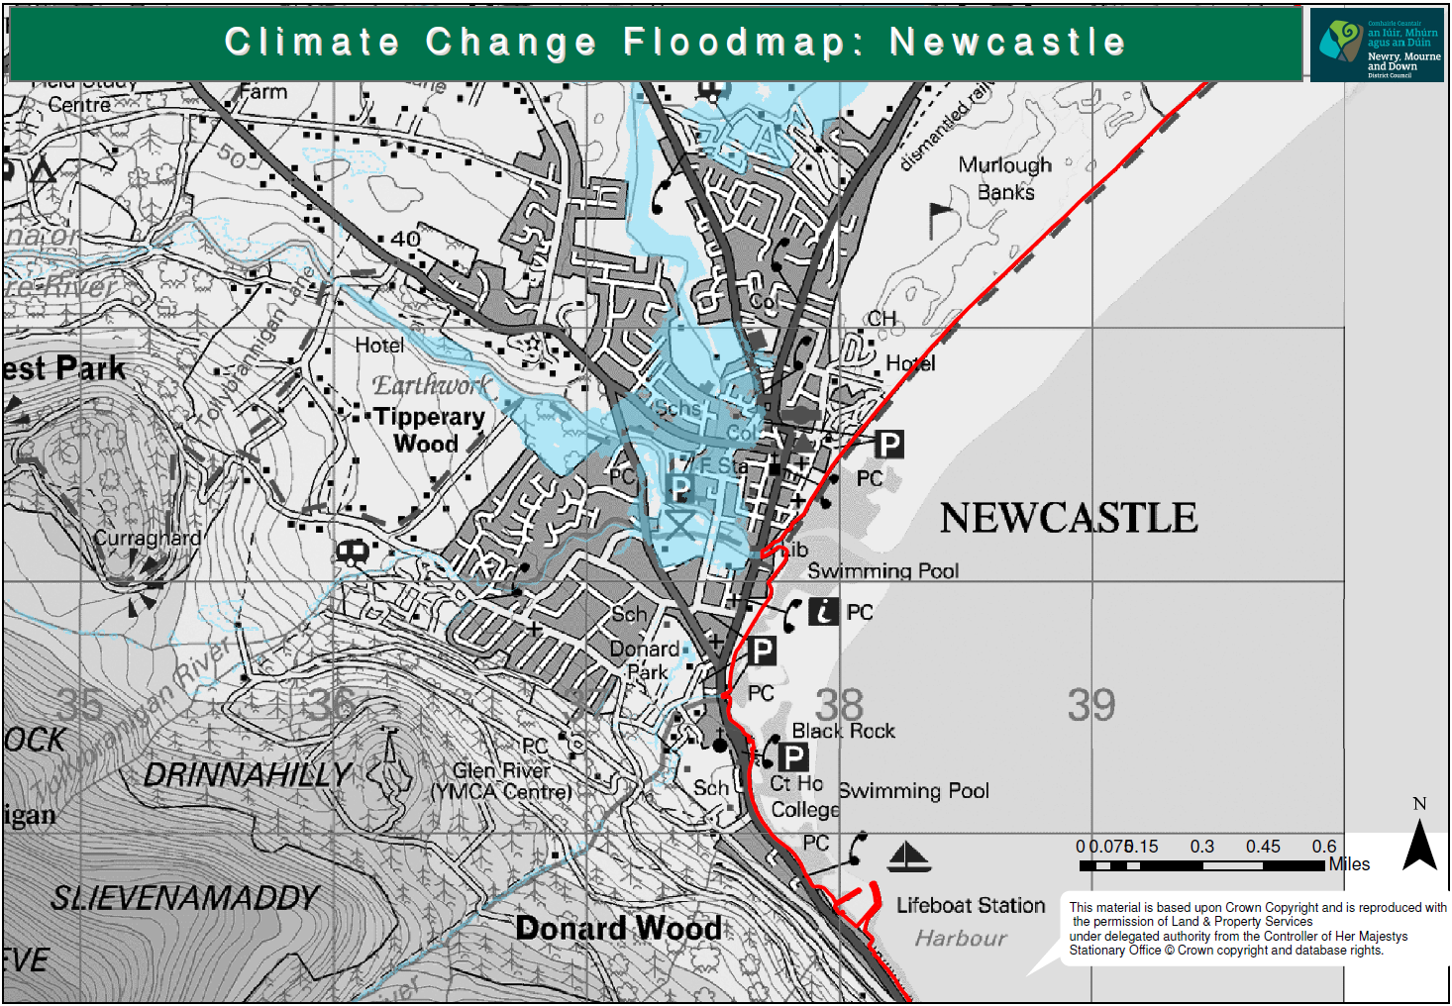

Appendix F: 1/100 Year Climate Change Floodmap: Newry
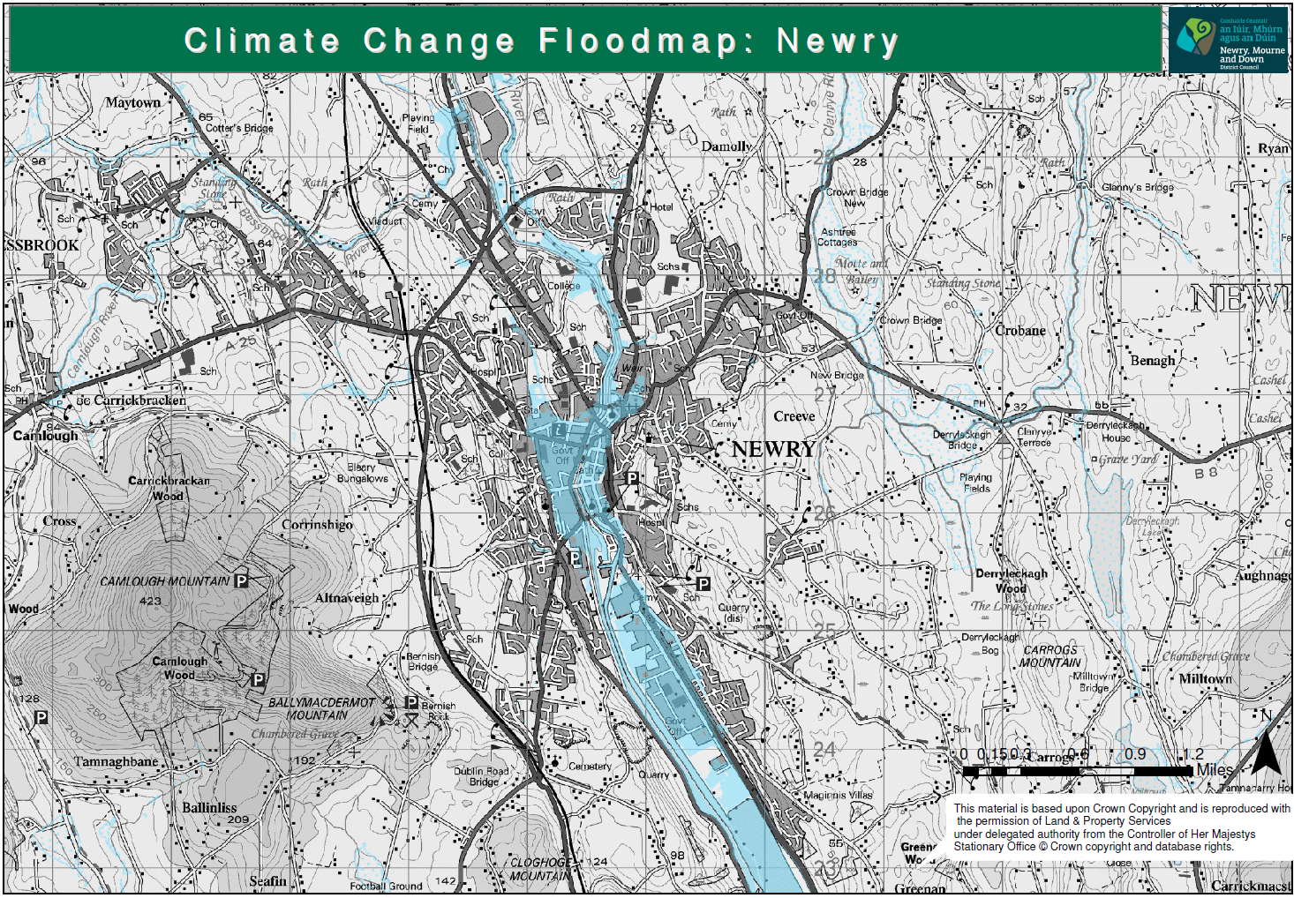
Appendix G – Waste Water Treatment Works
As displayed below, NI Water have devised a new informative to convey both the present capacity condition of each of its Wastewater Treatment Works and also how this condition may change depending on a range of potential growth scenarios. The Informative presents two sets of indicators; one relating to current capacity and the associated impact on the availability of new sewerage connections; the second is an estimated projection of treatment capacity were prescribed growth factors to be applied to the existing drainage catchment flows.

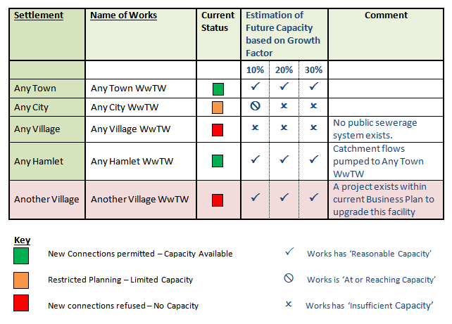
The indicators are a combination of Red, Amber and Green (RAG) traffic lights for current capacity and a variety of tick box symbols for future capacity. The distinct formats were adopted to help emphasise the certainty of the current status compared with the more speculative conclusion looking forward. The respective keys explain the relevant implications, information on planned investment for wastewater treatment or other relevant information will appear as a supplementary comment against each listed WWTW. The current capacity for settlements within this District has been provided overleaf.

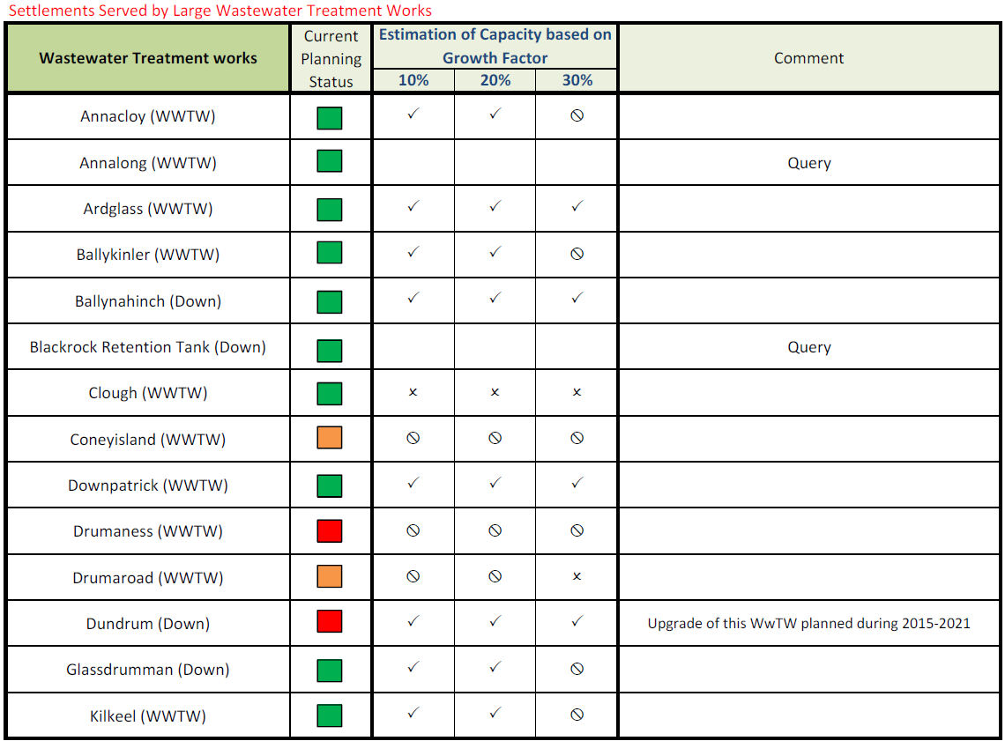
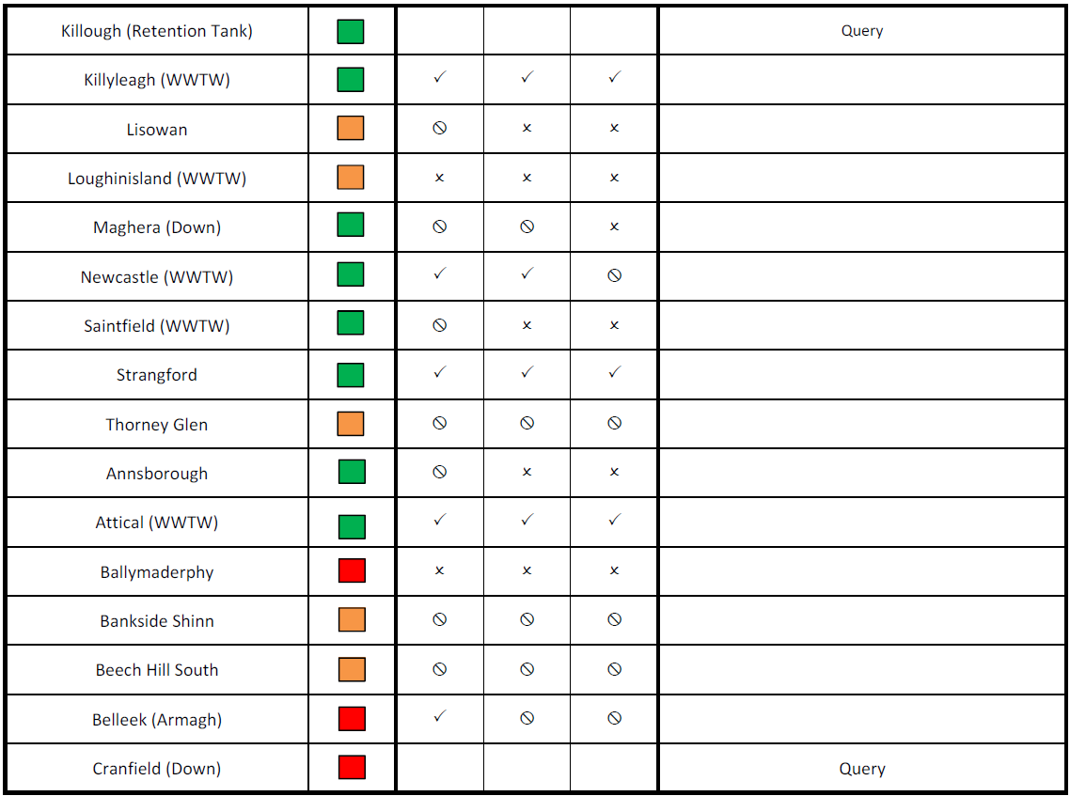
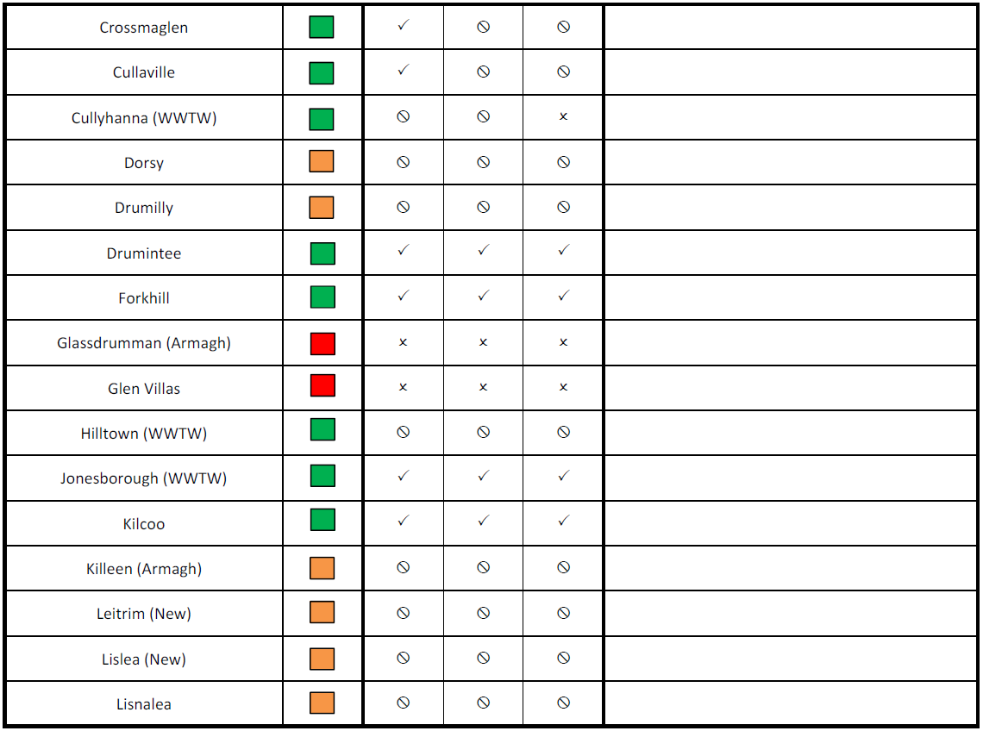
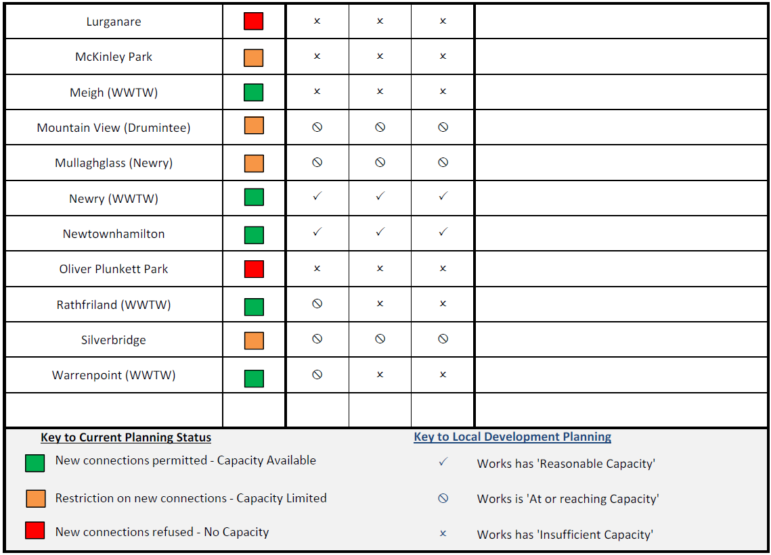

Development that does not require Planning Permission through The Planning (General Permitted Development) Order (Northern Ireland) 2015
The Tandragee – Louth 275 Kv line is currently the primary means for power to flow between Northern Ireland and the Republic.
Following a European Commission decision with respect to responsibility for planning investments for the Northern Ireland electricity transmission network, Northern Ireland Electricity Networks' (NIE Networks') transmission investment planning activities transferred to the System Operator Northern Ireland (SONI) on 1 May 2014.
Draft Programme for Government 2016 – 2021 Outcome 02

