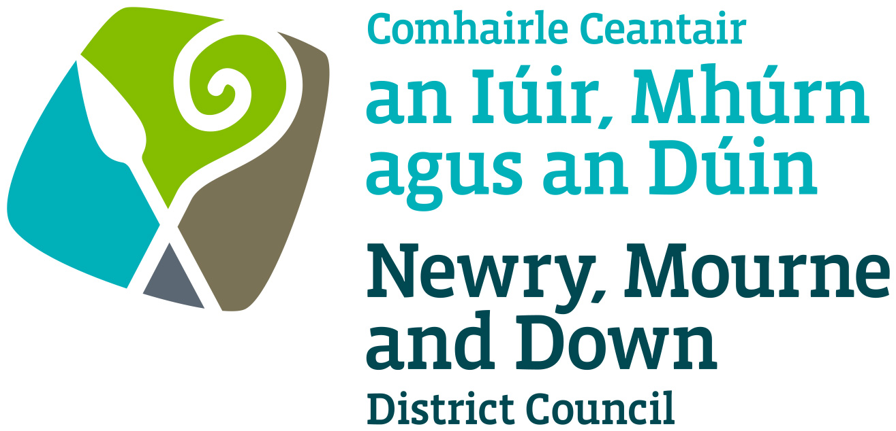

Local Development Plan
Preparatory Studies

Paper 5: Transportation

December 2015

Contents | Page No
Purpose and Content | 3
1.0 Introduction | 4
2.0 Regional and Local Policy Context | 5
Regional Development Strategy | 5
Regional Transportation Strategy | 6
Regional Strategic Transport Network Transport Plan 2015 | 7
Ensuring a Sustainable Transport Future | 8
Sub Regional Transport Plan 2015 | 8
Accessible Transport Strategy 2005 | 9
Planning Policy Statement 3 | 10
Planning Policy Statement 13 | 11
Strategic Planning Policy Statement | 11
Newry, Mourne & Down Corporate Plan | 13
Newry, Mourne and Down Economic Regeneration & Investment Strategy | 13
3.0 Existing Development Plans and Masterplans | 13
Banbridge, Newry & Mourne Area Plan 2015 | 14
Ards and, Down Area Plan 2015 | 15
Local Masterplans | 15
4.0 Transport Within the Newry, Mourne and Down District | 16
Road Network | 17
Car | 19
Ecar | 21
Car Parking | 21
Bus | 22
Community Transport | 23
Rail Network | 24
Walking & Cycling | 25
Airports | 27
Harbours & Ferries | 27
6.0 Conclusion & Recommendations | 28
Glossary | 31

APPENDICES

Appendix A: Travel to Work or Place of Study (16-74)

Appendix B: Travel to Work or Place of Study (primary school &
over, in full time education and those aged 16-74)

Appendix C: Protected Routes within Newry, Mourne and Down Area

Appendix D: Transport NI Proposed Works (Spring Report to Newry, Mourne and Down Council)

Appendix E: Summary of Transportation Proposals within Local
Masterplans

Appendix F: Ecar Charge Points Within Newry, Mourne and Down

Appendix G: Strategic TransportationNetwork Proposals Map

Appendix H: Ballynahinch Bypass

Purpose

To provide Newry, Mourne and Down District Council with an overview of the regional planning and roads policy context in relation to transportation and to provide information on the current transportation provision and future transportation initiatives within the Newry, Mourne & Down District.

Content

The paper provides:-

- An overview of the regional policy context for formulating Local Development Plan transportation strategies and policies;

- An overview of the existing transportation situation including strategic road network, modes of travel, various transportation schemes, existing car parking provision and public transport services within the Council area;

- A summary of key future transportation proposals and initiatives relevant to the Council area.

1.0 Introduction

1.1 The purpose of this paper is to inform members about the current transportation situation within the District by providing details on the strategic road network, current and proposed transportation schemes, car parking provisions and public transport services. This will assist the Council in the preparation of the Plan Strategy. It also provides an overview of the regional planning and roads policy context in relation to transportation.

1.2 This paper allows members to commence consideration of the priorities for the improvement of the main transport corridors that form the regional transportation network whilst seeking to promote sustainable development and sustainable transport choices. At this stage the paper only aims to provide a foundation for future decision making which will need to be further developed and informed through the local development plan process in the integration of transportation and land use.

1.3 The movement of people and efficient distribution of goods and services are essential to the functioning of any area. Good communications are important to the local economy and to attract inward investment. Good transport links also support people socially and provide access to leisure and recreational opportunities. Transportation is therefore a key component of any land use plan. Whilst transport planning is a function that will remain primarily with the Department for Regional Development DRD, it will be important that the Local Development Plan (LDP) integrates transportation with land use. As part of the plan process, it will also be important to look closely at how greater encouragement can be given to more sustainable forms of transport such as buses, cycleways and walkways. Parking provision including off street parking, which is now a local government responsibility, will also considered.

2.0 Regional and Local Policy Context

2.1 The Regional Development Strategy 2035 (RDS) is the key document underpinning development in Northern Ireland and is supported by the Regional Transportation Strategy 2002-2012. Both strategies place emphasis on the development of regionally important infrastructure and also increasing emphasis on sustainable modes of transport, this is reflected in Planning Policy Statements and supporting documents. At a local level the RDS is delivered through the Sub-Regional Transportation Strategy which details blueprints for the development of sustainable transport networks in main towns and cities and guidance for improvements in the rural areas. Several local Masterplans, village plans and existing adopted Area Plans provide detailed proposals and goals for settlements within the Council Area.

The Regional Development Strategy 2035 (RDS)

2.2 The RDS is the key policy guiding development in Northern Ireland and is underpinned by a Spatial Framework and Strategic Planning Guidelines based on focusing development in gateways, hubs and clusters, and prioritising the improvement of the main transport corridors that form the regional transportation network. Within the Council area, both Newry and Downpatrick have been identified as main hubs whilst Newcastle and Warrenpoint have each been identified as local hubs (see map 1). The RDS has outlined the potential for clustering between Downpatrick with Newcastle and Newry with Warrenpoint. Given the strategic position of Newry and the major port of Warrenpoint, both together have been identified as one of 6 key Gateways within the RDS. Gateways are strategically important transport interchanges which are important for economic development, freight distribution activities and additional employment generation. The close proximity of Newry to Dundalk provides the potential for further clustering, the two settlements are located along the Belfast-Dublin corridor which has the potential to become a significant axis of development within the wider European context. The European Union has included this corridor as a section of the ‘North Sea - Mediterranean Corridor’, part of the European Unions ‘Trans European Network’.

2.3 Policy RG2 from the RDS aims to deliver a balanced approach to transport infrastructure in order to remain competitive in the global market by promoting transport which balances the needs of our environment, society and economy. This focuses on managing the use of our road and air space and using our network in a better, smarter way. This will be developed further by Improving connectivity, maximising the potential of the Regional Strategic Transport Network, using road space and railways more efficiently, improving social inclusion, managing the movement of freight, improving access to our cities and towns and improving safety by adopting a ‘safe systems’ approach to road safety.

Map 1: Regional Development Strategy Hubs & Clusters of Hubs
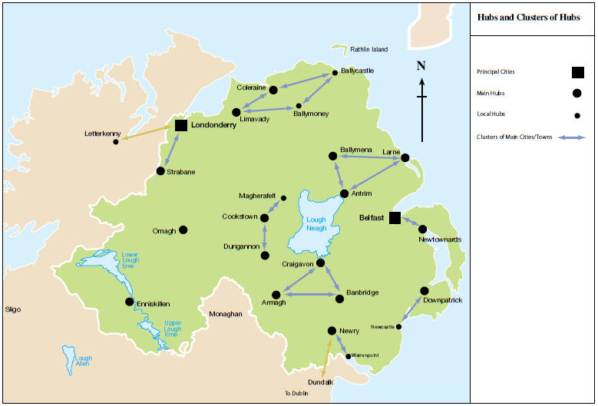
Source: Regional Development Strategy 2035

The Regional Transportation Strategy (RTS) 2002-2012
2.4 The Regional Transportation Strategy (RTS), set out a vision “to have a modern, sustainable, safe transportation system which benefits society, the economy and the environment and which actively contributes to social inclusion and everyone’s quality of life”. This vision is still appropriate for the DRD’s new approach to regional transportation which will refocus and rebalance our transport priorities and present a fresh direction for transportation with sustainability at its core.

2.5 The RTS covers a 10-year period from 2002 to 2012 and is now being delivered through three transport plans:

1. Regional Strategic Transport Network Transport Plan 2015;
2. The Sub-Regional Transport Plan 2015 (covers the area of Northern Ireland outside of The Belfast Metropolitan Area Transport Plan); and
3. The Belfast Metropolitan Area Transport Plan 2004;

The first two plans are the most relevant to Newry, Mourne & Down District Council. These contain the detailed programmes of major schemes and transport initiatives that the DRD wants to carry out to achieve the RTS objectives and targets. These Transport Plans link with relevant Development Plans and thus provide Northern Ireland with an integrated approach to transportation and land use planning. The RTS also gave a commitment that DRD would develop an Accessible Transport Strategy for NI which was published in 2005.

Figure 1: Linkages between RDS & RTS
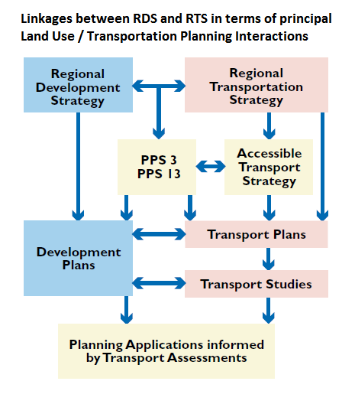
Source: DRD

- Regional Strategic Transport Network Transport Plan 2015 (RSTN TP)

2.6 The Regional Strategic Transport Network Transport Plan 2015 is based on the guidance set out in the RDS and the RTS. The Regional Strategic Transport Network (RSTN) of Northern Ireland (see map 2) comprises the complete rail network, and road network including:

• 5 Key Transport Corridors (KTCs);
• 4 Link Corridors;
• The Belfast Metropolitan Transport Corridors; and
• The remainder of the trunk road network

The RSTN incorporates 5% of the road network, which carries around 37% of total vehicle travel, and all of the railway system. The Regional Strategic Transport Plan presents a range of multi-modal transport initiatives to manage, maintain and develop the Strategic Transport Network.

Map 2: Strategic Transportation Network
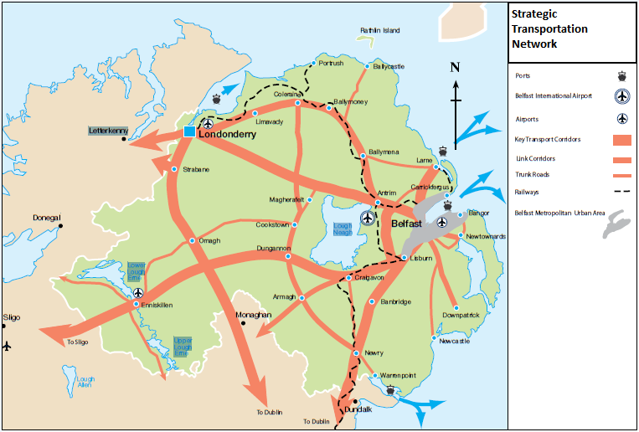Source: RDS 2035

- Ensuring a Sustainable Transport Future: A New Approach to Regional Transportation.

2.7 In March 2012, the DRD published its new strategic document ‘Ensuring a Sustainable Transport Future – a New Approach to Regional Transportation’ which sets out how regional transportation will be developed beyond 2015 when the current transport plans reach their conclusion. This strategy is different from the current strategy in that it is not constructed on schemes and projects; rather it sets three High Level Aims and twelve Strategic Objectives for transportation that form the basis for future decision-making on transportation funding priorities beyond 2015. The Department will continue to implement the current transport plans until their planned expiry and a new Delivery Plan is published.

- Sub Regional Transport Plan 2015

2.8 The Sub-Regional Transport Plan (SRTP) is based upon the guidance provided by the RDS and the RTS. The SRTP deals with the transport needs of the whole of Northern Ireland with the exception of the Belfast Metropolitan Area and the rail and trunk road networks which are covered in earlier Transport Plans. The purpose of the SRTP is to study the needs of the designated areas in detail and to confirm a package of transport schemes, consistent with the general principles and indicative levels of spend in the RTS. In line with the RTS, the SRTP notes the highway linkages with the Regional Strategic Transport Network and identifies separate packages of measures for the period 2002 – 2015 by mode of transport:

• Walking and cycling;
• Bus;
- Rail; and
- Highways.

2.9 The costs of the packages are consistent with the relevant indicative expenditure, by mode of transport, given in the RTS, enhanced by the Investment Strategy for Northern Ireland (ISNI). The SRTP is concerned with two quite distinct areas, designated by the RTS:

- Other Urban Areas (OUA) – the towns and cities; and
• Rural Areas – the smaller settlements and the dispersed population living in the open countryside.

- Accessible Transport Strategy 2005

2.10 The DRD Accessible Transport Strategy 2005 was published with the vision “to have an accessible transport system that enables older people and people with disabilities to participate more fully in society, enjoy greater independence and experience a better quality of life”. In 2005 less than 8.5 million journeys were made on public transport by older people and people with a disability. By 2014/15 this has increased to 13 million journeys highlighting the value of public transport as a sustainable and affordable travel option to these groups. A new Accessible Transport Strategy serving up to 2025 has recently concluded its public consultation phase in November 2015. The Accessible Transport Strategy is one of a range of Departmental initiatives that can have a positive impact on reducing social exclusion and\or rural isolation. The benefits accrued from the Strategy (for example upgraded rail or bus stations) are often shared by the wider travelling public. Pre-consultation engagement with various stakeholders, including those organisations representing older people and people with a disability have identified five themes which will form the basis of the new 2025 Strategy.

• Enhancing the accessibility of the public transport network
• Improving accessibility of the wider transport network
• Enhancing the customer experience
• Enhancing the accessibility of information
• Working in collaboration with partners and stakeholders

The recently concluded consultation phase aims to influence the strategic direction of the Strategy over the medium term.

- Planning Policy Statement 3: Access, Movement and Parking

2.11 Planning Policy Statement 3: Access, Movement and Parking (PPS 3) sets out the Department’s planning policies for vehicular and pedestrian access, transport assessment, the protection of transport routes and parking. It forms an important element in the integration of transport and land use planning. PPS 3 has been prepared in close consultation with the Department for Regional Development and needs to be considered together with Planning Policy Statement 13: Transportation and Land Use (PPS 13) and associated guidelines produced by both Departments on Transport Assessment. Supplementary Planning Guidance is set out in Developer Control Advice Note 15 (DCAN 15) for intending developers, their professional advisors and agents on the standards for vehicular access and also in ‘Parking Standards’ which sets the parking standards that the Department will have regard to in assessing proposals for new development. A complete list of Protected Routes that are within the District is included in Appendix C page 36.

The main objectives of PPS 3 are to:

• Promote road safety, in particular, for pedestrians, cyclists and other
vulnerable road users;
• Restrict the number of new accesses and control the level of use of existing accesses onto Protected Routes;
• Make efficient use of road space within the context of promoting modal shift to more sustainable forms of transport;
• Ensure that new development offers a realistic choice of access by walking, cycling and public transport, recognising that this may be less achievable in some rural areas;
• Ensure the needs of people with disabilities and others whose mobility is impaired, are taken into account in relation to accessibility to buildings and parking provision;
• Promote the provision of adequate facilities for cyclists in new development;
• Promote parking policies that will assist in reducing reliance on the private car and help tackle growing congestion; and
• Protect routes required for new transport schemes including disused transport routes with potential for future reuse.

Map 3: Protected Routes within Northern Ireland
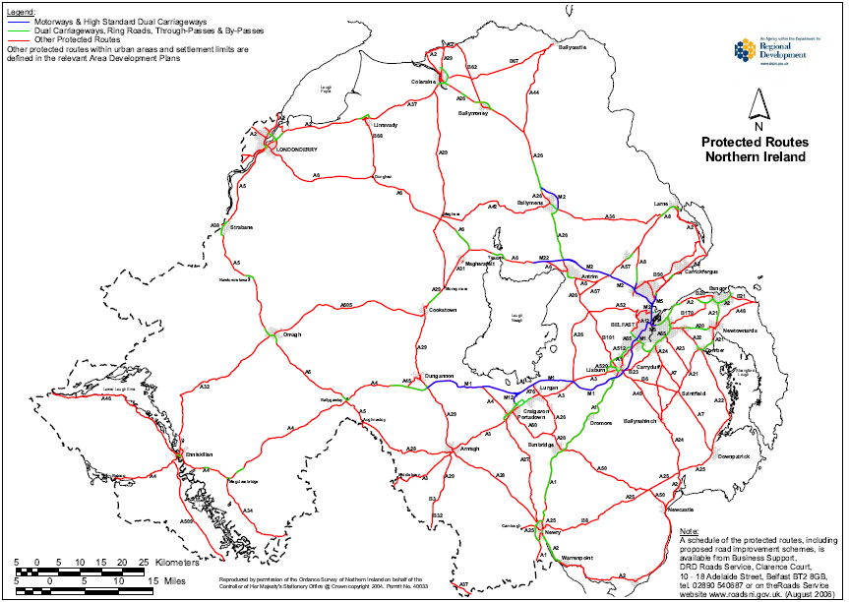
Source DRD

- Planning Policy Statement 13: Transportation and Land Use

2.12 Planning Policy Statement 13: Transportation and Land Use (PPS 13) has been prepared to assist in the implementation of the RDS. It aims to guide the integration of transportation and land use, particularly through the preparation of development plans and transport plans. It is also a material consideration in dealing with individual planning applications and appeals.

The primary objective of PPS 13 is to integrate land use planning and transport by:

• Promoting sustainable transport choices;
• Promoting accessibility for all; and
• Reducing the need to travel, especially by private car.

- Strategic Planning Policy Statement

2.13 The Strategic Planning Policy Statement (SPPS) was published in September 2015 and consolidates 20 separate policy publications into one document, and brings forward new strategic policy relating to town centres and retailing. It sets out the core planning principles to underpin delivery of the reformed two-tier planning system including promoting sustainable development, well-being and shared space. The provisions of the SPPS must be taken into account in the preparation of the LDP. The aims of this SPPS with regard to transportation are to secure improved integration with land-use planning, consistent with the RDS; and to facilitate safe and efficient access, movement and parking.

The policy objectives for transportation and land-use planning are identified to;

- Promote sustainable patterns of development which reduce the need for motorised transport, encourages active travel, and facilitate travel by public transport in preference to the private car;
- Ensure accessibility for all, with the needs of people with disabilities and others whose mobility is impaired given particular consideration;
- Promote the provision of adequate facilities for cyclists in new development;
- Promote parking policies that will assist in reducing reliance on the private car and help tackle growing congestion;
- Protect routes required for new transport schemes including disused transport routes with potential for future reuse;
- Restrict the number of new accesses and control the level of use of existing accesses onto Protected Routes; and
- Promote road safety, in particular for pedestrians, cyclists and other vulnerable road users.

2.14 The preparation of a LDP provides the opportunity to assess the transport needs, problems and opportunities within the plan area and to ensure that appropriate consideration is given to transportation issues in the allocation of land for future development, including appropriate integration between transport modes and land use. Preparation of a local transport study will assist in this process. Councils should seek early engagement with DRD, or the relevant transport authority, and take account of their 'The New Approach to Regional Transportation’ document and any subsequent transport plans.

2.15 LDPs should identify active travel networks and provide a range of infrastructure improvements to increase use of more sustainable modes. In particular, within urban areas, providing enhanced priority to pedestrians, cyclists and public transport and an appropriate level of parking provision which is properly managed, should assist in reducing the number of cars in our urban areas. Transportation issues to be addressed in the LDP should include:

• Land Use Allocations and Associated Transport Infrastructure;
• New Transport Schemes, Walking and Cycling;
• Disused Transport Routes;
• Car Parking; and
• Protected Routes
j) Newry, Mourne and Down Corporate Plan 2015-2019

2.16 The Newry, Mourne and Down Corporate Plan 2015-2019; identifies the Councils mission as to lead and serve a District that is prosperous, healthy, as well as sustainable from an economic, environmental and social perspective.

2.17 The corporate in looking at the District and the challenges that it faces points out that the District enjoys excellent road and rail links with Dublin as well as Belfast and contains a number of ports and harbours, providing direct access by water. However; internal connectivity is highlighted as a problem in terms of road infrastructure. The Councils priority is to improve internal connection (transport and roads) of the entire District, as well as addressing traffic congestion in our urban areas and tourist resorts. Key actions identified are to prioritise infrastructure development and economic regeneration as part of the new LDP and to lobby for the improvement of roads within and across the District.

- Newry, Mourne and Down Economic Regeneration and Investment Strategy 2015 - 2020

2.18 The Newry, Mourne and Down Economic Regeneration and Investment Strategy 2015-2020 sets out the Councils vision to make Newry, Mourne and Down a vibrant, dynamic and connected region for investment, tourism and culture. This strategy identifies strategic priorities and actions for economic development, tourism development, urban development and regeneration, rural development and regeneration and for the arts and culture.

2.19 Within the economic development theme, a key action is to review land use and infrastructure provision for business development and to inform the LDP. The development of new routes i.e. Greenway from Omeath to Carlingford, establish link from Carlingford to Portadown form part of the tourism theme similar to the aim to maximise the use of natural spaces and assets, i.e. canal, waterways, forestry, walkways, cycling routes for rural development and regeneration. Also within the rural development and regeneration theme is the strategic priority to improve infrastructure across the rural area in order to meet the needs of the rural communities, rural services and rural business. The LDP can explore options for improving connectivity across the District.

3.0 Existing Development Plans and Masterplans

3.1 Within the Newry, Mourne and Down Area two adopted development plans are currently in place and these remain the statutory plans which provide the policy framework against which to assess development proposals. Both plans have been developed in line with the RDS and RTS’s guidance, policies and proposals in seeking to meet the region’s transportation needs.

- Banbridge, Newry & Mourne Area Plan 2015:

3.2 The Banbridge, Newry & Mourne Area Plan 2015 (BNMAP) proposes two specific schemes within the Newry area:

- Rathfriland Road Link, Newry (NY102): This single carriage road would link the A25 Rathfriland Road and B8 Hilltown Road with the A1 Belfast Road and the Regional Strategic Transport Network. This scheme would relieve traffic from surrounding residential areas and is described as partially development led necessary in the longer term for the development of the area beyond 2015.

- Bridge Street Newry Widening (NY103): This scheme involves the widening of Dublin Bridge / Bridge Street to facilitate two lanes of through traffic in each direction through this part of Newry. It is mentioned that this scheme however will need to be either development led or as resources permit.

3.3 Also mentioned in the plan is the proposed Newry Southern Relief Road Scheme linking the A1 Dublin Road with the A2 Warrenpoint Road. This scheme would reduce traffic volumes through the centre of Newry and improve access to the port of Warrenpoint. Whilst a proposed route for the road was originally included on the Draft BNMAP this was excluded from the adopted version. Although the route is not yet finalised, as the project progresses, inclusion of the route as part of the new LDP is an option that will be explored. As of April 2015, the proposal progressed into Transport NI’s Forward Planning Schedule and work has commenced on the Stage 1 Preliminary Options Scheme Assessment. Potential sources of funding for the scheme are being explored.

3.4 The disused tram line linking Bessbrook to Newry and rail line linking Newry to Warrenpoint have been highlighted as having potential for transport or recreational purposes, these are protected under policy AMP 5 of Planning Policy Statement 3.

3.5 The safeguard of Protected Routes throughout the plan area is mentioned throughout the BNMAP. In the absence of significant additional transport proposals to some of the settlements the plan states that traffic management measures such as the refinement of junction layouts, changes to waiting restrictions and alterations to the direction of flow of traffic may be required to maintain network efficiency as traffic patterns change and as development land is taken up over the plan period.

3.6 Key site requirements have been attached to some of the land use zonings making provisions for other enhancements to the transport network to be implemented in connection with development proposals.

- Ards and Down Area Plan 2015:

3.7 The Ards and Down Area Plan 2015 (ADAP) through Policy Tran 1 seeks to both prevent the development of land that would prejudice the availability of land available for road schemes.

3.8 Policy Tran 2 seeks to ensure developments, which rely on the construction of road schemes to provide safe access and or reduce the impact on the adjacent road network of traffic generated by the development, are not permitted in advance of the road scheme being completed to an appropriate stage.

3.9 Disused transport routes such as the former rail track beds linking several of the main towns in the plan area have been identified across the plan area. Such routes have potential for re-use or potentially future recreational use and are protected under PPS 3. Specific transportation proposals mentioned within the plan include the following:

- The Strangford Road – Saul Road Link (DK 17) includes the construction of the development road from Rathkeltair Road to Saul Road, the up-grading of the northern section of Rathkeltair Road between Strangford Road and the development road, and the up-grading of the Rathkeltair Road / Strangford junction. All road works are to be designed and implemented to the satisfaction of the Transport NI of the DRD. Although a Road Line is indicated, the exact road line will be determined at detailed design stage and is subject to a separate statutory process.
- Ballynahinch Bypass (BH 19): In accordance with Policy Trans 1, the proposed Ballynahinch Bypass route is protected against any development proposals which may prejudice its implementation.
- Ballynahinch Informal Park & Ride and Park & Share site (COU 9).
- Clough Informal Park & Ride and Park & Share site (COU 10).

- Local Masterplans

3.10 Within the Newry, Mourne and Down Council Areas, a series of masterplans have been prepared by two of the previous councils in conjunction with the Department for Social Development. The plans seek to inform regeneration over a 10-15 year period.

- Newry City Masterplan
- Downpatrick Masterplan
- South East Coast Masterplan
- Ballynahinch Masterplan

3.11 These plans together with a series of village renewal plans seek to inform all with a stake in the future development of the area. Specific Transportation proposals / issues have been identified as part of the plan process, a full list of all the key proposals and issues highlighted for the major settlements within the district have been included in Appendix E, P39.

3.12 Work has now commenced on reviewing these Masterplans and prioritising actions to inform future project development. The LDP team will work closely with the ERT Directorate to ensure appropriate linkages are established between the Masterplans and the LDP.

4.0 Transportation within the Newry, Mourne & Down District

4.1 Newry, Mourne & Down District has a comprehensive network of transport infrastructure and services. There is an extensive network of roads ranging from major strategic routes to minor rural roads. There is an extensive footpath system in most designated settlements. Elements of the National Cycle Network pass through the District. Public transport provision consists of a network of urban and rural bus services including inter-urban express routes, the area is also connected to the Northern Ireland Rail Network. The following section outlines the main features of existing transportation provision.

Table 1: Travel to Work or Place of Study
 | Percentage of all usual residents of primary school age and over in full-time education or aged 16 to 74 in employment and currently working
Method of Transport | N.Ireland | NM&D
Do not travel: Work mainly from Home | 11.19 | 12.24
Train | 1.32 | 0.42
Bus, minibus or coach | 12.22 | 13.05
Motorcycle, scooter or moped | 0.29 | 0.16
Driving a car or van | 39.53 | 39.92
Passenger in a car or van | 14.47 | 15.9
Car or van pool, shared driving | 7.03 | 7.58
Taxi | 1.38 | 0.87
Bicycle | 0.67 | 0.4
On Foot | 11.26 | 8.7
Other method | 0.63 | 0.76
Total of all usual residents of primary school age and over in full-time education or aged 16 to 74 in employment and currently working | 1,126,346 | 106,630
Source: NI Census 2011 Key Statistics Summary Report

Road Network

4.2 Transportation within the Council Area is primarily provided by the Road Network with 82.45% of households owning at least 1 car or van and at least 77% of journeys to work or place of study using the road network.

4.3 Transport NI, previously known as DRD Roads Service, are the sole Road Authority in Northern Ireland. Transport NI is responsible for over 25,000km of public roads, 9700km of footways, 5800 bridges and 271,000 street lights. They were also previously responsible for 367 public car parks, however off street parking, has from the 1st April 2015, became a Local Government responsibility. Transport NI operates within the policy context set by DRD, whose strategic objectives are to maintain, manage and develop NI’s transportation network. DRD is responsible for formulation of the Regional Transport Strategy, whilst Transport NI is responsible for its implementation.

Table 2: Road lengths within NM&D
 | Northern Ireland | Newry, Mourne & Down*
Road Length (km) | 25507.2 | 2913.3
Motorway Road Length (km) | 114.9 | 0
A Roads: Dual Carriageway Road Length (km) | 210.2 | 28.9
A Roads: Single Carriageway Road Length (km) | 2079.2 | 313.9
B Roads: Road Length (km) | 2093.8 | 280.1
C Roads : Road Length (km) | 4724.9 | 573.6
Unclassified Road Length (km) | 15474.2 | 1716.9
Source: www.ninis2.nisra.gov.uk
*Figures exclude Ballyward area of NM&D
4.4 Within the council area, the A1 linking Newry with Belfast and Dublin is the only Road identified as a Key Transport Corridor within the Strategic Transportation Network (STN). Two routes within the District have been identified as ‘Link Corridors’ these being the A7 section linking Downpatrick to Belfast and the A28 section linking Newry with Armagh. Several ‘Trunk Roads’ are located within the district these being the A2 section linking Newry to Warrenpoint, the A27 linking Newry to Portadown and the A2 & A24 travelling north from Newcastle to Ballynahinch and then Belfast. The STN whilst serving a number of the council’s main settlements, is better for journeys into and out of the District than for journeys between the main settlements within the District.

4.5 The A1 and A2 Newry to Warrenpoint Road form the only sections of dual carriageway within the Council area. There are no motorways within the Council area. The remaining routes within the Council area are single carriage ‘A’ Roads, ‘B’ Roads or minor Roads, both Classified and Unclassified. Several of the roads within the District have been identified as ‘Protected Routes’. These have been identified on plans for information purposes. Where appropriate, development plans can identify and prepare local policies for those stretches of a Protected Route to be subjected to further access restrictions beyond those set out in Policy AMP 3 of PPS 3, for instance due to a history of traffic collisions, high volumes of traffic or speed of vehicles.

4.6 A proposed improvement to the Strategic Roads Network within the District is the Ballynahinch Bypass, as detailed in Table 3 below. Strategic and other improvements to the network including junction improvements, provision of footways and high friction surfaces have been outlined in the Transport NI Spring Report presented to Council in summer 2015 which sets out proposed works for 2015/2016 and onwards. It is important to note that there are other potential future schemes not mentioned in the Spring Report but some of which have been included in current Development Plans. Other schemes not mentioned are also in receipt of Planning Permission or in early stages of planning, but are as yet dependant on the receipt of funding, uptake of development land, statutory process and public consultation etc. These schemes include the Narrow Water Bridge project, Downpatick Eastern Bypass, Rathfriland Link Road Newry and the proposed Irish Street to St Patricks Avenue Link in Downpatrick.

4.7 Whilst the Narrow Water Bridge project had previously been stalled by issues related to funding; under the recent ‘Fresh Start’ Stormont Agreement and Implementation Plan, the Irish Government indicated that it remains committed to the concept of the Narrow Water Bridge, which would provide a valuable North-South link between counties Louth and Down with potential to provide jobs and a significant boost to tourism in the area. The Northern Ireland Executive and the Irish Government agree to undertake a review of the project with a view to identifying options for its future development, for consideration by the North South Ministerial Council in June 2016.

4.8 The proposed Newry Southern Relief Road (see paragraph 3.3) whilst currently identified on the Newry City Masterplan as high priority over the medium term, this has been identified within Council as one of a number of key priorities that the Council should seek to have moved forward within the current term.

Table 3: Strategic Improvements to Road Network within Council Area 2015/16 -
Onwards

Location | Proposal | Status
Newry Southern Relief Road | New Link Road | Scheme moved into Transport NI's forward Planning Schedule in February 2015. Work has commenced on Stage 1 Preliminary Options Scheme Assessment. Scheme dependant on a number of factors including clearing of statutory procedures and availability of funding.
A24 Ballynahinch Bypass | New Bypass | Scheme currently being progressed through stage 3 of scheme assessment process. Public enquiry commences January 2016.
A7 Rowallane to Doran’s Rock | Road Upgrade | Environmental Assessment currently on-going, vesting order will also be required and scheme still to clear statutory procedures and dependant on future availability of funding.
Source: Transport NI Spring Report to NM&D Council 2015
4.9 It is important to acknowledge that whilst Newry, Mourne and Down Council is now responsible for off street parking, the road network is still primarily the responsibility of Transport NI. The new LDP may indicate a desire to see improvements to the existing road network within the Council area but ultimately it is DRD as roads authority that have the authority and control the mechanisms for implementing such changes.

Car

4.10 In the period 2011-2013 the car was the most commonly used main mode of transport for both men (71%) and women (75%) in NI. With limited rail connections and nearly 82.45% of Newry, Mourne and Down households owning a private vehicle, road travel appears set to remain the dominant mode of transportation over the Plan period.

4.11 The Census 2011 shows that of the 68,277 residents in employment in the District, 76.48% travelled to work by car/van (this includes those driving (59.82%), travelling as a passenger (5.14%) or as part of a car pool (10.86%)).

4.12 Figures show that people living within the District are more likely to travel substantial distances to place of employment. 20.23% of people in District travel 20km plus to work compared to 5.58% in Belfast and 13.77% across NI as an average In terms of shorter journeys to work, 30.99% of residents of the District travel 0-5km to work in comparison to 62.42% in Belfast and 37.99% across NI.

4.13 These statistics clearly emphasise the greater reliance on the private car as a mode of transport and the longer distances travelled by people living in Newry, Mourne and Down.

Table 4: Car or Van Availability within NM&D
 | Percentage of Households With
Number of Cars or Vans | N.Ireland | NM&D
No Cars or Vans | 22.7 | 17.55
1 Car or Van | 41.38 | 40.37
2 Cars or Vans | 27.04 | 30.42
3 Cars or Vans | 6.29 | 7.83
4 or more Cars or Vans | 2.58 | 3.82
All Cars or Vans | 884,589 | 87,802
All Households | 703,275 | 61,998
Source: NI Census 2011 Key Statistics Summary Report

Ecar

4.14 The Ecar consortium is a cross-departmental, cross-industry body founded with the aim to bring the growing electric vehicle industry to Northern Ireland. Since 2010 the consortium has raised money from both public and private sector sources and 22 charge points have now been installed mainly on public sector controlled sites across the Council area. (See appendix F Page 41)

Car Parking

4.15 The main areas of public car parking are located within the District and local towns, these comprise mainly pay-and-display and free-parking formats. The availability of city centre car parking is an important issue in the management of town and city centre traffic.

4.16 Until 31st March 2015, Transport NI were responsible for car parking including ticketing, enforcement, maintenance and tariff setting. Transport NI implemented proposals to maximise the utilisation of the existing parking provision in the main towns and devised parking strategies to provide convenient short stay car parking close to each town centre with longer stay parking located further out. Where practical, parking has also been proposed convenient to bus stations to encourage public transport use by commuters. Since 1 April 2015, off-street parking is the responsibility of Newry, Mourne & Down District Council.

4.17 It should be noted that there are a number of other ‘publicly available’ car parks that are privately owned – though primarily for customer use. In Newry, these include paid car parks such as the Quays and Buttercrane shopping Centres and other free to use car parks such as Damolly Retail Park and at the ASDA and surrounding complex in Downpatrick and other smaller car parks throughout the District.

Table 5: Off Street Parking transferred to NM&D
Town | No of Car Parks | Total Spaces
Ardglass | 1 | 40
Ballynahinch | 4 | 394
Crossgar | 1 | 61
Downpatrick | 6 | 514
Kilkeel | 4 | 159
Newcastle | 2 | 102
Newry | 12 | 1,130
Rostrevor | 1 | 18
Saintfield | 1 | 66
Warrenpoint | 5 | 275
Total | 37 | 2,759
Source: NM&D Council
4.18 Shaping parking provision can contribute to achieving many objectives including delivering on economic and environmental goals. For instance, some may be of a mind to increase parking in urban areas to allow more car user access to businesses, whereas others may want to reduce traffic through parking policies to resolve problems of town centre congestion or pollution.

4.19 There are a limited number of park & ride / share sites within the Newry, Mourne and Down District. In terms of reducing the overall number of vehicles on the road and reducing the length of time vehicles spend on the road, park and ride or park and share sites offer the potential to reduce congestion in town centres, reduce pollution and save money for the traveller. At present there are 3 main sites within the District.

Table 6: Park and Ride / Choose site within NM&D
 | Location | Spaces | Comments
Newcastle/Clough | A24 Newcastle Rd/Clough Rd Roundabout | 16 | Bus service (to Belfast)
Sheepbridge, Newry | A1 | 25 | Na
Cloghogue, Newry | A1 | 25 | Na
Source: http://www.nidirect.gov.uk/travelwise-park-and-share

Bus

4.20 Public bus services for Newry, Mourne and Down are provided primarily by Translink/Ulsterbus. There are 3 main Ulsterbus Stations in the Newry, Mourne and Down District, offering a variety of facilities, and several sub-depots located throughout the District. Regular services operate to the main towns and villages though many are limited to school time requirements. Within the urban areas, there are several services within the main settlements. Several Rural Rambler services also operate throughout the district supported by the Rural Transport Fund. Express (Goldliner) services run to destinations within Northern Ireland and the Republic of Ireland.

Table 7: Goldliner Services serving NM&D
Goldliner Services Within Newry, Mourne & Down District Council
 |  | No of services
Service No | Route | M-F | Sat | Sun
238 | Newry - Belfast | 26 | 15 | 8
238A | Newry - Belfast | 5 | 0 | 0
X1 | Belfast - Newry - Dublin (Airport) Dublin | 21 | 21 | 21
215 | Downpatrick - Belfast | 15 | 0 | 0
237 | Newcastle - Belfast | 3 | 0 | 0
237A | Newcastle - Belfast | 2 | 0 | 0
240 | Newry - Downpatrick | 7 | 6 | 4
Source: Translink
4.21 With nearly one in five households in Newry, Mourne and Down not owning a private vehicle, the availability of public transport is a key service particularly for those who are elderly or economically or socially disadvantaged. It is also an essential service for children who rely on buses to travel to school.

4.22 The Census 2011 shows that of the 106,630 residents within the District of primary school age and over in full-time education or aged 16 to 74 in employment and currently working, 13.47% travel to work or place of education using bus or rail. Excluding those under the age of 16 or in education from this figure, the percentage using bus or rail falls to just 3.14%. This compares with the N.Ireland average of 13.53% and 6.08% respectively.

4.23 These figures highlight that whilst there is a need for public transport it is underutilised. The TSNI found that 60% of those travelling to work by car said that their journey was not possible by public transport with 25% citing both poor connections and too far/long journey time by public transport as reasons for not using public transport. A high number of rural dwellers in the District are likely to fall into this category.

4.24 Translink recently held a public consultation to assess service provision in light of the budget settlement for 2015-16. It is expected that there will be significant reductions in service delivery as well as other efficiency savings which are likely to impact on current services within Newry, Mourne and Down.

4.25 Aside from public transport buses, several private coach operators provide schedule services within the District. These include services connecting Newry to Dublin Airport, and Dundalk, and services linking Kilkeel, Warrenpoint and Newry to Belfast and the Queens University and University of Ulster campuses.

Community Transport

4.26 Community Transport is a term covering a wide range of solutions usually developed to cover a specifically identified transport need, typically run by the local community for local neighbourhoods on a not-for-profit basis. Community transport provides the connectivity needed to get otherwise isolated or excluded groups of people to a range of destinations, and helps to develop sustainable communities. It is often provided through minibuses and volunteer car schemes.

4.27 The Rural Transport Fund (RTF) is administered by DRD since November 1998. Its primary objective is to support transport services designed to give people in rural areas improved access to work, education, healthcare, shopping and recreational activities and by so doing assists in reducing their social isolation. RTF provides a Rural Bus Subsidy annually to support socially necessary but uneconomic bus services in the rural area (e.g. the Mourne Rambler and Slieve Gullion Rambler) as well as providing revenue and capital funding for the Rural Community Transport Partnerships (RCTPs), managed by the Community Transport Association (CTA).

4.28 RCTP’s are set up and managed by volunteers on a non-profit basis and may take different forms, reflecting their local nature. They encourage volunteers to use their own cars as part of social car schemes or to drive minibuses. RTCPs have effectively become the primary source of accessible transport for many older people and people with disabilities living in rural areas. RCTP’s operating within the District include Newry & Mourne Community Transport and Down District Accessible Transport

4.29 As CTA is supported by DRD, there is potential that the level of funding provided by the DRD may be reduced due to budget constraints. CTA Northern Ireland generates additional finance to support its core services in Northern Ireland from its social enterprise activities and fund-raising to help make a difference for members.

Rail Network

4.30 There is one train station serving the District, this is located on the edge of Newry and connects the city with the main Belfast to Dublin Line. Census figures show that just 0.42% of residents within the Council Area use rail as a means of transport to place of work or full time education. This compares with 1.32% as an NI average. Possible reasons for the low numbers using rail are due to the lack of availability in the eastern and northern areas of the district. The recent improvements to the A1 Belfast to Dublin Road has been attributed as contributing to a steady decline in the popularity of the main Belfast to Dublin Enterprise service in recent years. Also, the location of the station on the edge of the settlement limit may be an issue; a shuttle bus does operate at times between the town centre and train station however this does not operate to coincide with all rail services.
4.31 Recent years however have seen a marginal increase in the popularity of the service and in November 2014 a refurbishment programme began with modifications to both the trains and carriages as well as changes to reservation and passenger information systems. These changes aim to meet customer requirements and expectations in 2015 and for the next 10-15 years. At present there are no immediate significant proposals to add new rail services to other parts of the District. There is however remnants of the former railway network evident throughout the District, many of which still retain features such as stone bridges, embankments and cuttings. These disused routes offer the opportunity for transport and or recreational purposes e.g. the former Newry to Bessbrook tram line.

Walking & Cycling

4.32 A key theme of government at all levels is to promote a modal shift from private car usage to walking and cycling, which in turn will have clear benefits in relation to reducing congestion, vehicle emissions and improving health. Census 2011 reports that 20.37% of residents within the District live within 2 km of their place of work, despite this only 7.26% of those travelling to work in Newry, Mourne and Down do so on foot or on bicycle. The implementation of the walking measures identified in the sub-regional transport plans and work of previous councils in this area through the activities of their Recreation Departments and as part of town centre initiatives and other environmental improvements played a key role in encouraging a change.

4.33 DRD have taken responsibility for co-ordinating relevant cycling and walking policy. A Cycling Unit was established in November 2013 and provides a focus and co-ordination role for cycling issues and cycling related activities. The Unit works towards making cycling an integral part of network planning and development and ensures that cycling provision is a key element in both strategy and delivery. In August 2014 DRD published a Draft Bicycle Strategy for NI which sets out how they plan to make NI a cycling community over the next 25 years. The strategy promotes the development of a ‘three pillar approach’ for the development of cycling which includes careful planning, high quality infrastructure and effective behaviour change campaigns.

Figure 2: DRD’s Three Pillar approach
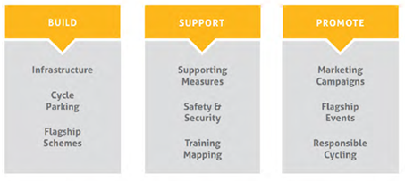
Source DRD Draft Bicycle Strategy 2014

4.34 The Cycling Unit plans to develop a number of Bicycle Network Plans for the urban areas within Northern Ireland. DRD has also established a Greenways Working Group to scope a plan for the development of greenways.

4.35 Greenway routes are best suited to old railway beds or canal banks where gradients tend to be small and attract new inexperienced and young cyclists. However, greenways can be potentially developed anywhere with similar properties. Examples within the District include the existing greenway linking Newry with Craigavon along the Canal tow path, and the proposed scheme to link Newry to Omeath. This scheme could potentially provide a continuous walking / cycle route from Carlingford to Craigavon with the potential for further development. Other potential routes within the district include the former railway beds linking Downpatick with Newcastle and Ardglass, Newry to Warrenpoint and Newry to Bessbrook.

4.36 Further to disused transport routes, Newry, Mourne and Down District Council, in partnership with Ards and North Down Council are proposing the new Mourne and Strangford Lough Coastal Path. This pathway which will be mainly for recreational / tourism purposes is a 130 km (81 miles) path stretching from Greencastle, near Kilkeel to Portavogie in the North Down and Ards District. It follows the coastline from Greencastle to Strangford, crosses Strangford Lough to Portaferry and continues along the coastline to Portavogie passing through the three fishing villages of Kilkeel, Ardglass and Portavogie.

4.37 As part of a wider programme of work to develop more sustainable transport arrangements, the DRD established a Cross-Sectoral Active Travel Forum in March 2010. Drawing representation from across government departments, local government, the voluntary and community sector, and the private sector, the Forum was tasked with developing a high level strategy for Active Travel.

4.38 This document was produced in 2013 and aims to put walking and cycling at the heart of local transport arrangements. The Active Travel Strategy and Draft Bicycle Strategy will assist with the aim of making it easier to walk and cycle and will encourage a modal shift. These documents should be given due consideration at preferred option stage by Newry, Mourne & Down Council.

4.39 Travelwise NI is an initiative to encourage the use of sustainable transport options such as walking, cycling, public transport or car sharing. The Travelwise Team forms an integral part of the Cycling Unit and continues to promote all sustainable options through supporting events, media campaigns and awareness programmes in partnership with schools and businesses.

Map 4: National Cycle Network
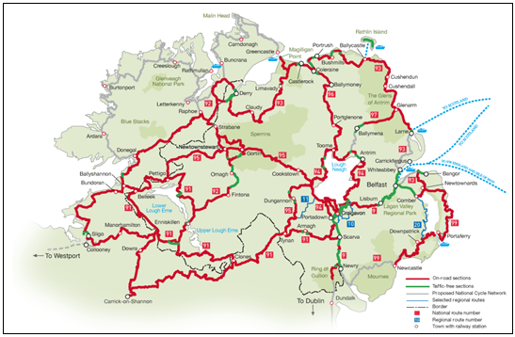
Source: Cycleni.com

4.40 At a local level Transport NI are responsible for implementation of the infrastructure to encourage walking and cycling along public highways. Other Departments also have a role to play e.g. Department of Education have been involved in encouraging “Safer Routes to School”, recently this programme has delivered enhanced high profile flashing amber light signs on approaches to St Patrick’s Primary School, Mayobridge; Windsor Hill Primary School, Newry and Annesborough Integrated Primary School. Voluntary and community organisations also have a part to play. The largest of these is Sustrans, an independent charity. Sustrans is active in promoting cycling infrastructure, particularly the National Cycle Network.

Airports

4.41 At present there are no Airports located within the District. Belfast International is Located approximately 50 km north of Newry City and Dublin International Airport is located approximately 80 km south of the City whilst ‘George Best’ Belfast City Airport is approximately 30 km north of Downpatrick.

Harbours & Ferries

4.42 Warrenpoint Harbour is located upon Carlingford Lough and is the second busiest general cargo port in Northern Ireland and the fifth busiest on the island of Ireland. The port operates daily roll-on roll-off services to Heysham in Lancashire and Container Services to Cardiff and Bristol. Warrenpoint Harbour received its first Cruise ship in July 2014 and it is envisaged that the port will see further growth for cruise and recreational purposes through the ports Marina facility.

4.43 Also within the area, Transport NI continues to operate the Strangford to Portaferry vehicular ferry providing a link between Strangford and the Ards peninsula. Last year the ferry completed 98.84% of 22,152 scheduled sailings. Anticipated delivery of a new ferry to the route is August 2016, a planning application is currently pending for works to the associated Moorings and Slipway area.

4.44 In Greencastle, Planning Permission has been granted for a private operator to construct ferry terminal facilities and associated works for the operation of a vehicular ferry connecting Greencastle with County Louth.

4.45 Having considered the different modes of travel and the responsibilities for their provision, it is apparent that in order to conform with Regional Policy, the new Newry, Mourne and Down Local Development Plan needs to promote a modal shift to more sustainable forms of transport.

5.0 Conclusion & Recommendations

5.1 This paper has provided an overview of transportation provision within Newry, Mourne and Down and in moving forward, it will be important to ensure that the new LDP meets the needs of all road users whether they are living in the area, working in the area or visiting it or have businesses in the area and require better connectivity within the district and beyond, and between the two main hubs. To meet transportation needs, the Local Development Plan Strategy could therefore include measures to:

5.2 Promote and improve connectivity, particularly in rural areas;

- Facilitating new road proposals within the District. The proposed Ballynahinch Bypass is shortly to go to public enquiry. Other potential schemes within the District include the Newry Southern Relief Road and Downpatrick Eastern Bypass amongst others. The LDP can protect the line of such routes to ensure that new development proposals do not impact on their deliverability.

- Encourage the improvement of other important roads within the District and in particular between the main hubs. A significant proportion of the Distircts population live outside the main hubs and therefore reliance on the private car will continue. It is therefore imperative that roads within the District can accommodate this. There is currently good connectivity to Belfast from the two main settlements of Newry and Downpatrick within District due to proximity to the KTC’s and good connectivity to Armagh and Dundalk from the Newry area. The Kilkeel area in particular remains geographically isolated from the Strategic Transportation Network and connections between the two main hubs of Newry and Downpatrick are poor.

- Continue to apply the ‘Protected Routes’ policy which will help to ensure road safety and also help ensure that travel times are no impacted due to a proliferation of accesses on to such routes.

5.3 Promote more sustainable transport modes including walking, cycling and public transport;

- By protecting any existing and proposed park and ride facilities;

- By ensuring that new development is situated, where possible, close to public transport facilities.

- Ensuring that new developments are designed in a manner that can accommodate public transport provision within them where necessary.

5.4 Protect road users and improve road safety for car users, public transport, cyclists and walkers;

- By safeguarding existing and proposed walk ways such as the Ulster Way and the SUSTRANS cycle network;

- By encouraging the design of new housing development schemes to ensure permeability between them and within towns and to encourage links with green spaces and corridors within the towns.

- By encouraging the adoption of the Safer Routes to Schools concept so that children can walk and cycle to school. This will invariably reduce the number of cars using the roads within the towns at key times.

5.5 Based on the current transport situation and different modes of travel and responsibilities for their provision, it is apparent that in order to conform with Regional Policy, the new LDP needs to promote a modal shift to more sustainable forms of transport. In order to achieve a change, any successes will be primarily achieved in the main settlements. For the rural dweller, particularly in the more isolated parts of the District, the private car will remain the primary form of transport. As such, complementary measures should be introduced in the plan which are aimed at reducing the need to travel long distances in order to access shops, recreation facilities and public services within the District.

5.6 Therefore, in preparing the LDP for Newry, Mourne and Down, it is important to assess the transport needs, problems and opportunities within the plan area and to ensure that appropriate consideration is given to transportation issues in the allocation of land for future development. Consideration should also be given to the DRD Regional Transportation Strategy and the relevant Transport Plans. This will ensure that the LDP and Transport Plans have a complementary role to play in promoting greater integration of transportation and land use planning. The SPPS seeks to secure this improved integration with land-use planning, consistent with the RDS; and to facilitate safe and efficient access, movement and parking.

5.7 The local transport studies carried out as part of the SRTP go some way to detailing transport issues, problems and opportunities in the main settlements within the Council area. Consultation will be required with Transport NI when considering land use allocations and future development sites. This will allow for a detailed assessment of the impact of proposed development on the highway network and the possibility of providing suitable access.

5.8 It should also be noted that in the current climate of austerity with budget reviews and potential budget cuts, there may be some impact on the timing of the delivery of some of the major road schemes. Cuts to funding also have significant implications for public transport, particularly community transport and the impact this will have on the more economically disadvantaged and vulnerable in our society. Furthermore, as DRD will continue to make decisions and take responsibility of transportation services across Northern Ireland, the Council’s role in relation to transportation will be inevitably restricted.

Glossary of Terms

Belfast Metropolitan Urban  Area | BMUA is defined as the continuous built up area centred on Belfast with an arc from Jordanstown to Knocknagoney and includes the city of Lisburn and towns of Bangor, Carrickfergus and Holywood.
Cluster | Cities and towns which can work together to create a critical mass to attract economic development and deliver services.
Connectivity | Connectivity refers to the directness of links and the density of connections in a transport network.
Economic Corridors | These are based on the Regional Strategic Transport Network and connect Belfast and Londonderry and main centres of economic activity with external gateways.
Gateway | Strategically important transport interchange points which connect ports and airports to the internal transport network.
Link Corridors | Arterial Routes linking main and local hubs
Park & Ride/Share/Choose | A system for reducing urban traffic congestion, in which drivers leave their cars in car parks on the outskirts of a city/town and travel to the city centre on public transport. In some instances a facility may allow for the provision of a choice of modes for completing onward journeys such as public transport, car pool, cycling and walking
Protected Route Type 1 | Motorway and high standard Dual Carriageways
Protected Route Type 2 | Dual Carriageways, Ring roads, Through Passes and By-Passes, Towns
Protected Route Type 3 | Other Protected Routes - outside Settlement Limits
Regional Strategic Transport  Network | A core transport network made up of the rail system, five key transport corridors, four link corridors and the Belfast Metropolitan Area transport corridors, along with the remainder of the trunk road network.
Strategic or Trunk Roads | Key transport corridors between major urban areas

Appendices

Appendix A: Travel to Work or Place of Study
 | Percentage of all usual residents 16-74 (excluding students) in employment and currently working who usually travel to work
Method of Transport | N.Ireland | NM&D
Do not travel: Work mainly from Home | 10.32 | 11.9
Train | 1.31 | 0.49
Bus, minibus or coach | 4.77 | 2.65
Motorcycle, scooter or moped | 0.39 | 0.23
Driving a car or van | 57.7 | 59.82
Passenger in a car or van | 4.92 | 5.14
Car or van pool, shared driving | 9.83 | 10.86
Taxi | 1.35 | 0.66
Bicycle | 0.85 | 0.52
On Foot | 7.74 | 6.74
Other method | 0.82 | 1
Total of all usual residents aged 16-74 (excluding students) in employment and currently working | 738,659 | 68,277
Source: NI Census 2011 Key Statistics Summary Report

Appendix B: Travel to Work or Place of Study
 | Percentage of all usual residents of primary school age and over in full-time education or age 16 to 74 in employment and currently working
Method of Transport | N.Ireland | NM&D
Do not travel: Work mainly from Home | 11.19 | 12.24
Train | 1.32 | 0.42
Bus, minibus or coach | 12.22 | 13.05
Motorcycle, scooter or moped | 0.29 | 0.16
Driving a car or van | 39.53 | 39.92
Passenger in a car or van | 14.47 | 15.9
Car or van pool, shared driving | 7.03 | 7.58
Taxi | 1.38 | 0.87
Bicycle | 0.67 | 0.4
On Foot | 11.26 | 8.7
Other method | 0.63 | 0.76
Total of all usual residents of primary school age and over in full-time education or aged 16 to 74 in employment and currently working | 1,126,346 | 106,630
Source: NI Census 2011 Key Statistics Summary Report

Appendix C: Protected Routes within NM&D Area
Route Location | Route No | Route | Protected Route Type
Comber - Ballynahinch | A21 | jct A21 (Comber Square) - jct A24 Ballynahinch | 3
Belfast - Downpatrick | A22 | jct A20 Belfast (Upper Newtownards Rd) – jct A22 Comber (Killinchy Rd) - | 3
Carryduff - Downpatrick | A7 | jct A24 Carryduff - jct A25 Downpatrick (New bridge St) | 3
Belfast - Clough | A24 | jct A55 Belfast (Upper Knockbreda Rd) - Ballynahinch (Belfast Rd - Harmony Rd - Windmill St - High St - Main St - Church St) - jct A25 / A2 Clough R,bout | 3
Saintfield - Lisburn | B6 | jct A7 Saintfield - jct A49 Lisburn | 3
Ballynahinch - Lisburn | A49 | jct A24 Ballynahinch - jct A1 Lisburn | 3
Belfast - Border | A1 | Jct 7 M1 (Sprucefield) (Boundary division Eastern) - Border (Killeen) | 1
Newry | A28 | Carnbane Way (Fiveways Roundabout - Customs Station Roundabout - Damolly Roundabout) - Belfast Rd - Downshire Rd - Trevor Hill - Abbey Way - William Street - (Junction with Kilmorey St) | 3
 | A2 | William St (Junction with Kilmorey St) - Bridge St - A1 Cloghogue Junction | 3
 | A27 | Craigmore Way - (Camlough roundabout Junction - Fiveways Roundabout) | 3
Downpatrick - Kilcoo | A25 | jct A7 Downpatrick - jct B8 Kilcoo | 3
Kilcoo - Newry | B8 | jct A25 Kilcoo - jct A25 Newry | 3
Newry - Camlough | A25 | jct B8 Newry - Newry (Sandy St) - jct A1 Newry - jct A1 Newry (Camlough Rd - Monaghan St) - jct A1 Newry - jct B30 Camlough | 3
Clough – Newry | A2 | jct A24 Clough - jct A50 Newcastle (Castlewellan Rd) - Mound Road Roundabout (Warrenpoint) - Greenbank Roundabout (Newry) - jct A1 Newry (Willian St) | 3 & 2
Newcastle - Banbridge | A50 | jct A2 Newcastle - jct A26 Banbridge (Church Square) | 3
Craigavon - Newry | A27 | jct A3 Craigavon (Mandeville Rd) - Lurgan Rd - Bridge St - Castle St - High St - Market St - Mandeville St - Church St) -Mahon Rd (inc. Mahon rd - Northway rbt) - Jct A1 Newry | 3 & 2
Crossmaglen | A37 | Border - Crossmaglen (Cullaville Rd) - Border | 3
Newry - Aughnacloy | A28 | Newry (Canal St - Armagh Rd) - Fiveways Roundabout - jct A3 Armagh (Friary Rd) - jct A5 Aughnacloy | 3
Source: DRD Protected Route Schedule 2014

Appendix D Transport NI Proposed Works (Spring Report to NM&D Council)
Minor Works: Schemes under construction and planned for 2015 / 2016
Location | Scheme Aim
B7 Milltown Street, Burren | New 350m Footway
B30 Crossmaglen Road / Longfield Road, Camlough, Newry | Enhanced safety with the provision of high friction carriageway surfacing and road markings at this bend on the Crossmaglen Road at Longfield Road junction

Schemes planned for beyond 2016/17
Location | Scheme Aim
U318 Vianstown Road / Bishops Brae Road, Downpatrick | Improved Visibility and improvements to junction radii and localised carriageway widening.

Developer led schemes
Location | Scheme Aim | Progress
Mill Road Kilkeel | Footway link along Mill Road, Kilkeel | Progress on these schemes will remain on hold until the full extent of related private developer proposals is known. The schemes will be reviewed annually for consideration for inclusion on a Priority List for the NM&D Council area.
Kitty's Road Kilkeel | Junction Visibility Improvement and footway provision

Traffic Calming (subject to funding and outcome of consultation process)
Year | Location
2015/2016 | College Square, Bessbrook
 | Martins Lane, Newry
2016/2017 | B175 Ballylough Road Annesborough, Castlewellan
 | A25 Dublin Road /A50 Bann Road Castlewellan

Traffic Management Schemes Proposed
Year | Location | Status
2014/2015 | Collins Corner Downpatrick - Proposed Junction Improvement | Scheme delayed, alternative design currently undergoing consideration.
2015/2016 | Downpatrick Traffic Study | Survey work underway with consultants AMEY ltd
 | Langley Road Estate, Ballynahinch - Proposed Pilot 20mph Speed Limit | Public consultation phase complete, legislation being prepared
Appendix E: Summary of Transportation Proposals within Local Masterplans
Master-Plan | Summary of Proposals / Issues
Ballynahinch Masterplan | Benefits of town Bypass
 | Windmill St car park enhanced pedestrian links
 | New Street and River Park
 | Review of one way system when Bypass constructed
 | Need for a sustainable transport strategy
 | Extension of Riverside Pathway
Downpatrick Masterplan | Church Street Redevelopment
 | Laneways and Reopened Entries
 | Saul Street Extension
 | Downpatrick & County Down Railway Line extension, park & ride development, depot relocation
 | New Street
 | Creation of linear park, including public transport
 | Transportation and Parking Study Implementation of transport and parking measures
Newry City Masterplan | Southern Relief Road
 | Park and Choose Facilities
 | National Canal Re-opening
 | City Wide Greenway
 | City Centre Gateway Car Parks
South East Coast Masterplan (Newcastle) | Real time parking displays to reduce volume of circulating traffic
 | Targeted car park charging to discourage all day parkers from town centre
 | Improved security in car parks to reduce demand for on street parking
 | Footway improvements along town centre side roads
 | Potential for other off road cycle tracks through town
 | Increase in cycle facilities
 | Explore cycling blueprint provided by SRTP
 | Potential of higher visitor numbers to justify better public transport services and facilities e.g. real time displays highlighting town services and inter-urban routes
 | Improved transport services to tourist destinations
 | Reduce traffic on main street and central promenade through: 1) Sending more traffic down Donard Street 2) Two Way traffic on Shimna Road 3) Reconfigeration of Railway Street
South East Coast Masterplan (Kilkeel) | Introduction of all parking charges to discourage all day parkers from town
 | Oppertuinity sites may be developed to provide additional public car parking
 | Additional crossing points and pedestrian signage to help promote walking
 | Increase in cycling facilities
 | Explore cycling blueprint provided by SRTP
 | Provision of taxi parking throughout town
 | Improved bus stop facilities and frequency of town service and marketing campaign to increase use of public transport
 | Use of Knockree Avenue to promote access to sea front
 | In event of congestion worsening, potential for alternative routes to run directly from Greencastle Street to Newry Road and A2 (near Moor Road) to Newry Road.
 | A Private Company is interested in providing a Greencastle to Greenore ferry service.
South East Coast Masterplan (Warrenpoint) | Better management of existing spare capacity in car parks
 | Improved security in car parks to reduce demand for on-street parking
 | Provision of additional crossing facilities to provide access to off-street car parks
 | Explore cycling blueprint provided by SRTP
 | Improve Square car park taxi rank
 | Use of former Newry to Warrenpoint rail track bed for transport or recreational purposes
 | Town Bus Service
 | Potential one way or partial one way system
 | Newry Southern Bypass providing improved access to harbour
 | Improved Signage to various tourist attractions
 | Traffic implications / opportunities arising from Narrow Water Bridge project

Appendix F: Ecar Charge Points Within Newry, Mourne and Down
E-Car Charge Points Within NM&D
Town | Location
Newry | The Quays Shopping Centre
 | Bridge Street Car Park
 | Hill Street Newry (On Street)
 | Canal Court Hotel Car Park
 | Monaghan Street (On Street)
 | Basin Walk Car Park
 | Five Ways Shop & Service Station
 | Newry Train Station Car Park
Downpatrick | Rathkeltair House Market Street
 | Church Street / Saul Link
Newcastle | Dundrum Road
 | Slieve Donard Hotel
 | DRD Car Park Shimna Road
 | Donard Park
Warrenpoint | Havelock Place
Kilkeel | Mourne Esplanade
 | Greencastle Street
Ballynahinch | DRD Car Park Lisburn Street North
Castlewellan | Main Street
Crossgar | DRD Car Park, The Square
 | Spar, Saintfield Road
Strangford | The Quay, Strangford
Source: www.ecarni.com

Appendix G: Strategic TransportationNetwork Proposals Map
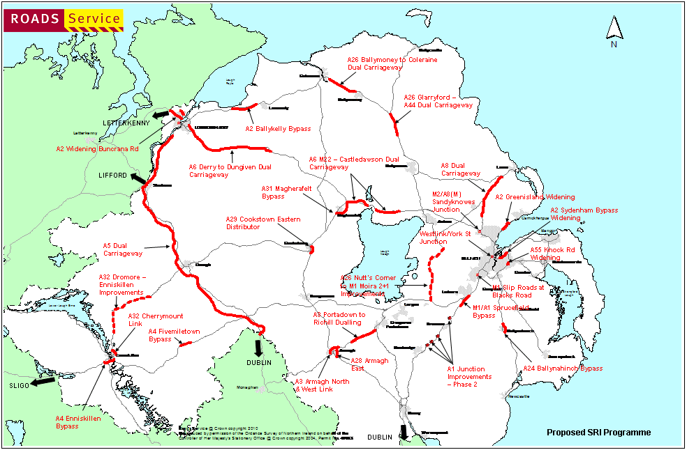
Source: DRD

A24 to NEWCASTLE

A49 to LISBURN

Appendix H: Ballynahinch Bypass

Policy AMP3 – Access to Protected Routes

