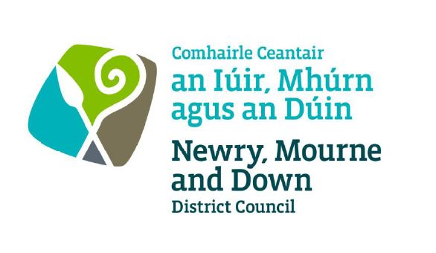

Local Development Plan
Preparatory Studies

Paper 4: Town Centres and Opportunity Sites
November 2015

CONTENTS PAGE

Purpose ………………………………………………………………………………… 3

Content Overview…………………………………………………………………….. 3

- Introduction………………………………………………………….………… 4

- Regional Policy Context…………………………………………………….. 4

- Overview of Retail Trends in NI …………………………….……………. 8

- Existing Development Plans ……..……………………………………….. 11

- Town Centre Masterplans and Village Plans …..………..……………. 21

- Town Centre Studies………………………………………………………… 28

- Conclusions……………………………………………………………………. 35

- Recommendations…………………………………………………………… 37

APPENDICES

Appendix 1 Town Centre Health Check Indicators & Retail Capacity Studies Best Practice Guidance
Appendix 2 Glossary of Terms
Appendix 3 City/Town Centre Boundaries & Development Opportunity Sites
Part 1 Newry
Part 2 Downpatrick
Part 3 Ballynahinch
Part 4 Crossmaglen
Part 5 Kilkeel
Part 6 Newcastle
Part 7 Newtownhamilton
Part 8 Warrenpoint

Purpose

The purpose of this paper is to provide Newry, Mourne and Down Council with an overview of the retail provision in the Council area and to provide information to help determine the need to formulate a detailed retail strategy to accommodate growth and enhance the vitality and viability of existing town centres up to 2030.

Content

The paper provides:-

- the regional policy context for retailing in Newry, Mourne and Down;

- a brief overview of retail trends across Northern Ireland and the UK;

- an overview of town centre policy within the current Area Plans, an examination of current Masterplans, and the provision of opportunity sites including take-up;

- an overview of the health and vitality of existing towns based on the findings of Town Centre Studies for the towns within Newry, Mourne and Down; and

- a summary of recommendations.

1.0 Introduction

1.1 The purpose of this paper is to inform the Members for Newry, Mourne and Down about the nature of the current retail offer within Newry City and the main towns in the District, the take up of town centre development opportunity sites and vacancy rates. The focus of the paper is on Newry, Downpatrick, Warrenpoint/Burren, Ballynahinch, Crossmaglen, Kilkeel, Newcastle and Newtownhamilton. In compiling the paper the main sources of information have included the South East Coast Masterplan, and the Masterplans for Newry City Centre, Downpatrick Town Centre and Ballynahinch Town Centre. The findings of a report by GL Hearn looking at town centres in Northern Ireland on behalf of DOE Planning 2014 as part of the formulation of the Strategic Planning Policy Statement (SPPS) are also included in this paper. The paper allows Members to commence consideration of how policy for the enhancement of town centres may be formulated within the context of the Regional Development Strategy 2035 (RDS) and the SPPS.

2.0 Regional Policy Context

2.1 The Regional Policy Context is provided by the NI Executive’s Economic Strategy and Sustainable Development Strategy; the Department for Regional Development’s RDS and the Department of the Environment’s SPPS. A summary of these documents as they pertain to formulation of town centre and retail development policy and proposals in the Local Development Plan (LDP) is provided in the following sections.

- Regional Development Strategy 2035 (RDS)

2.2 The RDS is the key policy guiding development in Northern Ireland and is underpinned by a Spatial Framework and Strategic Planning Guidelines. The Spatial Framework consists of urban hubs and clusters. The RDS identifies Newry and Downpatrick as main hubs, forming clusters with the local hubs of Warrenpoint and Newcastle respectively. Newry is the South Eastern City gateway due to its proximity to the land border and the port of Warrenpoint. Newry is also well positioned on a key transport corridor while a link corridor connects Downpatrick to the Belfast Metropolitan Urban Area.

2.3 Policy SFG 11 within the RDS aims to promote economic development opportunities at hubs. Hubs perform important economic roles in their area and have the potential for further economic expansion. This policy thus directs LDPs to consider the hubs and clusters of hubs first for any new development proposals. In reference to the RDS infrastructure wheel retail provision at each settlement level would be considered as follows:

- Level 1 (Villages); These are locations that will have shops primarily to meet resident’s needs. They may also have other commercial services e.g. pub, post office, petrol station. Any growth is likely to be minimal. Consideration should be given to defining village centres in the LDP.
- Level 2 (Urban or District Centres/Smaller Towns): These are locations that meet both the daily and weekly needs of surrounding residents. They offer supermarkets, restaurants and a mix of retail facilities.
- Level 3 (Regional Towns/Clusters): These are locations where the proximity of business facilitates competition from which all consumers are able to benefit and maximises the opportunity to use a means of transport other than the car. They will have shops to meet the weekly and longer terms needs of residents. They will also have a mix of different retail/commercial facilities e.g. shopping centres, retail warehouses, range of restaurants/bars.
- Level 4 (Principal Cities): These are locations which in addition to those services provided in Level 3 settlements also have department stores, specialist shops, arts and cultural activities.

2.4 It may be useful to investigate if there are any locations worthy of designation as a District or Local Centre (definition within glossary) within the Newry, Mourne and Down City/Towns. These are locations within an existing town, usually beyond the town centre boundary that provide locally accessible convenience goods to meet the daily and weekly needs of local residents. A local centre is currently designated at Fiveways in Newry and at Ballymote in Downpatrick. There are no District Centres currently designated in the Newry, Mourne and Down City/Towns.

2.5 The RDS makes specific reference to the retailing in the District. It acknowledges that Newry is a significant employment centre with a strong retail offering, which benefits from its strategic location on the Belfast Dublin corridor. It recognises that Downpatrick performs a higher order role than might be expected by its size, with it being the main location for retail provision for the surrounding area. It also recognises that Downpatrick and Newcastle act as important centres for retailing, commerce and business and serve a substantial number of dispersed rural settlements.

- Strategic Planning Policy Statement (SPPS)

2.6 The Department of the Environment’s SPPS (September 2015) will eventually replace existing planning policy statements once a Council has its LDP Plan Strategy adopted. However in the case of retailing policy the SPPS replaces the existing policy provisions within PPS 5 Retailing and Town Centres with immediate effect. The SPPS states that there should be a town centre first approach for retailing and other town centre uses. This is reflective of the ‘sequential approach’ introduced in Draft PPS 5. The SPPS also states the importance of adopting a variety of uses, good urban design and accessibility within the town centre.

2.7 In preparing Local Development Plans, the SPPS requires Councils to undertake an assessment of the need or capacity for retail and other main town centre uses across the plan area. A key element in developing the evidence base will be the preparation of Town Centre Health Checks and the SPPS also requires Councils to undertake and regularly update these (at least once every five years). They will contain information on a range of indicators , including:

- existing town centre uses;
- vacancy rates;
- physical structure and environmental quality – including opportunities, designations and constraints;
- footfall;
- retailer representations;
- attitudes and perceptions;
- prime rental values; and
- commercial yields.

2.8 The SPPS suggests that as part of the process of identifying sites to be allocated for town centre uses in the plan Councils should undertake a ‘call for sites’ exercise. An example of this process can be examined further here:

https://www.lichfielddc.gov.uk/Council/Planning/The-local-plan-and-planning-policy/Local-plan/Local-Plan-Allocations.aspx

2.9 Litchfield District Council (LDC) commenced a ‘call for sites’ in 2015 inviting anyone who wished a site within the District to be considered for development to complete and submit a call for sites suggestion form. LDC sought a range of information to enable all potential development sites to be fully considered. The information sought included a description of the proposed future use and the site’s capacity, details of site ownership, the degree of market interest in the site, the availability of utilities on the site and any site constraints.

2.10 The requirement to allocate sites should be considered on the basis of fulfilling sustainably and objectively assessed needs for retail/economic development during the plan period.

2.11 Arising from the evidence base, LDP’s should include a Retail Strategy and contain appropriate policies and proposals that must promote town centres first for retail and other main town centre uses. Plans should also:

- define a network and hierarchy of centres – town, district and local centres;
- define the spatial extent of town centres and the primary retail core;
- set out appropriate policies that make clear which uses will be permitted in the hierarchy of centres and other locations, and the factors that will be taken into account for decision taking;
- provide for a diverse offer and mix of uses, which reflect local circumstances; and
- allocate a range of suitable sites to meet the scale and form of retail, and other town centre uses.

- Planning Policy Statement 5 – Retailing and Town Centres

2.12 As highlighted in paragraph 2.6 above, PPS 5 Retailing and Town Centres has now been cancelled by the Department of the Environment following introduction of the SPPS. Many of the themes running through PPS5 have now been reiterated in the SPPS.

(d) NMD District Council Corporate Plan

2.13 The Plan highlights the importance of the retail sector across the District with 17.23% of the workforce employed in this area. Whilst the District is seen to be well served with a strong retail offering the challenge is the vulnerability of the retail sector to exchange rate fluctuation and the rise in online shopping.

2.14 The new LDP has an important role to play in not only protecting but enhancing town centres through policies and proposals which promote diversity in town centres, promote high quality design and improve accessibility. The LDP will aim to support and sustain vibrant town centres making them attractive to retailers and consumers alike.

3.0 Overview of Retail Trends in NI

3.1 As part of the preparation of the SPPS a study was undertaken by GL Hearn on behalf of DOE Planning to research issues surrounding town centres and retailing in Northern Ireland (January 2014). This included health checks for a number of town/city centres as designated in adopted plans using a variety of health check indicators. For the Newry, Mourne and Down District Newry, Downpatrick and Newcastle town centres were included within the study. This research also included an assessment of town centre and retail trends. Overall the town centre checks did not identify any towns that were performing badly, but equally there was little evidence of any particularly strong performance. Therefore there is room for improvement in the vitality and viability of town centres and a policy stance which seeks to protect and enhance town centre performance and diversity will contribute to uplifting existing city centre vitality and viability.

3.2 In compiling the GL Hearn study, town centre composition data was obtained from Experian Goad who carry out physical town centre surveys and prepare occupier plans for most town centres in the UK. Some of the key findings regarding town centres in Northern Ireland included:

- Newry has a city centre footprint floorspace of 132,710 sqm, Downpatrick 61,190 sqm and Newcastle 27,920 sqm. In comparison to towns in the rest of the UK, Northern Irish towns tend to have smaller catchment areas.
- Diversity of uses shows the importance of the service sector in town centres (42%), followed by non-food shops (35%). Service uses take up a larger proportion of town centres by unit number, reflecting the smaller sized units these units tend to occupy.
- Convenience goods floorspace is focused in a proportionately small number of larger units reflecting the wider UK trend of the dominance of larger supermarkets in meeting shopping needs.
- Independent operators typically comprise 76% of town centre occupiers. In most centres, independents have a strong offer in food, non-food and service sectors. Unlike many town centres in the rest of the UK, local independent food retailers remain a feature of Northern Irish towns. Newry, Mourne and Down area has a good representation of independent long-established family businesses offering convenience and comparison retailing and service uses.
- The proportion of other town centre uses was notably higher in NI than the UK average. The other category includes transport services, employment and commercial activities, religious buildings, wholesale trade, civic and unclassified buildings.
- Having a range of other uses within town centres should be considered a positive attribute which confirms town centres are performing as a hub for a range of activities thereby contributing to overall vitality and viability
- In 2013 the Northern Ireland vacancy rate is notably higher, both by floorspace and unit numbers (14.5% & 11.9%) than the UK average (12% & 10%).
- NI City/Town Vacancy rates for 2013 (both by unit numbers and floorspace) are shown in the graphs below (Figures 1 & 2).

Figure 1: NI vacancy rates by unit numbers

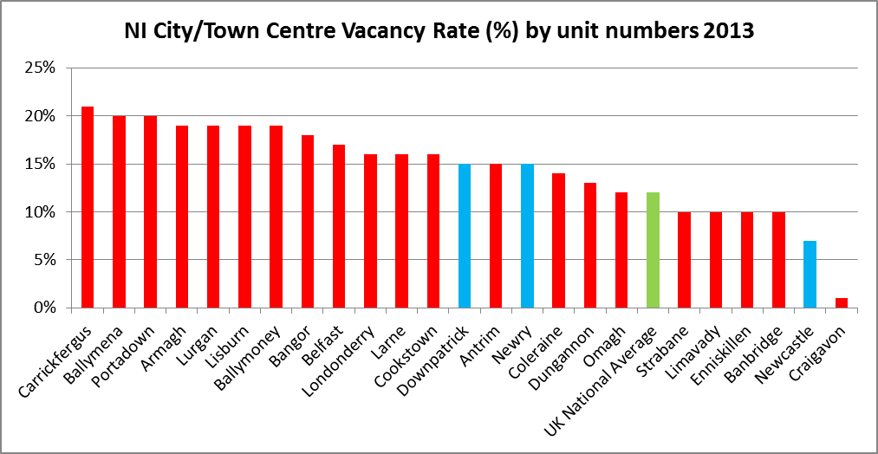

Figure 2: NI Vacancy rates by floor area

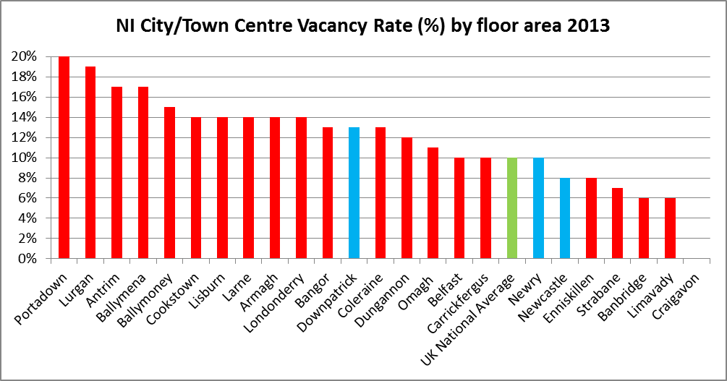
Source: GL Hearn Town Northern Ireland town centres and retail report

Further detail on the main findings of the town centre health checks for the Newry, Mourne and Down Area is provided in Section 6.0 covering Town Centre Studies.

3.3 The report highlighted that out-of-centre retailing is focused outside larger town centres or on strategic routes. In terms of functions, the role of these retail parks is almost exclusively retail. In comparison to the rest of the UK, leisure uses such as cinemas and bowling alleys are not commonly found in these locations. The report indicates that in Newry, Downpatrick and Newcastle, there are no notable out-of-centre retail parks, however this is not the case as Damolly Retail Park is located approx. 1.5 miles north of the city centre. Damolly Retail Park is considered further within this report at paragraph 6.13.

3.4 There are also a number of town centre issues facing Northern Ireland towns which are summarised in Table 1 below. The weaknesses and threats identified by GL Hearn “indicate that it would be appropriate to have a stronger policy stance on protecting and enhancing town centres, encouraging private sector investment and development and making town centres the focus for not just retail but other significant footfall generating uses.”

Table 1: Town Centre Issues

Strengths/Opportunities | Weaknesses/Threats
- Diversity of existing town centres.  - Strong local independent retail offer.  - Good quality physical environment  - Town centre parking, particularly short stay ‘on street’ provision.  - Employment uses within town centres.  - Good accessibility and public transport hubs. | - Vacancies and potential obsolesce of some floorspace.  - Low and falling retail rents.  - Amount and profile of out of centre retailing.  - Development pipeline.  - Limited private sector investment/development in town centres.  - Heavy traffic flows and congestion leads to conflict with shoppers.

3.5 The retail sector is constantly evolving and adapting in response to consumer and lifestyle trends and other market influences. Much of this change has been in the growth in personal income and disposable consumer spending, coupled with population growth. Such trends and influences have and will continue to transform traditional high street retailing and commercial leisure development. The economic downturn has had a negative effect on consumer spending and retail spending is forecast to remain low for the next three to four years.

3.6 National trends in consumer expenditure show a growth in home shopping and electronic commerce. The home shopping sector includes a number of retailing channels including catalogue sales, direct retailing, TV shopping and internet shopping. The growth in online shopping habits does not however mean the end of the high street. Whilst online sales are increasing so too is ‘click and collect’ where consumers order online but visit the store to collect their goods. This service can help ensure that town centres will attract people and remain viable.

3.7 Although there are fewer retailers actively looking for units in Northern Ireland than elsewhere in the UK, certain retailers are taking new units. These include discount stores; the likes of Home Bargains and Poundworld. The food sector including restaurants and coffee shops are also showing growth. This report states that there is a growing trend by national multiple retailers to achieve increasing economies of scale. This results in centralisation of services whereby larger stores serving an extensive catchment are replacing a number of smaller stores. These new stores are unlikely to be accommodated in existing town centres.

3.8 The GL Hearn report concludes that many of Northern Ireland’s towns have remained reasonably vital and viable due to a number of factors:

- many towns retain a good mix of uses, in particular services within the heart of the centre;
- most towns have reasonable/good accessibility on the street and nearby surface parking;
- most visits appear to involve a number of linked trips (shopping, leisure, social and business);
- many have a high level of independent and long standing family business providing provenance of food and quality of service;
- there is a degree of loyalty to the town centre as being the heart of the community; and
- some towns are finding niche markets or their own “brand” identities – cultural, visitation, seaside, gateway to countryside, specialist food etc.

3.9 Town centres however do need to offer an experience above the average functional shopping trip which might otherwise be carried out online or at an out-of-town retail park.

4.0 Existing Development Plans

4.1 The existing adopted Area Plans, the Banbridge/Newry and Mourne Area Plan (BNMAP) and Ards and Down Area Plan (ADAP) are the statutory Development Plans for the District and provide the policy framework against which to assess development proposals. Newry, Downpatrick, Ballynahinch also have their own non-statutory Town Centre Masterplans which provide the basis and justification for the Department for Social Development’s decision making on the promotion, implementation and timing of urban regeneration initiatives in the respective town centres.

4.2 The existing Development Plans designate Town Centre boundaries and Primary Retail Cores (PRC) within Newry, Downpatrick, Ballynahinch and Newcastle. Regional Strategic Planning Policy for town centres and retailing is now contained in the SPPS following its publication in final form in September 2015. Where town centres are defined it was anticipated that commercial activity would concentrate within them. The vitality and viability of the town centres is retained by new shopping and office development. Within the Development Plans for the District, Development Opportunity Sites are also identified for the main towns. These sites are identified within the Plans as having special merit for a particular land use. The status of the sites is illustrated in Tables 1 - 8 below. Within a number of towns the Plans also designate Areas of Townscape Character, Areas of Archaeological Potential and Local Landscape Policy Areas. However these designations do not unduly limit the potential for retail development within the towns.

Banbridge, Newry and Mourne Area Plan 2015 (BNMAP)

4.3 To sustain and enhance the vitality and viability of town centres the Plan adopts a strategy for accommodating retail, commercial and leisure growth within existing centres based on their role within the settlement hierarchy. It recognises that bars, cafes and restaurants have an important role complementing the primary shopping function of city and town centres and contributing to tourism and the evening economy. Town centre housing also has an important role both in terms of vitality of a city/town centre and offering a sense of security.

Newry

4.4 A city centre boundary together with primary retail core and frontage have been designated in Newry to ensure the continuance of a compact and attractive shopping environment, offering both choice and convenience. The Newry Conservation Area covers all of the primary retail core and additional lands to the west (Abbey Way) and north (Trevor Hill, Sugarhouse Quay and New Street).

4.5 The city centre boundary (see Appendix 3, Part 1) extends north to the largely office area of the Downshire Road and the commercial/industrial area north of Upper Edward Street and Cecil Street, west to the campus of the Southern Regional College and neighbouring business, and south to the Quays shopping complex and major brownfield development opportunity sites at the Albert Basin and Warrenpoint Road.

4.6 The primary retail core centres around Hill Street, John Mitchel Place, Merchant’s Quay and the upper part of Monaghan Street, together with Buttercrane and The Quays shopping centres.

4.7 A primary retail frontage is designated along both sides of Hill Street. This is to retain the focus of retail use and ensure the maintenance of a compact shopping environment.

4.8 The plan also contains a policy on town centre housing. It is acknowledged that specific housing areas provide valuable housing stock and are homes for established communities which contribute to the variety and vitality of life in the city centre. Accordingly there is a policy restricting change of use to non residential uses. In addition proposals for new housing on derelict or backland sites and re-use of upper floors for residential use can help support variety and vitality within the city centre.

4.9 Ten Development Opportunity Sites have been identified within the City Centre. Table 1 provides the current status of the development opportunity sites identified in the BNMAP.

Table 1: Newry Development Opportunity Sites

Plan Ref | Location | Area Plan Proposal | Current Status | Planning History
NY81 | Lower Catherine St | Office and residential use | Tbc at Survey Stage | Car Parking – Approved 20/05/2013
NY82 | Merchants Quay North | Office, commercial, leisure and cultural together with residential | Not developed | Nothing Applicable
NY83 | Merchants Quay Middle | Office, commercial, leisure and cultural together with residential. | Not developed | Nothing Applicable
NY84 | Bank Parade | Residential, office, leisure and cultural. | Not developed | Mixed Use development (49 residential units, cafe and offices) Approval lapsed.
NY85 | Merchants Quay South | Retail, office, commercial, leisure and cultural | Not developed | Nothing Applicable
NY86 | North Street | Office, leisure and residential use | Not developed | Nothing Applicable
NY87 | John Mitchel Pl/St Mary’s St | Retail, office, and commercial together with a residential | Not developed | Nothing Applicable
NY88 | Courtney Hill | Employment, educational, leisure and cultural together with residential element. | Not developed | Development of Community Treatment and Care Centre  Outline Approval 14/05/2015
NY89 | Middlebank, Albert Basin | Mixed use – office, leisure and residential. | Not developed | Upgrading existing pathway and access along greenway, new pedestrian crossings at the weir and Victoria Lock gates – Decision Pending
NY90 | Warrenpoint Road | Mixed use | Tbc at Survey Stage | Retail led, mixed use scheme incorporating a food superstore, non-food retail units, enterprise centre and 50 No apartments - Approved 25/06/2012
(For DOS locations see map in Appendix3, Part 1)
Crossmaglen

4.10 The largest town in South Armagh, it has developed around a large market square. More recently the focus of commercial activity has moved from the square to North Street. There are opportunities for retail activity within the town centre in particular around Cardinal O Fiaich Square and along Newry Street where there are vacant and underutilised units.

4.11 A town centre boundary is designated for Crossmaglen (see Appendix 3, Part 4). This includes Cardinal O Fiaich Square, North Street leading to No. 7 Blaney Rd, Newry Street as far as No.26 and Cullaville Rd to the PSNI station. An Area of Townscape Character is also designated, this incorporates most of the town centre with the exception of the PSNI station, Crossmaglen Enterprise Centre and the Health Centre.

4.12 Three Development Opportunity Sites have been identified within the town centre. Table 2 provides the current status of the development opportunity sites identified in the BNMAP.The Mill Lane opportunity site comprises the cattle market and adjoining under-utilized backlands. The Cardinal O Fiaich Square site occupies a prominent position fronting onto the square and entails a vacant plot of land. The Dundalk Road site comprises undeveloped rear cultilages of 29-30 Cardinal O Fiaich Square and land adjacent to No.8 Dundalk Rd.

Table 2: Crossmaglen Development Opportunity Sites

Plan Ref | Location | Area Plan Proposal | Current Status | Planning History
CM13 | Mill Lane | Commercial & residential | Not developed | Nothing Applicable
CM14 | 38-40 Cardinal O Fiaich Square | Commercial & residential | Tbc at Survey Stage | New office premises – Approved 7/02/2014
CM15 | Dundalk Road | Commercial & residential | Not developed | P/2010/0964/F  Retail unit and 4 apartments  Approval lapsed  LA07/2015/0780/F  Retail unit and 4 apartments – Pending.
(For DOS locations see map in Appendix3, Part 4)

Warrenpoint

4.13 A town centre boundary is designated for Warrenpoint (see Appendix 3, Part 8). It includes Charlotte Street and Church Street between the PSNI Station and the Church of Ireland and on the opposite side between the Square and Great Georges Street (South). It also includes the Square and Dock Street. An Area of Townscape Character is also designated and incorporates the town centre and seafront.

4.14 There are opportunities for new retail activity within the town centre particularly on Church Street where there are vacant and under-utilised units. These have the potential to be re-developed or refurbished with an option to use the upper floors for non-retail use.

4.15 Five Development Opportunity Sites have been identified within the town centre. Table 3 provides the current status of the development opportunity sites identified in the BNMAP. The Newry Street, Dockside site entails a car park. The current plan suggests that new development fronting Newry Street with car parking relocated to the rear would provide enhanced visual approach to the town centre.

4.16 The site of the former Liverpool Hotel on Mary Street is identified as an opportunity site. Now demolished this vacant site could be suitable for residential, hotel or office use. The site at the corner of St Peter’s Street and Thomas Street comprises the old technical college and adjacent under-utilised land.

Table 3: Warrenpoint Development Opportunity Sites

Plan Ref | Location | Area Plan Proposal | Current Status | Planning History
WB 29 | Newry Street, Dockside | Resaurant, bar, office or retail | Not developed | Nothing Applicable
WB 30 | Mary Street | Residential, hotel or office use | Not developed | Nothing Applicable
WB 31 | St Peter’s Street/Thomas Street | Office and residential. |  | P/2007/0731/F. Retention of conversion to 2 self contained flats
WB 32 | Osborne Hotel, Osborne Promenade | Residential or hotel use. | Not developed | P/1997/1251  Apartments & townhouses  Approval lapsed.
WB 33 | The Baths, Seaview | Leisure/watersports or conference facility. | Not developed | LA07/2015/0369/F  Redevelopment of the Warrenpoint Baths including refurbishment and extension of existing Adventure Centre, Community Function Room, Seaweed baths/spa, Coffee shop and external venue space.  Decision pending.
(For DOS locations see map in Appendix3, Part 8)

Newtownhamilton

4.17 It is acknowledged that Newtownhamilton is smaller both in terms of population (800) and its services and facilities base in comparison with other towns across the District. Nonetheless it is a market town with a high level of service provision for its size which operates as a service centre and focal point for a large rural area. The Planning Appeals Commission in their Public Examination Report on the BNMAP concluded that “retention of its town status is necessary to provide the framework for its growth and development”.

4.18 A town centre boundary is designated for Newtownhamilton (see Appendix 3, Part 7). It includes part of Armagh Street and Dundalk Street, Shamble Lane, the Common and part of Newry Road.

4.19 Seven Development Opportunity Sites have been identified within the town centre. Table 4 provides the current status of the development opportunity sites identified in the BNMAP 2015. The Armagh Rd/The Common comprises a derelict service station with adjoining undeveloped land, together with the livestock market. The site adjacent to No. 60 Armagh Street entails a linear plot with narrow road frontage and is situated between existing residential properties at the northern end of Armagh St. The Shamble lane site is adjacent to the Church of Ireland and forms part of a Local Landscape Policy Area (LLPA) encompassing the church and its setting. The site of a former public toilet block, now demolished, the Shamble Lane/Newry Rd site entails a prominent road frontage site opposite the PSNI station. The Newry Street site entails an undeveloped road frontage site opposite the PSNI station with a community centre and a public house at either end.

Table 4: Newtownhamilton Development Opportunity Sites

Plan Ref | Location | Area Plan Proposal | Current Status | Planning History
NN 08 | Armagh Rd/The Common | Mix of commercial and residential | Not developed | Nothing Applicable
NN 09 | Adjacent to 60 Armagh St | Residential | Not developed | Nothing Applicable
NN 10 | 28-30 Armagh St | Small business units | Partly developed | P/2007/0532/F Housing Development (3 units) – Approved 16/07/2008
NN 11 | Shamble Lane | Residential or community use | Not developed | P/2006/1536/F Residential Development of 10 apartments. Approval lapsed.
NN 12 | Shamble Lane/Newry St | Retail or commercial premises | Not developed | P/2006/1536/F  Residential Development, of 10 apartments. Approval lapsed.
NN 13 | Newry St | Retail or office development with residential on upper floors. | Not developed | Nothing Applicable
NN 14 | 45-47 Dundalk Street | Mixed-use development | Developed | P/2012/0565/F  Temporary Hot food outlet – 3 year approval granted 07/12/2012
(For DOS locations see map in Appendix3, Part 7)

Kilkeel

4.20 A town centre boundary is designated for Kilkeel (see Appendix 3, Part 5). It includes part of Newry Street and Greencastle Street, part of Harbour Road adjacent to the square and Newcastle Street.

4.21 Three Development Opportunity Sites have been identified within the town centre. Table 5 provides the current status of the development opportunity sites identified in the BNMAP 2015. The opportunity site at Harbour Road contains a mixture of occupied and vacant properties with an under used car park at the southern end. Harbour Road provides a direct link from the town centre to the harbour. The former health centre site in Knockchree Ave, now demolished, entails a road frontage site flanked by established residential properties. Given the established residential character adverse impact on amenity is a consideration for any development proposals at the Knockchree Ave site.

Table 5: Kilkeel Development Opportunity Sites

Plan Ref | Location | Area Plan Proposal | Current Status | Planning History
KL 26 | Newry St /Greencastle St | Supermarket & pharmacy – RM approval 22/11/05 | Developed | P/2005/0785/RM supermarket, with asociated car parking  P/2009/1352/F Ground floor change of use to retail unit Approved 18/12/09
KL 27 | Harbour Road | Retailing and offices, residential, cultural and leisure | TBC at survey stage | P/2006/2176/F Apartment development - Approval lapsed.  P/2012/0242/F  Change of use of former hardware store and amusement arcade to car mechanic and body workshop. Approved 18/07/13
KL 28 | Old Health Centre, Knockchree Ave | Civic, community, office or residential | Undeveloped | P/2006/2173/F  LA07/2015/0611/F  Erect 7 dwellings in substitution for previous approval.  Pending
(For DOS locations see map in Appendix3, Part 5)

Ards and Down Area Plan 2015 (ADAP)

Downpatrick

4.22 The focal point of the town centre (see Appendix 3, Part 2) is Breen’s Corner, with a number of streets extending out in a radial pattern from this point. Market St extends to the south west, English St which runs westwards to the Holy Trinity Cathedral and Irish St which runs south east towards St Patricks Church. Church St which extends to the north of Breen’s Corner, St Patrick’s Ave and part of Steam St are also included within the town centre boundary. The Conservation area runs in an arc along English Street, Irish Street and Stream St and is anchored at three points by the town’s key ecclesiastical buildings.

4.23 The primary retail core is linear in shape, comprising mainly of shops in Market Street, but also includes stretches of Irish Street, Scotch Street, English Street and St Patrick’s Avenue. The retail core is short and compact with few breaks in the frontages. The Down Retail Park on the Ballydugan Road is considered too remote to be included within the primary retail core.

4.24 There are a number of established residential communities within the town centre and these are designated protected housing in the plan. As well as contributing to the variety and vitality of the town centre, housing can also assist in securing the refurbishment and reuse of buildings of architectural and historic interest and importance.

4.25 The town centre housing areas also contain listed buildings at 73 Irish Street, 9 & 10 The Green, Irish Street and 14-24 Saul Street.

4.26 Within Downpatrick town centre five Development Opportunity Sites are identified. The details of the sites and their current status is provided in Table 7.

Table 6: Downpatrick Development Opportunity Sites

Plan Ref | Location | Area Plan Proposal | Current Status | Planning History
DK 25 | Courtyards to the rear of English Street | Specialist retailing, craft workshops, coffee shops | Partly developed | R/2008/0738/F  Refurbishment and extension to hotel, pub and restaurant.
DK 25 | Courtyards to the rear of Irish Street | Specialist retailing, craft workshops, coffee shops | Not developed | Nothing Applicable
DK 25 | Frontage to the Car Park at Scotch Street | New frontage, no specific use | Not developed | Nothing Applicable
DK 25 | Junction of Market Street and Irish Street | Shops and offices | Not developed | Nothing Applicable
DK 25 | Police Station, Irish Street | Residential or offices | PSNI Station still in use | Nothing Applicable
Ballynahinch

4.27 The town centre (see Appendix 3, Part 3)includes Main Street, High Street, Dromore Street, Harmony Road and part of Lisburn Street, Church Street and Windmill Street.

4.28 The primary retail core is focused on Main Street and High Street including the square and a portion of Windmill Street and Dromore Street. The commercial uses in the town are concentrated in the core area and comprise a mix of shops, chemists, cafes, service uses, bars and small business/office uses.

4.29 Town centre housing on parts of Church Street provide a valuable housing stock which contributes to the variety and vitality of the town centre. These are designated in the plan and subsequently afford protection against non-residential development proposals.

4.30 Within Ballynahinch town centre five Development Opportunity Sites are identified. The details of the sites and their current status is provided in Table 7.

Table 7: Ballynahinch Development Opportunity Sites
Plan Ref | Location | Area Plan Proposal | Current Status | Planning History
BH 27 | Gardens to the rear of High St, adjacent to Ballynahinch River | Commercial, civic, residential use | TBC at survey stage | R/2012/0371/F  Demolition of existing buildings and development of 2 new retail units with associated servicing and car parking.  Approved 24/04/13
BH 27 | Gardens to the rear of properties fronting the Square and Windmill St | Mixed commercial use | Not developed | Nothing Applicable
BH 27 | Court yards adjacent to High St | Retail, restaurant, tourism use | Not developed | R/2013/0532/F  Street frontage shop with 4 apartments above and access to courtyard and a further 12 apartments and car parking and a 3 storey town house to rear.  Pending
BH 27 | Gap Site adjacent to Dromore Street | Mixed retail | Not developed | R/2007/1081/F  2 Replacement retail units and 4 apartments.  Approval lapsed.
BH 27 | Harmony Street | Retail, office, and/or civic use | Not developed | Nothing Applicable
(For DOS locations see map in Appendix3, Part 3)

Newcastle

4.31 The town centre boundary (see Appendix 3, Part 6) extends in a linear form from Railway Street and Donard Street at its northern limit, along the full extent of both Main Street and Central Promenade to the northern side of the Bryansford Road. Main Street runs parallel to the seafront separating the promenade from the main residential area to the west of the town centre.

4.32 Newcastle’s retail area is dispersed along Main Street into two pockets of independent shops and commercial uses. A primary retail core is drawn to consolidate those areas considered to be the core areas of retail activity.

4.33 In addition the plan contains a policy on Amusement Arcades. Amusement Arcades are a traditional recreational and commercial use often found in established seaside resorts, such as Newcastle. They can interrupt the cohesion of the retail frontage particularly if dispersed along the street frontage. In Newcastle’s case Amusement Arcades have clustered along the central promenade, accordingly the plan has sought to retain this focus through the designation of an area reserved for Amusement Arcades. This area extends south from the Shimna River along the Central Promenade.

4.34 As previously indicated the plan seeks to protect town centre housing through restricting the change of use in certain area. Within the Newcastle town centre Valentia Place and Donard Place provide an opportunity to contribute to the variety and vitality of life in the town centre and the plan seeks to restrict the spread of commercial uses into these housing areas.

4.35 Within Newcastle town centre 11 Development Opportunity Sites are identified. These opportunity sites are pedestrian linkages and offer the opportunity for enhanced access to the seafront and Valencia Ave (see Table 8).
Table 8: Newcastle Development Opportunity Sites

Plan Ref | Location
NE 26 | Rear of Donard Hotel, Main Street
NE 26 | Donard Place
NE 26 | Adjacent to Newcastle Presbyterian Church
NE 26 | Savoy Lane
NE 26 | Between 89 & 93 Main Street
NE 26 | Downs Road
NE 26 | Between 113 & 115 Main Street
NE 26 | Castle Place
NE 26 | Post Office Lane
NE 26 | Causeway Road

(For DOS locations see map in Appendix3, Part 6)

5.0 Town Centre Masterplans and Village Plans

5.1 Whilst the Development Plans provide the statutory planning framework for land use proposals, Town Centre Masterplans, which were commissioned by the Department for Social Development (DSD) in partnership with the former District Councils, are non-statutory documents which focus on regeneration initiatives and public realm improvements in town centres. Town Centre Masterplans set out a vision for a particular town centre and identify key proposals for realising that vision over a set period of time. Newry has a City Centre Masterplan, the South East Coast Masterplan covers Warrenpoint, Kilkeel and Newcastle, and Downpatrick and Ballynahinch both have masterplans. In addition Village Plans for a number of settlements including Crossmaglen and Newtownhamilton were commissioned by Newry and Mourne District Council under sponsorship of DARD and the EU Agricultural Fund.

Newry City Centre Masterplan

5.2 The Newry City Centre Masterplan (October 2011) sets out the blueprint to inform regeneration and development decisions relating to Newry City over a 10-15 year period and is informed by a detailed information gathering process and analysis. Rather than a proscriptive blueprint, the masterplan establishes key principles and identifies projects for seven key areas of the city centre.

In terms of physical attributes the masterplan identifies Newry’s twin watercourses (the Clanrye River and Newry Canal) as a key feature of the city centre. Flowing side by side through the length of the city centre they provide a strong visual link to the city’s history, a natural habitat in a central location and a special focal point setting Newry apart from most urban centres.

5.3 The Masterplan sets out 6 development principles:

- protect and enhance historic buildings and landmarks;
- introduce a sustainable transport hierarchy;
- develop a network of streets not roads;
- ensure frontage onto Good Quality Open Space;
- support and strengthen communities; and
- animate Newry through appropriate Mixed Use Development.

5.4 Masterplan proposals are made for seven key areas of the city centre:
- Waterfront – creating a word class, city centre. This entails a comprehensive waterfront project extending from Sugar Island to Albert Basin.
- Sugar Island – Nurturing a unique, creative quarter. Proposals include flagship extension to the town hall, new civic square and modernised and extended arts centre as part of a mixed used scheme.
- Four Parks – Establishing a new network of city parks. Improved linkages and coordinated enhancement to Heather, Kilmorey and the Rocks Park together with new public park in grounds of former Abbey Grammar School.
- Hill Street and Abbey Way – Regenerating Newry’s primary streets. Hill St proposals include Public realm works, redevelopment to provide modern retail space and shop frontage improvements. Relocation of Health & Social Services Clinic and long term goal of returning Abbey Street from dual carriageway to a city centre street.
- Monaghan & Upper Edward Street – Revitalising key areas through health and education. Relocation of Monaghan Row Council office and extension to Daisy Hill hospital. Comprehensive redevelopment of land north of Upper Edward St to include new health village and leisure facilities.
- Buttercrane & the Quays – Integrating city centre retail. Improved pedestrian linkage with rest of town centre together with creation of a retail waterfront.
- Albert Basin – Establishing a flagship city quarter. An opportunity to regenerate the 6 hectare waterfront site on Middlebank Island and reconnect with the rest of the city.

South East Coast Masterplan

5.5 The South East Coast Masterplan (January 2013) provides guidance on the location and form of development in the town centres of Newcastle, Kilkeel and Warrenpoint over a 20 year period. It sets out a range of proposals showing how and where development opportunities might be realised.

5.6 Whilst the Masterplan focuses on improving the local economy through tourism it acknowledges that retail remains the foundation of any town centre. It indicates that that a number of initiatives could be followed by all three towns which would not only improve their retail offering for local residents but put them in a stronger position to capture spend from tourists visiting the area.

- Shop front improvement schemes
- Retail performance programmes
- Development of vacant or derelict sites
- Introduction of town centre markets
- Urban Development Grants
- Vacant unit animation schemes
- Purple flag programme
- Car parking strategy

5.7 The masterplan suggests that Newcastle would benefit from the redevelopment of Railway Street to provide fit for purpose retail units on ground floor with office or residential accommodation above. Creation of a new public square in Railway Street would also enhance this gateway location into the town centre. The Newcastle Centre and Tropicana are also identified as opportunity sites where redevelopment could entail retail and craft village together with a new hotel. Islands Park could be redeveloped into a new outdoor leisure development with the potential to draw tourists into the heart of the town.

5.8 Kilkeel would benefit from the development of a riverside park and walkway stretching from the town square to the harbour. Highlighted in the previous paper on economic development, this has the potential to attract tourists into the town centre through a linkage of the harbour and retailing centre. This area has the potential to support a new indoor leisure centre which would again draw people into the centre of the town.

5.9 In Warrenpoint the masterplan proposes a redesign of the town square. The square has the potential to be a high quality pedestrian friendly space, acting as a hub of activity in the town. The masterplan suggests that improved use and design of this space could encourage more restaurants and cafes to open with a knock on effect on the main shopping street.

Downpatrick Masterplan

5.10 The Downpatrick Masterplan (July 2010) sets out a vision for the future development of Downpatrick up to 2030. The vision seeks to capitalise upon the town’s rich heritage, while ensuring appropriate new development can take place to enhance the town’s economy and make it better equipped to compete with other areas.

5.11 The information gathered for this study was wide ranging and helped to establish the strengths and weaknesses associated with retailing in the town centre. In addition the analysis identified key opportunities for regeneration and development.

5.12 The historic buildings in Downpatrick are generally three storeys in height, feature pitched roofs, rendered stone and have a consistent rhythm along the building line. These architectural elements and streetscapes contribute to a strong sense of character in Downpatrick. Throughout the town centre however there are a number of examples of lesser quality architecture, including a number of single storey buildings along market street. The tight street pattern which has evolved is fundamental to the town’s character but also contributes to the town centre congestion.

5.13 A survey of the retail property market highlighted a number of key issues:

- Importance of retaining the historic buildings and streetscape benefits due to the associated unique charm and history;
- Limited retail offer;
- Significant retail leakage to Ballynahinch, Newcastle, Belfast, Lisburn and Banbridge for convenience goods;
- Inadequate restaurant provision;
- Lack of evening economy;
- Limited office market, highly dependent on the public sector;
- Relatively low employment in financial and business services sector; and
- Negative impact of traffic congestion.

5.14 The masterplan suggests that tourism and visitor activity should be the primary driver for rejuvenation of the town centre, providing a stimulus to business development. It points to a number of development opportunities within Downpatrick which require particular attention to enhance the environmental quality. These include Courcey Square, the Grove and the area of car parking behind the Grove Shopping Centre.

5.15 The masterplan identifies a range of projects within four distinct areas. Two of these areas focus on streets that make up the town centre and primary retail core. These are the Church Street, English Street, Irish Street area and Market Street area. The masterplan contains a number of proposals which seek to enhance and interlink these areas:

- Laneways, Arcades and Reopened Entries – one of the objectives of the masterplan is to enhance the historic fabric through the development of new laneways, arcades and reopened entries.
- English Street Public Realm – opportunity to enhance setting of historic buildings.
- St Patrick’s Square – building on existing public realm improvements, the masterplan proposes a second phase to double the size of the square.
- Market Street Renewal – sensitive renewal to modernise retail units whilst respecting the historic integrity. Replace single storey units with two and three storey buildings.
- The Grove Retail Quarter – Comprehensive redevelopment of this area to create a retail-led, mixed use quarter. Opportunity to enhance and expand retail offering.
- New Link Road – through the site of the PSNI Station between Irish Street and St Patrick’s Ave. Part of Transport NI’s traffic study in 2015, seen as medium term proposal (3-10yrs).
- Frontage Improvement Scheme – Focused primarily Market Street but also including sections of Irish Street, Church Street, English Street, Scotch Street and St Patrick’s Ave .
- Living over the Shops – these schemes encourage the conversion of vacant and derelict upper floors of retail and commercial units.

5.16 Since publication of the Masterplan a town centre public realm scheme has been completed.

Ballynahinch Town Centre Masterplan

5.17 The Ballynahinch Masterplan (Oct 2014) provides a platform upon residents and traders alike can develop a shared vision for the future development of the town over a fifteen to twenty year period. It identifies a series of strategic objectives for the town, and in turn outlines proposals to bring about the realisation of these objectives.

5.18 A number of the Masterplan proposals focus on improving landscape quality, improving accessibility, improved signage and environmental improvements and include the following:

- River Pathway – The masterplan proposes the extension of the riverside pathway along the entire length of the Ballynahinch River this
- Town Centre Frontage Improvements – Targeted frontage improvement scheme focused on Market Square.
- Town Centre Living - The masterplan suggests that all new town centre development projects should include an element of residential use. Efforts should also be made to convert upper floors of existing buildings re-establishing the town centre tradition of ‘living over the shops’.
- Laneways and Archways – Enhance movement throughout town centre through linking key streets, car parks, open spaces and residential neighbourhoods more effectively;
- Conservation Area – In order to safeguard and promote the existing quality streetscape, the masterplan proposes that the merits of introducing a town centre conservation area be explored.

5.19 The urban form of Ballynahinch town centre, while generally orientated around Market Square is made up of three main streets, namely high Street, Main Street and Windmill Street. The cohesive and attractive street layout is compromised by a number of prominent backland areas within the built form. Used largely for off street car parking, these large backland areas, coupled with closed pedestrian access routes, significantly undermine the built environment and quality of pedestrian connectivity throughout the town centre.

5.20 The development of opportunity sites will be a key driver in enhancing Ballynahinch town centre. The low quality backlands identified in the masterplan are reflective of a number of the opportunity sites designated in the Ards and Down Area Plan and identified in Table 7 of this paper.

5.21 The masterplan proposes reconfiguration of the Windmill Street car park, including new development to provide active frontage over the car park and strengthen the building line along Windmill Street. The masterplan also proposes a new street and linear park on the backlands between High Street and the River. Under the statutory ADAP it is acknowledged that this area is underutilised and represents a genuine resource within the town centre however land assembly is seen as a significant hurdle to any development proposals.

5.22 To help inform the Masterplan a retail capacity study was undertaken, this indicated that there was limited capacity in expenditure terms and retail would continue to be influenced by competition from nearby larger centres. Nevertheless there was high demand for more and better convenience shopping provision within the town. Referencing a CBRE Property and Market Context and Analysis Report the study concluded that an opportunity existed to provide a large food store in the town centre to prevent food leakage to large supermarkets outside the town.

5.23 A town centre health check was carried out and identified issues which were detracting from the vitality and viability of the town centre. Both town centre user and business surveys highlighted traffic congestion particularly at peak times such as school hours being a problem on the town centre, and an issue which affected both the quality of life and commercial growth of the town. Limited cycle provision and linkages to green spaces and the river.

Newtownhamilton Renewal and Development Plan

5.24 The Newtownhamilton Renewal and Development Plan (July 2012) is a Village Plan produced under the Northern Ireland Rural Development Programme. This proposes a range of initiatives and a number of these are particularly relevant to the town centre. Traffic management through the town was seen as a significant issue. The combination of a large volume of through traffic, narrowness of the street and on street parking all contributed to traffic congestion. The plan suggested that a transport study should be undertaken considering:
- One way system;
- Provision of accessible car parking as an alternative to on street parking;
- Potential traffic calming measures in Armagh Street, Dundalk Street and Dungormley Estate.

5.25 The town contains a number of derelict units and sites which represent development opportunity sites.

Crossmaglen Cluster – Village Renewal and Development Plan

5.26 The Crossmaglen Renewal and Development Plan (September 2012) is a Village Plan produced under the Northern Ireland Rural Development Programme with the aim of creating a long term vision for the village and surrounding area.

5.27 The plan built on the earlier Strategic Development Framework (March 2004) vision for Crossmaglen as a ‘Vibrant Tourist Service Centre’ and a number of proposals were suggested that could help deliver on this vision.

- Community Centre Extension;
- Creating a high quality shared space –Cardinal O’Fiaich Square;
- Redevelopment of underused and vacant units; and
- Development of Community Enterprise

5.28 The community centre was identified as a key building in the square and the development of this would provide a greater visual and community focus.

5.29 The square was identified as a major asset which was not being used to its full potential. The plan indicated that the square would benefit from an environmental improvement scheme. Redevelopment of the square could enable festivals and events to be held bringing increased footfall to the surrounding retail and service uses. A review of parking and provision of children’s play area was also proposed. A vibrant, attractive square would act as an economic driver for the rest of the town, bringing in visitors and investors

5.30 In the short term the plan proposed that the appearance of derelict and run-down buildings could be improved through painting and initiatives which animated vacant and derelict shop units. Development of a shop frontage improvement scheme should be pursued and pop up shops encouraged through rate relief.

5.31 The development of an enterprise centre which would support local business creation and development was seen as key to the future development and growth of the town centre.

6.0 Town Centre Studies

6.1 Regional Planning Policy requires Councils in preparing a Local Development Plan to undertake both an assessment of the health of town centres and a retail capacity study. A town centre health check is essentially a qualitative assessment in that it looks at the attractiveness, accessibility and amenity of the town centre. Although no single indicator can effectively measure the health of a town centre, the use of a series of them can provide a view of performance and offer a framework for assessing vitality and viability (see Appendix 1). Vitality is a measure of how busy a centre is and viability is a measure of its capacity to attract on-going investment for maintenance, improvement and adaption to changing needs.

6.2 A retail capacity study is a quantitative assessment of the need for additional retail floorspace over the plan period. This will include catchment area definition, calculating total expenditure and turnover of convenience and comparison goods, and projection of future needs.

6.3 As a health check or retail capacity study has not yet been carried out to inform this section of the paper, we have instead relied on the findings from a review of exiting town centres in Northern Ireland contained in the 2014 GL Hearn report, the 2014 Ballynahinch Retail Capacity study produced by Strategic Planning and the South East Coast Retail Capacity Study published by Roderick MacLean Associates.

6.4 It should be noted that where there is reference to a particular retailer, this is included to give an indication of the retail variety within a city/town centre at the time the health check was undertaken. This represents a snapshot in time and does not take account of any changes in retail provision that may have taken place in the intervening period.

6.5 Vacancy rates are considered as an important measure of how healthy a town centre is. According to the Northern Ireland Retail Consortium (2015), town centre vacancy rates have fallen in NI from 20% in 2011 to 16.3% in January 2015. Despite this welcome fall in the NI vacancy rates, they still remain significantly higher than the UK average (10.4%).

Newry

6.6 The GL Hearn report shows that the total floorspace within the city centre is estimated to be 132,710 sq. metres.

6.7 Newry has a diverse selection of national and international multiples, independent and more traditional traders spread throughout the City. There are four distinct and differing shopping areas within and outside the City Centre these are as follows:

1. Hill Street
2. Buttercrane Shopping Centre
3. The Quays Shopping Centre
4. Old Creamery Retail Park

6.8 A number of smaller scale local independent retailers are located in the Sugar Island, Canal Street and Monaghan Street Areas located within the town centre. Another popular shopping location, the Damolly Retail Park, is located outside the town centre adjacent to the Newry bypass. There are also a number of neighbourhood retailing centres/facilities throughout the city.

6.9 Hill Street is situated at the traditional heart of the City Centre, beside the Cathedral and is the City’s main shopping and commercial area. The entire street is located within the Newry Conservation Area and the quality of the build environment is high with many fine granite buildings. Some UK national multiple retailers (such as Boots) are located on Hill Street however most are located in the Quays and Buttercrane Shopping Centres. Local independent retailers currently occupy the majority of units on Hill Street. Also present on Hill Street are the major banks, building societies and community services. At the time of the GL Hearn health check surveys in 2013 there were only two vacant properties along the entire length of Hill Street.

6.10 The Quays provides a modern shopping and leisure/entertainment complex, situated along the Albert Basin. The centre is anchored by a Debenhams department store, Sainsbury superstore and Omniplex cinema. The Complex consists of the main shopping centre and a refurbished Drumalane Mill which accommodates three 185 sq. m units of specialist retail floorspace. Drumalane Mill also contains four 557 sq. m office suites. The Drumalane Mill Complex has specialist retailers Ulster Weavers, Place of Dress and Café Lenza at ground floor level while FPM Chartered Accountants and Parker Green occupy part of the office complex the rest of which is available to let. The third element to The Quays is retail warehousing units which accommodates O’Neills Sports, Springsteens Restaurant and Toyzone. The main shopping mall of the Quays a number of UK multiples including Boots, HMV, Monsoon, Early Learning Centre, Clinton Cards, Index, Next, Thomas Cook, Waterstones and Sports Direct. As well as offering high quality shopping facilities the Centre also has a ten screen Omniplex Cinema and food outlets. At the time of the health check survey there was one vacant unit which the centre manager stated was currently under offer. No information was publicly available on footfall through the centre. In July 2013 planning approval was given for an additional 7,794 sq. m of retail floorspace and 1091 sq. m of restaurant space on the site of the former petrol filling station and adjacent parking bays. This is currently under construction. Parking provision within the complex has reduced from 1204 to 1008 as a consequence of this development.

6.11 Monaghan Street is the more traditional commercial part of the City, home to a number of family run and independent businesses. The Old Creamery Retail Park is located between Monaghan Street and Merchants Quay on the site of the Old Corn Market. Tenants include Dunnes Stores, Argos, Peacocks, Poundstretcher and TK Max. At the time of the GL Hearn health check survey all the units were occupied.

6.12 The Sugar Island / Canal Street Area is a secondary retailing area located within the city centre. The area contains many small independent retailers as well as a number of public houses, fast food takeaway outlets and taxi offices. The Sugar Island / Canal Street area lies within the Newry Conservation Area.
Also located within the city centre is the Newry Variety Market. For over 100 years the market has operated on Thursdays and Saturdays from a site located at the southern end of Hill Street.

6.13 The main out of centre development serving Newry is Damolly Retail Park which is located around 1.5 miles north of the city centre at the intersection of the A28 and the A1. The retail park is anchored by B&Q along with Next Home, Halfords, Mothercare, Harveys, Currys and Smiths Toys. There is also a Lydl foodstore, a McDonalds drive thru restaurant and a Costa Coffee.

6.14 A Tesco Extra Superstore (circa 9,000 sq. m floorspace) opened in 2014 and is located just outside the city centre boundary on the Downshire Road.

6.15 Comparison goods retailing predominates within the aforementioned covered shopping centres which house the majority of Newry’s multiple retailers. Comparison goods shopping comprises approximately 35% of the city centre total retail and service provision.

6.16 The 2013 survey from the GL Hearn found 75 vacant units equivalent to a vacancy rate of 14%, this is slightly below the 15% rate recorded in 2012 Experian Goad Survey. In terms of distribution the survey found that most of the vacant units were located throughout the city centre however the greatest concentrations of vacant premises within the town centre are on St Mary’s Street and Mill Street. Both of these areas are very much seen as secondary shopping areas within the city.

6.17 Car parking provision with Newry City Centre is well supplied with between 1,300 and 1,400 spaces available in dedicated off-street car parks spread throughout the city centre. On street limited time period car parking (440 spaces) is available throughout the city centre. There are also parking facilities at the Quays and Buttercrane Centres, where over 2,000 private parking spaces are available.

6.18 The quality of the town centre is of great importance and can increase business confidence, foster public pride, and enhance local identity. A conservation area extends over and beyond the commercial area and includes a number of listed buildings. The public realm has been enhanced in recent years through projects jointly funded by the Department for Social Development and the Council. A £2.5 million Newry linkages public realm scheme was completed in 2014 along Buttercrane and Merchant’s Quay. This saw the enhancement and rejuvenation of Newry’s canal through the replacement of the existing canal boundary wall with a new decorative maritime railing and the removal of car parking spaces on the canal-side to facilitate the provision of a new wider granite paved/kerbed pathway. New decorative street lighting, street furniture, tree planting and public art was also introduced. A further £860,000 scheme is currently proposed for the city centre, the Newry Cathedral Corridor Scheme will focus on Margaret Street, Marcus Street, Upper and Lower Hill Street and will include the installation of new kerbing and paving, street furniture and lighting

Warrenpoint

6.19 In a retail capacity study produced by consultants for the South East Coast Masterplan in 2011 Warrenpoint had 5,900 sq. m (gross) of retail floorspace. In terms of convenience goods Warrenpoint has a limited offer, particularly as there is no mainstream supermarket. The study also noted that the town had a lower level of comparison floorspace when compared to the other towns in the study (Newcastle and Kilkeel).

6.20 The study highlighted that only 23% of shoppers surveyed in the primary catchment did their convenience shopping in Warrenpoint and stated that there was therefore the potential for up to 70% of the convenience shopping to be retained by new retail development in Warrenpoint. However given the proximity of Warrenpoint to Newry the study concluded that supporting an extra 1,400 sq. m of convenience floorspace by 2021 might be difficult.

6.21 The main focus for commercial development in Warrenpoint is along Church Street and around the Square, extending a small distance along Duke Street. The area is vibrant, lively and busy, with a wide variety of shops that are mainly independently owned with the exception of the grocery shops. These include a Spar and Nisa shops, two Gordons Chemists and an Extra Vision.

6.22 At the time of the retail survey there was little vacancy in the retail area with only two vacant premises in Church Street and four on Duke Street. There were no vacancies around the Square however there were some vacant residences along the Seafront on Osbourne Promenade. The main industrial areas in Warrenpoint fall outside of the town centre boundary, these are The Docks area, and Warrenpoint Industrial Estate on the Newry Road.

6.23 The quality of a town centre in enhancing local identity has been acknowledged in Warrenpoint through the designation of an Area of Townscape Character. The ATC designation identifies the Square as a key space with many buildings retaining their historic architectural detailing. The Dock, Dock Street, Duke Street and parts of Charlotte Street are all seen as integral to the quality of the square. A public realm scheme centred on Church Street, Charlotte Street, Town Square, Newry Road and Dock Street was scheduled to commence in October 2015. This will introduce new kerbing and paving, new street lighting and furniture as well as bespoke signage and landscaping.

6.24 The main area of car parking in Warrenpoint is the Square with provision for 135 vehicles with a further 139 spaces in car parks located at East St, Kings Lane, Mary St and Newry Street.

Kilkeel

6.25 In a retail capacity study produced in 2011 by consultants for the South East Coast Masterplan Kilkeel had 9,500 sq. m (gross) of retail floorspace. Convenience floorspace accounted for 3,818 sq. m (gross) of which Asda made up 2,168 sq. m (gross). In the Kilkeel primary catchment (see map1, zone 2) 77% of those surveyed did their convenience shopping in the catchment with 75% using the town itself. The study concluded that the potential to attract new trade from beyond the primary catchment was limited however the forecast growth in retained expenditure suggested that up to an additional 1,400 sq. m floorspace could be supported by 2021.

6.26 The main focus for commercial development in Kilkeel is centred on Greencastle Street, The Square, Bridge Street, part of Newcastle Street and Newry Street. There are a wide variety of shops that are mainly independent.
At one end of Newcastle Street lies the town’s main convenience retailing outlet, the Asda supermarket, along with other larger retailers such as Gordon’s Chemist. Kilkeel also acts as a service centre for the local area as well as providing social and community facilities.

6.27 The retail survey back in 2011 indicated a relatively high level of vacancy and dereliction in the town centre, with buildings in prominent locations lying empty.

6.28 The main car parks in Kikeel are located in Ben Crom Place, Bridge St, Harbour Road and Newry St with spaces for 159 vehicles.

Map 1: Primary Catchment Area for Newcastle (zone 1), Kilkeel (zone 2) and Warrenpoint (zone 3)

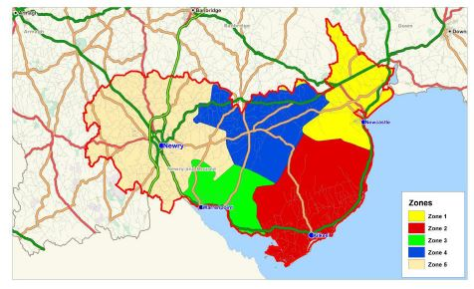
Source: South East Coast Masterplan Retail Capacity Study (November 2011)

Downpatrick

6.29 The GL Hearn report shows that the total floorspace within the town centre is estimated to be 61,190 sq. metres. The retail and central area commercial core of Downpatrick is focused on Market Street, St Patrick’s Avenue, English Street, Irish Street, Scotch Street and Church Street.

6.30 The main food store within the town centre is Lidl occupying a frontage site in Market Street. Other food shopping is provided by independent retailers and the town centre has a range of butchers, a greengrocer, a baker, health food store, off-licences and CTNs. The GL Hearn survey identified 17 convenience outlets within the town centre which comprised 7% of retail outlets.

6.31 There is a mix of comparison goods shopping and the town centre has a range of clothing and footwear stores including national multiples Top Shop /Dorothy Perkins, DV8 and Heatons. The Grove Shopping Centre is located on Market Street is anchored by B & M Bargains. Other multiples located in the town include Boots, Superdrug and Gordons Chemists.

6.32 The GL Hearn survey in 2013 found 37 vacant units equivalent to a vacancy rate of 14%. Downpatrick town centre has off street car parking provision in the region of 450 spaces with additional provision in the Down Retail Park.

6.33 Close to but outside the town centre is the Down Retail Park on the Ballyduggan Road. This is anchored by an Asda superstore (4,550 sq. m gross floorspace) and includes a further seven retail warehouses occupied by Harry Corry, Peacocks, Poundstretcher, Newlook, Argos and Halfords. The retail park also has a McDonalds fast food outlet and an Asda petrol filling station.

6.34 A £3.2M Public Realm and Environmental Improvement (PREI) scheme was completed in 2011. This consisted of replacement paving and new street furniture throughout the town centre, improved open space around St Patrick’s Square, installation of public art in Scotch St and St Patrick’s Square together with improved street lighting. This has enhanced the quality of the town centre environment.

Ballynahinch

6.35 Place Solutions within their Town Centre Health Check Report (April 2014) state that Ballynahinch has a vibrant and compact town centre with a wide range of shops and services concentrated along Main Street, High Street and Dromore Street. Convenience floorspace was estimated to be 12,749 sq. m (gross) while comparison floorspace amounted to 17,634 sq. m (gross). A Supervalu store is centrally located at the important junction of Main Street, Lisburn Street and High Street and this represents the only large convenience store in the town. While there are some national chain stores within the Town such as Supervalue, Iceland, and Lidl, the majority of the shops are smaller family run businesses. Overall there were 6 convenience outlets within the town centre which comprise 7% of outlets.

6.36 There are in excess of 400 car parking spaces in Ballynahinch town centre with car parks located in Lisburn St (north and south), Windmill St and Antrim Rd.

6.37 The centre however suffers from congestion because of its large volume of through traffic, due mainly to its location on the Belfast to Newcastle road. A bypass is proposed for Ballynahinch to ease traffic congestion. This scheme provides for a single carriageway bypass of Ballynahinch linking the Belfast Road near it’s junction with the Saintfield Road to the Drumaness Road at it’s junction with the Downpatrick Road. The bypass will cross the Crossgar Road near the old railway bridge and will provide major relief to the town centre.

6.38 A £2.1million Public Realm scheme, completed in 2015, has made the town centre a more attractive and pedestrian friendly environment with high quality civic space. In addition a £200,000 revitalisation scheme has supported shop front improvements throughout the town centre.

Newcastle

6.39 In a retail capacity study produced in 2011 by consultants for the South East Coast Masterplan Newcastle had 12,400 sq. m (gross) of retail floorspace. Convenience floorspace accounted for 3,430 sq. m (gross) within the town centre. The main food store within Newcastle town centre is Lidl which is housed in the former railway station building. Other food shopping is provided by independent retailers and franchise convenience stores (Centra). Independent foodstores include three butches, a greengrocer, two bakers, off-license and health food store and confectionery, and newsagents (CTNs).

6.40 The GL Hearn Report noted that in April 2013 Newcastle had 52 comparison goods outlets, equating to around 30% of the town’s overall outlets. Relative to other towns this was considered a low proportion of the comparison offer. Clothing and fashion retailers were present, with a local independent department store (Wadsworth of Newcastle) and regional multiple DV8. Other multiple comparison good retailers include Superdrug and Gordons Chemist.

6.41 Within Newcastle, the predominant town centre use is retail service comprising over 45% of all outlets. This reflects the town’s tourist and leisure role which supports a range of food and beverage offer, hair and beauty salons and financial and professional services.

6.42 A Tesco supermarket is located to the north of the town centre at Castlewellan Road. This store has a sales area of approximately 1,485 sq. m (gross).

6.43 The GL Hearn survey identified 13 vacant units in 2013, equivalent to a vacancy rate of 7.5%.

7.0 Conclusions

7.1 The purpose of this paper is to inform Members about the nature of the current retail offer in Newry City and the other towns within the Newry, Mourne and Down area, the take up of town centre opportunity sites and vacancy rates. The SPPS requires LDP’s to include a Retail Strategy and contain policies and proposals that promote the town centre first for retail and other main town centres uses. In line with this, the new LDP will need to ensure that retail growth remains focused on the main centres. The importance of retail hierarchy is also recognised and retail facilities in the small towns, villages and at a local level can complement the main centres.

7.2 A notable development has been the re-evaluation of the commercial rates payable by Land and Property Services (LPS) in April 2015. It is hopeful that this may lower the amount payable in key city/town centres areas and make them more affordable to retailers and lessen the vacancy rates in the town centres. This in turn, would also make these town centre locations more attractive than out of centre locations.

7.3 Within the existing settlement hierarchy NMD has six smaller local towns, Ballynahinch, Newcastle, Crossmaglen, Kilkeel, Newtownhamilton and Warrenpoint/Burren. The settlement hierarchy paper presented in September 2015 advised that the settlement hierarchy would be considered further as part of the settlement appraisal work and subsequently explored at workshops with members. The need for additional town centres to be identified will therefore be considered as part of this appraisal work.

7.4 While the SPPS states that there should be a town centre first approach for retailing it is worth exploring the role, form and merit of defining district centres, local / neighbourhood centres and village centres. As stated at paragraph 2.4 a local centre has been designated at Fiveways on the Armagh Rd, Newry and at Ballymote in Downpatrick. Neighbourhood Centres are centres within towns which can provide services to meet the daily needs of local residents. Designation of village centres should be considered for larger villages in the new Plan Area (e.g. Saintfield, Killyleagh and Castlewellan) as they have the ability to afford protection. Additional designations of local towns, district centres, neighbourhood centres and village centres should be considered in the preparation of the new LDP as to ensure their vitality within the overall hierarchy.

7.5 It is considered that further investigation is required to consider the extent of the existing Primary Retail Cores (PRC) the scope for designating them and extending PRCs. Consideration of this will require a thorough examination of retail capacity, full health checks and take up of opportunity sites. It is therefore recommended that a retail capacity study be undertaken promptly to inform options for public consultation.

7.6 A key difference in the past between the masterplans/development strategies and the statutory development Plans has been that the masterplans/development strategies have adopted a more proactive holistic approach to the town centre, whilst the development Plans have been more regulatory in nature. In preparing a new Local Development Plan informed by the Community Plan the opportunity exists to re-strike the balance and include non-land use actions taken by the Council to improve the attractiveness and amenity of the town centres.

8.0 Recommendations

8.1 In line with the conclusions from this study it is recommended that:

- That Newry and Downpatrick be reaffirmed as the main city/town centres in the Preferred Options Paper.

- That consideration be given to existing town centre boundaries, retail designations and opportunity sites as they currently exist and consider if they provide an adequate framework up until the new plan is adopted.

- That a retail capacity study be undertaken in the 8 city/town centres to determine their status and establish their capacity to support additional retailing. The options for achieving this, including the commissioning of consultants to undertake this work will be further considered in consultation with Enterprise, Regeneration and Tourism Directorate which has responsibility for town and city centre management.

- That a comprehensive health check be carried out for the city/town centres. This will be further considered in consultation with Enterprise Regeneration and Tourism Directorate which has responsibility for town and city centre management.

- That an appraisal be carried out to identify whether any settlements should be included in the Preferred Options Paper for reclassification from a village to a town and whether there is sufficient retail offer to warrant a town centre designation. Members input will be sought.

- That candidate locations should be appraised to establish whether any existing shopping facilities elsewhere in the NMD city/towns can be identified in the Preferred Options Paper as district / local / neighbourhood shopping centres.

- That villages should be appraised to establish whether there is sufficient facilities clustered together to warrant identifying as village centres in the Preferred Options Paper.

- That a policy review paper on retail be prepared for inclusion in the Preferred Options Paper. This may include suggested town centre policies and designations to reflect the changing role of town centres from retail led to multi-functional.

Appendix 1: Town Centre Health Check Indicators & Retail Capacity Studies Best Practice Guidance

Town Centre Health Check Indicators

- Existing town centre use, including resident population. Town centre diversity assessed by types of use (by number and floorspace);
- Vacancy rates: identification of ground floor vacancies;
- Physical structure and environmental quality – including opportunities, designations and constraints. Assessment looking at dominance of traffic, ease of pedestrian movement and details of any recent investment in public realm. Key opportunities in terms of vacant sites for expansion or clusters of vacancies which might point towards contraction;
- Footfall: identification of footfall on main shopping streets to assess vitality and identify main attractors within the centres.
- Retailer representations: notable retailers present in town and identification of any clear gaps in representation/evidence of retailer requirements in the centres;
- Attitudes and perceptions;
- Prime rental values: where available details of rental levels in the prime shopping areas; and
- Commercial yields: where available, analysis of yield data to provide insight on investor confidence in the centres.

Retail Capacity Studies – Best Practice Guidance

These studies provide a quantitative assessment of the need for additional retail floorspace within the plan area over the plan period.

They should include the following:
- The catchment area of the settlement being assessed. In order to define the catchment area household surveys should be conducted to establish existing patterns of shopping behaviour and retail consumer expenditure for the settlement. The surveys should quantify shoppers behaviour for the main goods categories: convenience, comparison and bulky comparison.
- Within the catchment area figures for expenditure and turnover should be obtained.
- Details of existing retail floorspace should be obtained for convenience, comparison and bulky comparison goods.
- A calculation of projected retail expenditure over the plan period should be carried out.
- Conversion of resulting expenditure figures into floorspace using appropriate forecast sales densities should be undertaken.
Appendix 2: Glossary of Terms

City/Town Centre: For the purpose of this paper , city/town refers to city centre or town centres which provide a broad range of facilities and services and which fulfil a function as a focus both for the community and for public transport.

Convenience goods: defined broadly as all purchases on food and grocery items (including food, drinks, tobacco, newspapers, magazines, cleaning materials and toilet products).

Comparison goods: broadly defined as all purchases on other non-food items that are not classified as being convenience goods.

Development Opportunity Site: Development Opportunity Sites are zoned where lands in city and town centres are under-utilized or vacant and where development, which might provide a mix of new uses, could promote the vitality and viability of the town centre, or could enhance the townscape, for example, by closing frontage gaps or replacing unattractive features.

District Centre: Groups of shops, separate from the town centre, usually containing at least one food supermarket or superstore and non-retail service uses such as banks, building societies and restaurants.

Edge-of-Centre: For the purposes of this report an edge of centre location is one which is, outside the town centre but is easily accessible on foot from the centre. The walking distance does not exceed 200 metres.

Local Centre: Small groupings of shops, typically comprising a general grocery store, a sub-post office, occasionally a pharmacy and other small shops of a local nature.

Out-of-Centre: A location outside a town centre boundary but within defined development limits.

Gross Retail Floorspace: the total built floor area measured externally which is occupied exclusively by a retailer or retailers; excluding open areas used for the storage, display or sale of goods.

Nett Retail Floorspace: the retail sales floorspace of a store, which is normally defined as the area within the store where members of the public have access or from which sales are made.

Primary Retail Frontage (PRF): The PRFs in town centres comprise those parts of the town centre that should be retained in retail use. Proposals for non-retail uses at ground floor level within the primary retail frontages will be resisted in order to retain the focus of retail uses and ensure the maintenance of a compact shopping environment.

Primary Retail Core (PRC): PRCs normally contain the traditional concentration of retailing and other town centre functions. The purpose in identifying a PRC is to control the location, scale and nature of new development in each core and to provide conformity with the retail uses.

Retail Capacity Study: A technical study to identify, in broad terms, the scope for new retail floorspace;

Retail Health Check: Retail Health Checks are produced to monitor the performance, or health, of the main retail centres within the study area.

Retail Services: Retail Services comprise, for example, services such as hairdressing, beauty salons, launderettes, dry cleaners, post office, clothing hire, opticians, travel agents, filling stations and vehicle rental.

Vacancy Rates: This relates to the (%) of vacant units within a defined area (e.g. town centre boundary) and is usually presented by the number of units or by the floorspace (square metres).

Vitality of Town Centre: Vitality is a measure of how busy a centre is.

Viability of a Town Centre: Viability is a measure of its capacity to attract ongoing investment for maintenance, improvement and adaptation to changing needs.

Appendix 3: City/Town Centre Boundaries & Opportunity Sites

The following maps are extracts from the existing adopted plans for the Newry, Mourne and Down District. These designations will be reviewed as part of the new Local Development Plan process and members input will be sought prior to them being finalised.

Part 1: Newry City Centre & Opportunity Sites
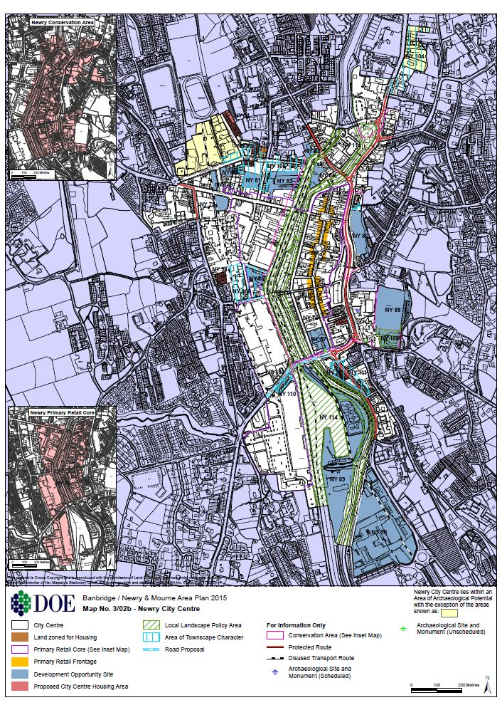

Part 2: Downpatrick Town Centre & Opportunity Sites

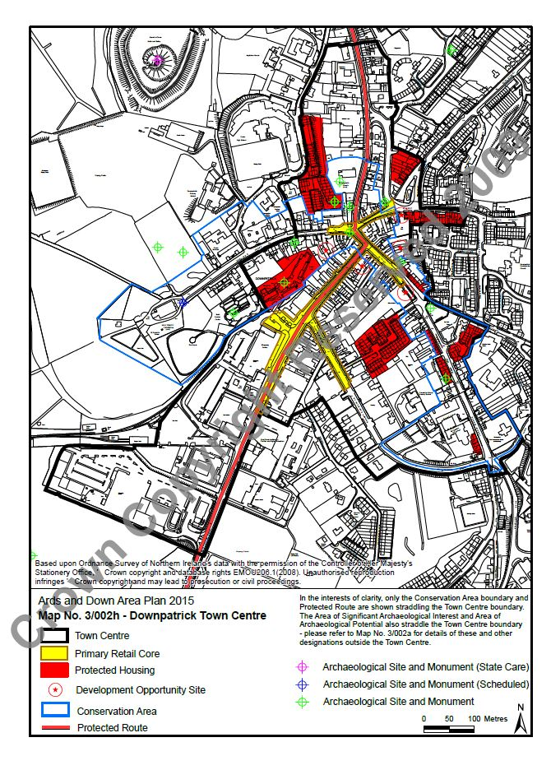

Part 3: Ballynahinch Town Centre & Opportunity Sites

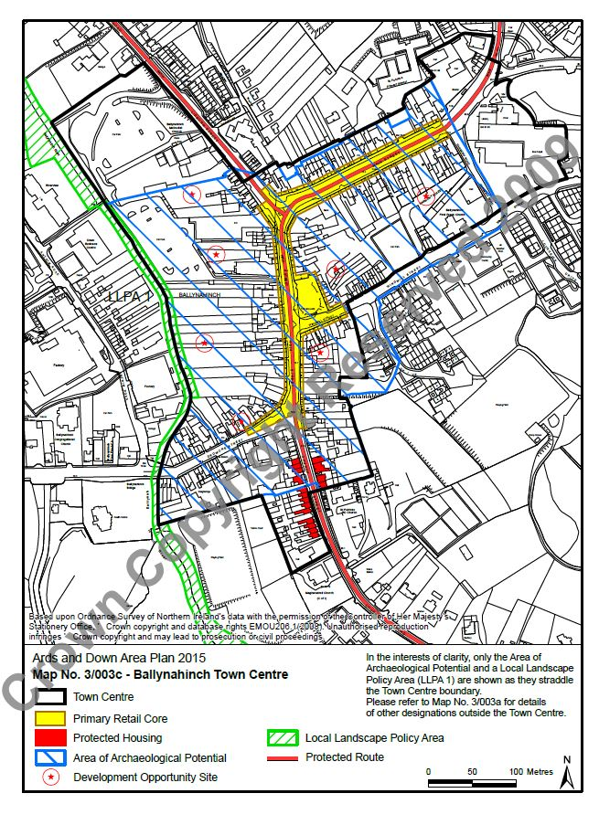

Part 4: Crossmaglen Town Centre & Opportunity Sites

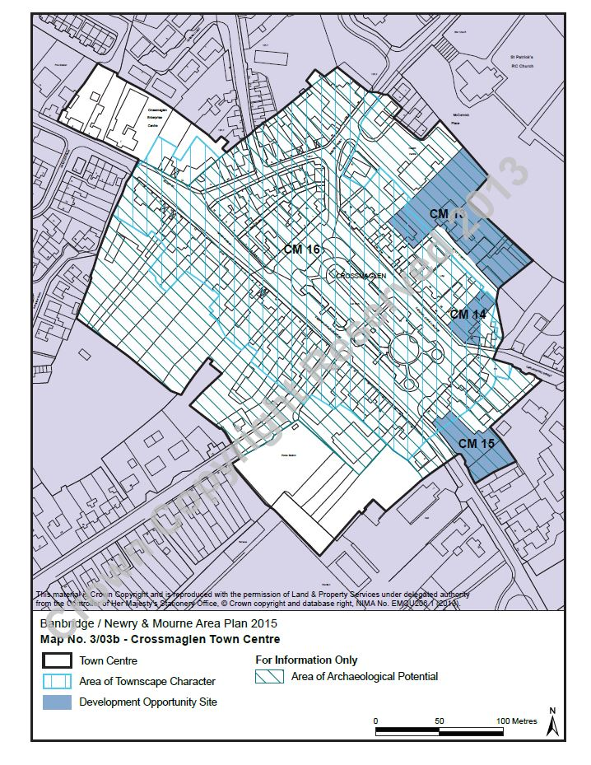

Part 5: Kilkeel Town Centre & Opportunity Sites
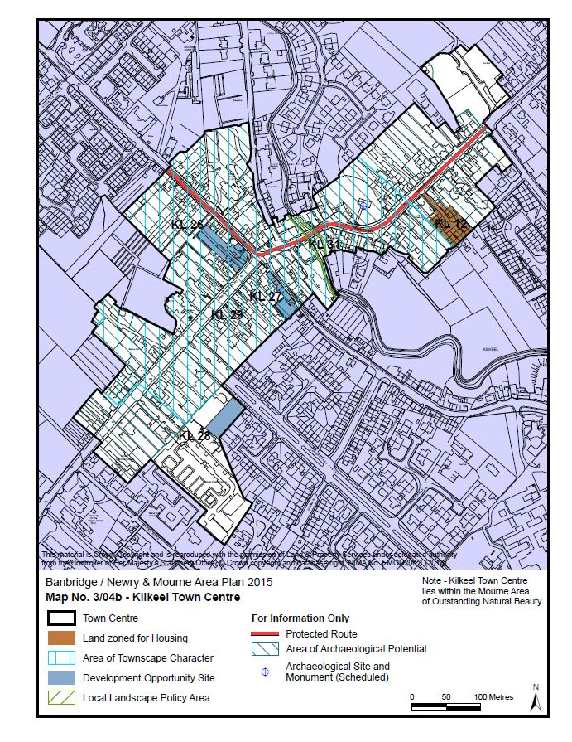

Part 6: Newcastle Town Centre & Opportunity Sites
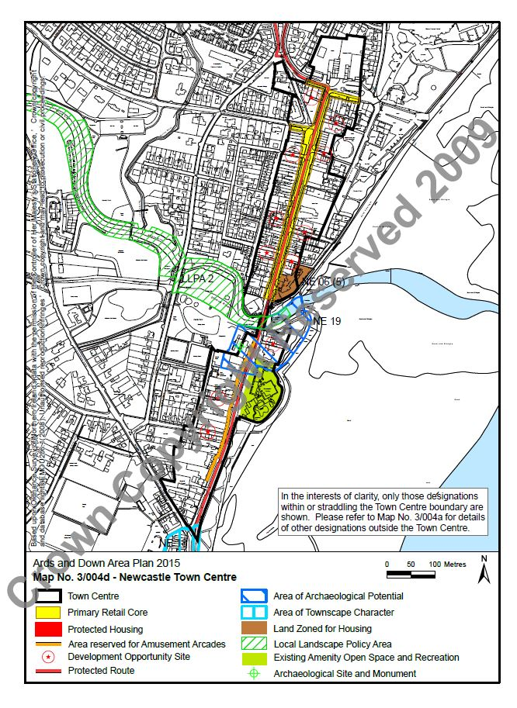

Part 7: Newtownhamilton Town Centre & Opportunity Sites
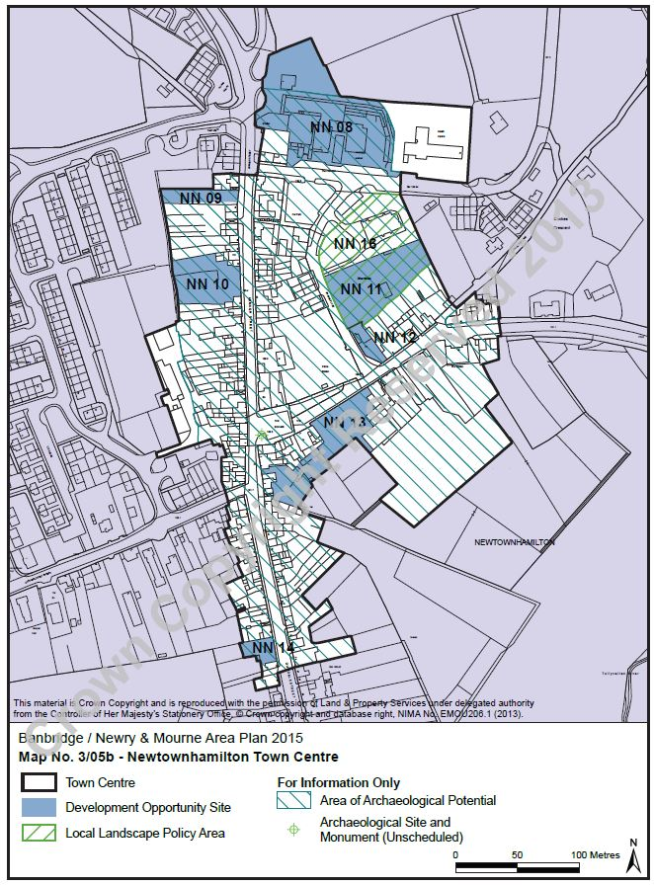

Part 8: Warrenpoint Town Centre & Opportunity Sites

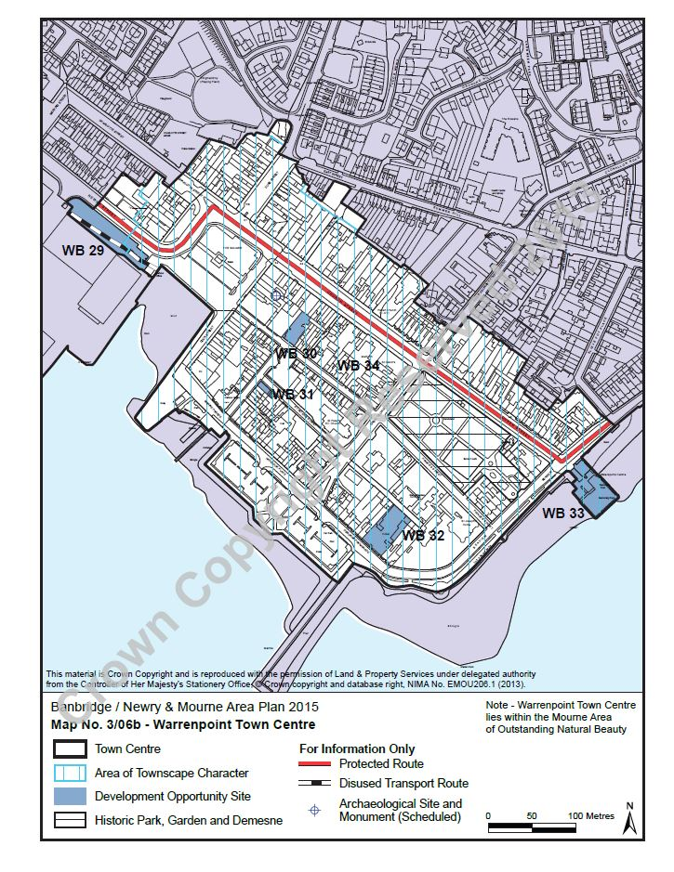

A consultancy consortium led by GL Hearn Limited was appointed in February 2013 by DOE Planning to carry out research into issues surrounding town centres and retailing in Northern Ireland.
Main and local towns which play a strategic role as centres of employment and services for both urban and rural communities.
Cities and towns which can work together to create a critical mass to attract economic development and deliver services.
Strategically important transport interchange points which connect ports and airports to the internal transport network.
Regional Development Strategy – Diagram No.22 , Hierarchy of settlements and Related Infrastructure Wheel
Published in July 2006 but never finalised. In April 2013 the Department announced that Draft PPS5 would not be taken forward instead a new fit for purpose retail policy would be included in the SPPS.
Experian Goad is a retail property intelligence system that provides retail location plans and reports covering over 3,000 shopping areas in the UK and Ireland.
DOE NI – GL Hearn Report, January 2014.
NI Commercial Property Report 2013 – Lisney
NISRA Census 2011 – Headcount and Household Estimates for Settlements Table
PAC Report published 26 March 2012, Paragraph 1.2.39
Ballynahich Masterplan Appendix 2 – Stage One Analysis Report.
Strategic Planning Policy Statement – Town Centres and Retailing, paragraph 6.274
In June 2013 Strategic Planning was commissioned by the Paul Hogarth Company on behalf of the Department for Social Development (DSD) to prepare a Retail Capacity Study for Ballynahinch.
In July 2011 DSD in partnership with Newry & Mourne and Down District Councils commissioned URS Scott Wilson to prepare a Masterplan for the South East Coast. A key component of this was the Retail Capacity Study prepared by sub consultants Roderick Maclean Associates Ltd.
Place Solutions were commissioned to undertake a Town Centre Health Check while Strategic Planning were commissioned to undertake a Retail Capacity Study.
SPPS Town Centres & Retailing Policy
PPS5 (Draft): Retailing, Town Centres and Commercial Leisure Developments

