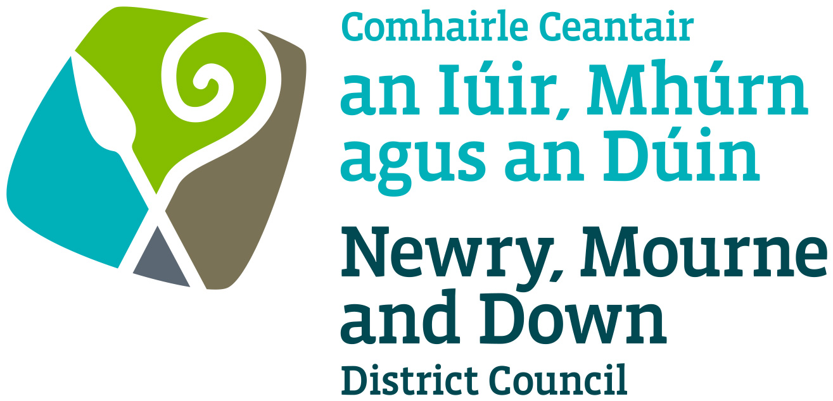

**Local Development Plan**

**Preparatory Studies**

**Paper 12 (Part 2): Countryside – Development Pressure Analysis**

**April 2017**

|  |  |
| --- | --- |
| **Contents** | **Page**  **Number** |
|  |  |
| **Figure Table** | **4** |
|  |  |
| **Purpose and Content** | **6** |
|  |  |
| **1.0 Introduction** | **7** |
|  |  |
| **2.0 Data Provision** | **7** |
|  |  |
| **3.0 Regional Planning Context** | **8** |
| 1. Regional Development Strategy 2035 | **8** |
| 1. Strategic Planning Policy Statement for Northern Ireland | **8** |
| 1. Planning Policy Statement 21: Sustainable Development in the Countryside | **9** |
| 1. Planning Policy Statement 18: Renewable Energy | **10** |
|  |  |
| **4.0 Existing Urban and Rural Housing Provision** | **11** |
|  |  |
| **5.0 Changes to rural policy impacting on trends within the open countryside** | **12** |
|  |  |
| **6.0 Development Pressure Analysis within the District Electoral Areas** | **18** |
|  |  |
| **7.0 Analysis of Wind Energy Development** | **22** |
|  |  |
| **8.0 Conclusions** | **25** |
|  |  |
| **Appendix 1 – Rural Pressure maps for each of the District Electoral Areas** | **27** |

**Figures and Tables Content**

**Figure 1:** Changes to rural planning policy within Northern Ireland

**Figure 2:** Total Number of decisions issued Annually within the rural Newry, Mourne & Down Area from 1st April 2002 – 1st September 2016

**Figure 3:** Total Number of Decisions issued monthly within the rural Newry, Mourne & Down Area from 1st April 2002 – 1st September 2016

**Figure 4:** Rural Pressure Analysis Overall map of the District post 2010

**Figure 5:** Total Number of Decisions issued for wind turbine applications from 2002 - 2014

**Figure 6:** Landscape Designations with Single Turbine and Wind Farm Applications (determined by 31.03.2015)

**Table 1:** Breakdown of Population in 2011 within Newry, Mourne & Down Settlement Hierarchy

**Table 2:** NINIS Update re Urban/Rural Split of Dwellings at 2009

**Table 3:** Planning Decisions for Single Dwellings in the Countryside (Full, Reserved Matters and Outline) in Newry, Mourne & Down District 2002-2016)

**Table 4:** Breakdown of dwellings in the countryside approved within each DEA from January 2002 to December 2009

**Table 5:** Breakdown of dwellings in the countryside approved within each DEA from January 2010 to September 2016

**Table 6:** Planning Decisions (Approvals & Refusals) for single wind turbines/wind farms in Newry, Mourne & Down District Council

**Appendices**

**Figure 7:** Rural Pressure Analysis DEA: Crotlieve

**Figure 8:** Rural Pressure Analysis DEA: Downpatrick

**Figure 9:** Rural Pressure Analysis DEA: Newry

**Figure 10:** Rural Pressure Analysis DEA: Rowallane

**Figure 11:** Rural Pressure Analysis DEA: Slieve Croob

**Figure 12:** Rural Pressure Analysis DEA: Slieve Gullion

**Figure 13:** Rural Pressure Analysis DEA: Mournes (to be forwarded from GIS)

**Development Pressure Analysis of Newry, Mourne & Down District Council**

**Purpose:** To provide members with a Development Pressure Analysis for the countryside of Newry, Mourne and Down District. Also known as a Rural Pressure Analysis, this analysis seeks to identify those areas where significant development pressure has occurred and/or where local rural character is under threat of significant change.

The paper provides information on:-

1. The Development Pressure Analysis for Newry Mourne & Down District,
2. Areas within the District where significant development pressure has occurred due to cumulative impact of one off single dwellings in the countryside and wind energy development, and
3. An analysis of the results of these finding in the context of environmental designations and the landscape character of the area.

**1.0 Introduction**

**1.1** The Development Pressure Analysis is one of the 4 strands of the Countryside Assessment[1]. Following on from the Landscape Character Assessment and along with the Environmental Assist Appraisal, and the on-going Settlement Appraisal exercise, it seeks to identify areas where significant development pressure has occurred and/or where local rural character is under threat of significant change. Analysis of this information involves assessing the distribution of single rural dwellings in the countryside. Given the high number of wind energy applications in recent years and their potential visual impacts on the countryside the remit of this report has been widened to include a consideration of wind energy development.

**1.2** This pressure analysis aims to identify areas that are particularly vulnerable and sensitive to further development and which may benefit from additional designations and a stronger rural policy approach. It is acknowledged that other types of development including large agricultural or industrial buildings can also create adverse visual impacts on the character of the countryside. In regard to these forms of development it is considered that sufficient control is currently provided within regional policies with the Local Development Plan also facilitating the opportunity to bring forward additional or amended policies to manage these forms of development.

**1.3** ‘The countryside’ as referred to in this paper is defined as the land outside designated settlement limits as identified in the Ards & Down Area Plan 2015 (ADAP) and the Banbridge/Newry & Mourne Area Plan 2015 (BNMAP).

**2.0 Data Provision**

**2.1** The data which has been used to inform the pressure analysis has been provided by the Department for Infrastructure (DfI). All residential planning applications in the Northern Ireland countryside with the exception of minor alterations and extension from April 2002 to September 2016 were identified and complied by DfI’s Analysis, Statistics & Research Branch. The relevant information has been extracted and the results have been used to produce a series of graphs and tables detailing the distribution trends over this period.

**2.2** Within this paper applications for single dwellings in the countryside have been plotted. Those on the same site are shown as one dot. The resultant information provides an indication of development pressure in the countryside (see Figure 4).

**3.0 Regional Policy Context**

**(a) Regional Development Strategy**

**3.1** The Regional Development Strategy (RDS) 2035 sets the context for the sustainable development of Northern Ireland to 2035 and acts as the spatial strategy of the Northern Irelands Executive’s Programme for Government. Within the RDS it encourages sustainable and balanced development in the countryside through the spatial framework.

**(b) Strategic Planning Policy Statement for Northern Ireland.**

**3.2** The Strategic Planning Policy Statement for Northern Ireland (SPPS) consolidated existing policy provisions, including provisions in relation to rural planning, into a shorter more concise statement of planning policy while placing sustainable development at the heart of the planning system. One of the keys aims of this document in relation to the countryside is to manage development in a manner which strikes a balance between protection of the built and natural environment from inappropriate development, while supporting and sustaining rural communities and adhering to the Northern Irelands Executives commitment to aid in protecting the regions biodiverstiy.

**3.3** The SPPS directs that policy approaches to new development in the countryside should reflect differences within the region, to be sensitive to local needs and be sensitive to environmental issues including the ability of settlements and landscapes to absorb development.

**3.4** To accomplish these objectives it will involve recognising areas that are both particularly sensitive to change and those areas which have lower sensitivities and therefore provide the required opportunities to accommodate sustainable development. All proposals for development in the countryside must be sited and designed to integrate sympathetically with their surroundings, including the natural topography, and to meet other planning policy and environmental considerations, including the policy approach to cluster, consolidate and group new development with existing established buildings, while therefore protecting the rural character of the area.

**3.5** In preparing Local Development Plans (LDPs) Councils are required to bring forward a strategy for sustainable development in the countryside, together with appropriate policies and proposals that must reflect the aims, objectives and policy approach of the SPPS, tailored to the specific circumstances of the plan area.

**3.6** As outlined above the SPPS states that the policy approach must be to cluster, consolidate and group new development with existing established buildings while also promoting the re-use of previously used buildings. While following this approach it should facilitate essential new development whilst mitigating against the potential adverse impacts on rural amenity and scenic landscapes arising from the cumulative effect of one-off, sporadic development.

**3.7** Other policies which are detailed in the SPPS and are relevant to the protection of the countryside require development integrating into the landscape, respecting the rural character as well as not marring the distinction between settlements and the surrounding countryside.

**3.8** The SPPS also acknowledges that some areas of the countryside exhibit exceptional landscapes such as mountains, lough shores and stretches of coast wherein the quality of the landscape and unique amenity value is such that development should only be permitted in exceptional circumstances. Within this District the three areas listed below have been designated as Special Countryside Area’s within the current BNMAP 2015.

* + - * Mournes Special Countryside Area;
      * Ring of Gullion Special Countryside Area; and
      * Slieve Croob Special Countryside Area.[2]

**3.9** As part of this process a further analysis will therefore be undertaken to assess whether this additional level of protection has aided in limiting sporadic unnecessary and inappropriate development as well as investigating whether other sections of the District would benefit from this additional level of control.

**3.10** A further aim of the SPPS is to facilitate the siting of renewable energy developments in appropriate locations without compromising environmental assets or valuable landscapes while working towards achieving the renewable energy targets set out by Government.

**3.11** The SPPS advises that particular care should be taken when considering the potential impact of all renewable proposals on the landscape. It advises that a cautious approach should be taken for such projects within designated landscapes which are of significant value such as the Districts 3 Areas of Outstanding Natural Beauty (AONB) Ring of Guillion AONB, Mourne AONB and Strangford and Lecale AONB. It is acknowledged that it can be difficult to accommodate renewable energy proposals such as wind turbines without having an impact on the regions cultural and natural heritage. Due to a significant increase in the number of wind energy applications within the District in recent years and the significant visual impact they can have on the landscape, both individually and cumulatively an assessment of their impact has been included within the remit of this paper.

**(c) Planning Policy Statement 21: Sustainable Development in the Countryside (PPS21)**

**3.12** PPS21 sets out policies for managing development in the countryside with one of its key themes being to conserve the landscape and natural resources of the rural area, to protect it from excessive, inappropriate or obtrusive development and from the actual or potential effects of pollution. PPS21 also outlines the four interrelated strands of the Countryside Assessment which includes the Development Pressure Analysis.

**(d) Planning Policy Statement 18: Renewable Energy (PPS18)**

**3.13** The aim of PPS18 is to facilitate the siting of renewable energy generating facilities in appropriate locations within the built and natural environment in order to achieve Northern Ireland’s renewable energy targets and to realise the benefits of renewable energy.

The objectives of the Statement are:

- to ensure that the environmental, landscape, visual and amenity impacts associated with or arising from renewable energy development are adequately addressed;

* to ensure adequate protection of the Region’s built, natural, and cultural heritage features; and
* to facilitate the integration of renewable energy technology into the design, siting and layout of new development and promote greater application of the principles of Passive Solar Design.

**4.0 Existing Urban and Rural Housing Provision**

Prior to examining the information relating to the rural pressure analysis, the context of the distribution of urban and rural population as presented within Paper 1: (2nd Revision) Populations & Growth - Settlement Hierarchy has been summarised below.

**4.1** The population of Newry, Mourne and Down District in 2011 census was 171,533 rising to 175,403 in the NISRA mid-year estimates published in June 2015. Based on census information approximately 16% of the household population of the District are living within the existing development limit of Newry city. 24% of the Districts population reside within the 7 existing towns as designated in the 2 existing Development Plans.

**4.2** 20% of the population live within the 28 villages as designated within the existing Development Plans while 5% of the population live within the remaining 52 small settlements. This leaves approximately 35% of the population or 59,317 people currently living within the open countryside.

**Table 1: Breakdown of Population in 2011 within Newry, Mourne & Down Settlement Hierarchy**

|  |  |  |  |  |  |
| --- | --- | --- | --- | --- | --- |
|  | **City** | **Towns** | **Villages** | **Small Settlements** | **Open Countryside** |
| **Population of settlements** | 26,893 | 41,982 | 34,573 | 8,768 | 59,317 |
| **Total % of Population** | 15.68 | 24.48 | 20.15 | 5.15 | 34.57 |

Source: Headcount and Household Estimates for Settlements in Northern Ireland published 26/03/2015 http://www.nisra.gov.uk/census/2011/results/settlements.html

**5.0 Changes to rural policy impacting on trends within the open countryside**

During the period April 2002 to September 2016 for which this analysis has been carried out proposals for rural dwellings have been influenced by a number of planning policies which are detailed in Figure 1 below.

**Figure 1: Changes to rural planning policy**

A Planning Strategy for Rural Northern Ireland

(September 1993)

RDS 2025: Shaping our Future

(September 2001)

Joint Ministerial Statement on Development Plans & Implementation of the RDS

(Jan 2005)

Draft Planning Policy Statement 14

Sustainable Development in the Countryside

(March 2006)

Draft Planning Policy Statement 14

Sustainable Development in the Countryside

(Revised October 2007)

Draft Planning Policy Statement 21 – Sustainable Development in the Countryside

(November 2008)

Ards & Down Area Plan (Adopted March 2009)

Planning Policy Statement 21 – Sustainable Development in the Countryside

(June 2010)

RDS 2035: Building a Better

Future (March 2012) Banbridge, Newry &

Mourne Area Plan

(Adopted Oct 2013)

Strategic Planning Policy Statement

(September 2015)

**5.1** Figures 2 and 3 together with Table 3 provide a summary of all rural single dwelling decisions (Outline, Full and Reserved Matters) issued between April 2002 and September 2016. The analysis shows that a total of 14,005 applications for rural dwellings have been processed in the District from 2002. Within the period April 2010 to September 2016 a total of 4619 outline, full and reserved matters applications for single rural dwellings were decided with 77% approved, 17% refused and 6% withdrawn.

**5.2** Figure 3 clearly shows that after the publication of draft Planning Policy Statement 14 (dPPS14), the adoption of the ADAP 2015 and the publication of PPS21 there was identifiable peaks in the number of decisions issued due to the additional clarity these documents gave.

**5.3** It can also be seen from Figure 2 that since March 2006 there has been a general downwards trend in the volume of applications made for single rural dwellings within the District. This can again be highlighted by comparing two four year periods between 2002 and 2016. Within the 4 year period 2003-2007 an average of 2013 applications were decided per year while from 2011-2015 the average figure dropped to 652 applications per year. To put this into further context the average number of applications decided in one year between 2003-2007 (2013) is more than the total number of applications processed to approval or refusal between the years 2012 and 2015 which was 1728.

**5.4** The number of planning applications issued peaked in 2005-2006 with a total of 2490 processed to either an approval (1346) or refusal (1144) with an additional 334 withdrawn before a decision was reached. As Figure 2 indicates this coincides with the Joint Ministerial Statement being released in January 2005. This statement gave clarity on the weight which should be afforded to policies and proposals within draft plans. In doing so the Statement expanded on the circumstances when it was considered appropriate to refuse planning permission on the grounds of prematurity. The statement also indicated that the weight to be attached to policies in the emerging plans should depend upon the stage of plan preparation and therefore as the publication of the adopted ADAP 2015 became imminent the numbers of decisions issued as refusals dropped awaiting clarity on rural policies. As the graph indicates following on from the adoption of this Plan the number of refusals issued within the District began to rise steadily over the subsequent 14 to 18 months as additional clarity had now been implemented.

**5.5** Following the publication of dPPS14 in March 2006 and its re-issuing in 2007 Figure 2 shows a significant drop in the total number of applications being dealt with by the DOE. In the preceding year April 2005 to March 2006, 2824 applications were issued (2490) or withdrawn (334), while within the following 12 month period this figure dropped by almost 1000 applications to 1794 with 1703 being issued and 91 withdrawn. A number of different reasons may give some indication as to why there was such a significant downtown in the numbers of planning applications around this time. These may have included agents and applicants allowing the policy to become embedded and to analyse how individual policies were interpreted together with the economic recession which began mid to late 2007.

**5.6** The high number of applications processed between 2003 and 2008 are reflective of the economic conditions that during this period.

**Table 3: Planning Decisions for Single Dwellings in the Countryside (Full, Reserved Matters and Outline) in Newry, Mourne & Down District 2002-2016)**

|  |  |  |  |  |
| --- | --- | --- | --- | --- |
| **Year** | **Approvals (%)** | **Refusal (%)** | **Withdrawals (%)** | **Total** |
| 2002-2003 | 1444 (75.4) | 171 (8.9) | 300 (15.6) | 1915 |
| 2003-2004 | 1606 (74.6) | 281 (13.0) | 263 (12.2) | 2150 |
| 2004-2005 | 1464 (63.8) | 511 (22.2) | 319 (13.9) | 2294 |
| 2005-2006 | 1346 (47.6) | 1144 (40.5) | 334 (118.) | 2824 |
| 2006-2007 | 1021 (56.9) | 682 (38.0) | 91 (5.0) | 1794 |
| 2007-2008 | 1321 (79.4) | 258 (15.5) | 83 (4.9) | 1662 |
| 2008-2009 | 1164 (95.0) | 22 (1.7) | 39 (3.1) | 1225 |
| 2009-2010 | 1069 (86.1) | 95 (7.6) | 77(6.2) | 1241 |
| 2010-2011 | 701 (68.5) | 223 (21.7) | 99 (9.6) | 1023 |
| 2011-2012 | 711 (76.3) | 172 (18.4) | 48 (5.1) | 931 |
| 2012-2013 | 599 (78.1) | 136 (17.7) | 31(4.0) | 766 |
| 2013-2014 | 445 (83.6) | 56 (10.5) | 31 (5.8) | 532 |
| 2014-2015 | 423 (81.3) | 69 (13.2) | 28 (5.3) | 520 |
| 2015-2016 | 309 (80.2) | 61 (15.8) | 15 (3.8) | 385 |
| 2016-2017 | 382 (82.6) | 51 (11.0) | 29 (6.2) | 462 |
| **Total** | **14,005 (71.0)** | **3,932 (19.9)** | **1,787 (9.0%)** | **19,724** |

**5.7** Table 3 indicates that in the years 2008-2009 and 2009-2010 only 22 and 95 applications were issued as refusals. These low figures can be explained by the number of applications that were being held awaiting the publication of the final version of PPS21. (Published in June 2010).

**5.8** Table 3 also shows that the number of decisions have declined almost steadily year on year from 2007-2008 with 1579 applications being issued until 2015-2016 when only 370 decisions were issued for one off dwellings. Within this period a notable dip in the number of approvals is evident from 2009-2010 to 2010-2011. This coincides with the publication of PPS21 in June 2010 which replaced dPPS21. The publication of PPS21 brought about a higher level of confidence to rural planning policy following a long drawn out period of uncertainty.

**5.9** Under PPS21 it is clearly evident that the rate of rural housing approvals is notably reduced when compared to approvals under historical rural planning policies. Within the first 3 years of assessing applications under PPS21 (2010 -2013) when compared to the following 3 year period (2013-2016) the average number of applications issued or withdrawn dropped significantly from 906 to 479.

**5.10** Within PPS21 provision is made for a range of types of development which in principle are considered to be acceptable in the countryside while contributing to the aims of sustainable development. Planning permission may therefore be granted for various types of individual dwellings including replacement dwellings, personal circumstances and farm dwellings etc.

**5.11** The introduction of PPS21 sought to strike a balance between the need to protect the environment while sustaining a strong and vibrant rural community. Within PPS21 provision has been made to provide a range of different categories of residential development. The statistics made available by Dfi’s Analysis, Statistics & Research Branch have therefore enabled some arbitrary analytical work to be carried out on the types and classifications of applications which have been submitted within the rural portion of the District. It appears evident that the most popular application type in the countryside from the implementation of PPS21 has been for replacement dwellings which equates to approximately 36% of all approvals issued from June 2010 followed by farm dwellings at 33%. These 2 application types appear to be the most predominant classifications however it must be taken into consideration that the way in which the applications are described can impact on the accuracy of these findings as a large percentage of applications are simply described as ‘dwelling in the countryside’ and can therefore manipulate the statistics. Other popular application types were found to be change of house type and substitution applications which count for approximately 15% of all applications.



Figure 3: Total Number of Decisions issued monthly within the rural Newry, Mourne & Down Area from 1st April 2002 – 1st September 2016

**6.0 Development Pressure Analysis within the District Electoral Areas**

**6.1** All rural single dwellings in the countryside applications i.e. approvals, refusals, withdrawals of Outline, Full and Reserved Matters applications have been identified through DfI statistics and plotted as a series of dot maps for the 7 District Electoral Areas (DEA’s) which can be seen in Appendix 1. Applications which fall on the same site will show as one dot only at the scale displayed. To illustrate the impact of different policies from 2002 all applications refused have been shown as red dots, withdrawn applications as green dots, approvals prior to 2010 have been shown indicated in blue while all approvals following this date have been shown in yellow. Figure 4 is a district wide map identifying all approved single dwellings in the countryside since the implementation of PPS21 in 2010.

**6.2** The statistics have been cleansed to ensure decisions issued in relation to household extensions have been removed and are not included in this analysis.

**Table 4 Breakdown of dwellings in the countryside approved within each DEA from Jan 2002 to December 2009**

|  |  |  |  |  |  |  |  |  |  |
| --- | --- | --- | --- | --- | --- | --- | --- | --- | --- |
| **DEA** | **2002-03** | **2003-04** | **2004-05** | **2005-06** | **2006-07** | **2007-08** | **2008-09** | **2009-10** | **Totals** |
| **Crotlieve** | 263 | 322 | 255 | 276 | 189 | 279 | 266 | 230 | **2080** |
| **Downpatrick** | 113 | 119 | 108 | 98 | 87 | 70 | 58 | 78 | **731** |
| **Newry** | 74 | 56 | 62 | 51 | 63 | 67 | 54 | 57 | **484** |
| **Rowallane** | 64 | 79 | 54 | 75 | 60 | 35 | 49 | 88 | **504** |
| **Slieve Croob** | 308 | 344 | 267 | 218 | 245 | 193 | 183 | 175 | **1933** |
| **Slieve Gullion** | 416 | 434 | 497 | 407 | 240 | 445 | 324 | 243 | **3006** |
| **The Mournes** | 206 | 252 | 221 | 221 | 136 | 232 | 231 | 198 | **1697** |
| **Totals** | **1444** | **1606** | **1464** | **1346** | **1020** | **1321** | **1165** | **1069** | **10435** |

**Table 5 Breakdown of dwellings in the countryside approved within each DEA from January 2010 to September 2016**

|  |  |  |  |  |  |  |  |  |
| --- | --- | --- | --- | --- | --- | --- | --- | --- |
| **DEA** | **2010-11** | **2011-12** | **2012-13** | **2013-14** | **2014-15** | **2015-16** | **2016-17** | **TOTALS** |
| **Crotlieve** | 156 | 139 | 122 | 85 | 83 | 63 | 76 | **724** |
| **Downpatrick** | 40 | 47 | 45 | 37 | 36 | 25 | 18 | **248** |
| **Newry** | 33 | 41 | 29 | 25 | 30 | 13 | 17 | **188** |
| **Rowallane** | 49 | 55 | 63 | 61 | 49 | 48 | 39 | **364** |
| **Slieve Croob** | 116 | 105 | 85 | 79 | 55 | 49 | 66 | **555** |
| **Slieve Gullion** | 175 | 203 | 142 | 77 | 93 | 59 | 78 | **827** |
| **The Mournes** | 132 | 121 | 113 | 81 | 77 | 52 | 88 | **664** |
| **Totals** | **701** | **711** | **599** | **445** | **423** | **309** | **382** | **3570** |

**6.3** On analysing Tables 4 and 5 it appears evident that from 2002, the start of the review period, the highest percentage of rural dwellings have been located within the Slieve Gullion DEA followed by Crotlieve DEA. It is also apparent that from the implementation of PPS21 there has been a downwards trend in the number of rural dwelling applications within the District as a whole however Slieve Gullion still represents 23% of the total number of planning applications followed closely by Crotlieve with 20%.

**6.4** Within the Slieve Gullion DEA a higher number of dwellings appear to be located within the central and southern sections of the DEA. This area accommodates a high number of small settlements and villages along with the town of Crossmaglen. High volumes of single dwellings are concentrated around these settlements and the inter-connecting road network. Within this DEA the area which contains the Slieve Guillion AONB also appears to have a greater concentration of rural dwellings approved than the lands to the north.

**6.5** Crotlieve DEA has remained the 2nd busiest electoral area within the District over the reporting period for rural dwellings approvals. Within 2002 to 2009, 2080 applications were approved within the area while from 2010 to September 2016, 724 applications were approved. Although this marks a substantial reduction (1356) in approvals it can be seen that approximately 20% of the Districts total rural dwellings have been located consistently within this DEA from 2002. Within the DEA there appears to be a concentration of approvals through the middle section of the area, stretching across the Derrylecky and Hilltown wards with another notable cluster in the northern portion of the Mayobridge ward. The southern portion of the DEA remains the least developed which corresponds with a both a section of the Mourne AONB.

**6.6** The 3rd most popular DEA for rural dwellings is The Mournes which accounts for 19%. As the overall map and the individual DEA map indicate development within this DEA is separated by the high Mournes with significant pressure being seen along both the coastal section of this DEA and the Mourne foothills to the north despite the added protection of being located within an AONB.

**6.7** Slieve Croob DEA has seen a downwards trend in the number of rural dwelling applications being issued as approvals. Within the period 2002 to the end of 2009, 1933 applications were approved within the Slieve Croob DEA equating to approximately 29% of the Districts rural approvals with this figure reducing to 555 approvals or 16% since 2010 which makes it the 4th busiest DEA in terms of rural approvals.

**6.8** Within Tables 4 & 5 it can be seen that Newry DEA has consistently had the lowest number of approvals which continues to move in a downwards trend. These tables indicate that Newry DEA equated to just under 5% of the rural dwelling approval between 2002 and 2009 having 484 rural dwelling approvals while during the period 2010 to September 2016 only 188 rural dwellings have been approved. Even when factoring in these lower approval ratings there does appear to be a clustering of dwellings approved to the south of Newry (Figure 4). These lower approval ratings within this DEA are as a consequence of a significant portion of this DEA incorporating the settlement of Newry and the smaller overall area of this DEA in comparison to the other 6 DEAs within the District.

**6.9** Downpatrick DEA has experienced a sizeable reduction in the number of applications from 2002 to the present day. Within the period 2002 to 2009 this DEA approved 731 rural dwelling applications while from 2010 and the introduction PPS21 the numbers dropped to 248. As with the Newry DEA part of the reasoning for this centres around the fact that a large portion of this DEA is located within an urban setting and the overall scale of this DEA in comparison to all others within the District alongside the more rigorous policy tests applied and detailed within PPS21. This reduction in applications numbers has moved this DEA from 5th in terms of rural approvals to 6th within the District.

**6.10** With regards to the Rowallane DEA although the number of rural dwelling applications has fallen from 504 to 354 within the reporting period the overall percentage of applications within this DEA has increased from just under 5% of the Districts total in 2002 – 2009 to 10% in 2010 – 2016 which has subsequently moved Rowallane DEA from 6th to 5th within the District.

**Figure 4 – Rural Pressure Analysis Overall map of the District**

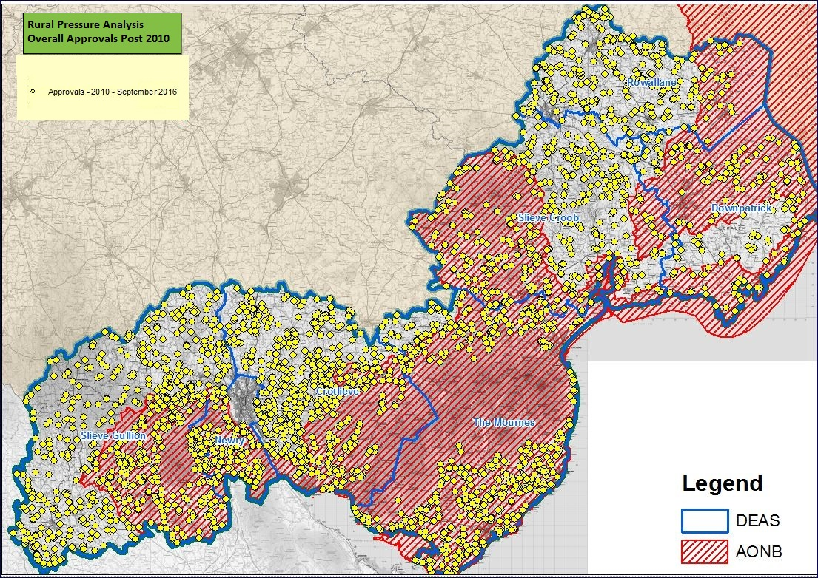

**7.0 Analysis of Wind Energy Development**

**7.1** Increasing the use of renewable energies was detailed as an objective within the Regional Development Strategy (RDS) for Northern Ireland 2035. The RDS refers to the Strategic Energy Framework for Northern Ireland (DETI 2010) which sets targets of 40% electricity consumption from renewable sources as well as achieving 10% penetration of renewable heat by 2020.

**7.2** NISRA indicated the number of planning decisions for single wind turbines and wind farm applications issued from 2002 to 2014.

**7.3** Prior to the publication of PPS18 Renewable Energy and the best practice guide entitled ‘Wind Energy Development in Northern Irelands Landscapes’, applications for wind energy development were primarily assessed under the Planning Strategy for Rural Northern Ireland and in-particular Policy PSU 12. However, following a change in direction in all Government policy as outlined above a more permissive renewable energy policy was introduced through PPS18. This together with a number of government subsidy schemes which were being rolled out explains the sharp increase in applications and approvals for wind energy development. It was therefore apparent that increasing numbers of renewable energy applications would be submitted, but that their approval would only be granted where they were appropriately sited to ensure they have a minimal impact on the surrounding environment.

**7.4** Table 6 shows all decided wind turbine applications from 2002 to 2014. All decisions have been identified and plotted as a ‘dot map’ (Figure 6) with applications which fall on the same site been shown as one dot. The accompanying graph (Figure 5) indicates a sharp increase in both the number of wind turbine applications and the approval rating since the introduction of PPS 18. Decisions reached a peak in 2008 with 90 wind turbine applications being issued with 90% of these being approved. In the following years the number of proposals fluctuated but the approval ratings remained high at approximately 74% between 2009 and 2013. These percentages are however not unexpected considering the Government’s aim to meet the European targets through the promotion of renewable energy.

**7.5** As outlined in Paper 9: Public Utilities and Paper 12 (Part 1): Countryside Landscape Character Assessment consideration must be given as to whether specific areas within the District should be zoned specifically for turbine development which would help to eradicate the piecemeal development which is currently found in some sections of the District. A more detailed analysis of the location and numbers of wind turbine application has been provided within Paper 12 (Part 1) but the following graph, table and map give an indication into the numbers of applications submitted and the areas in which they are concentrated.

**Figure 5: Planning Applications for wind energy development in Newry, Mourne & Down 2002 - 20015**

**Table 6: Planning Decisions (Approvals & Refusals) for single wind turbines/wind farms in Newry, Mourne & Down District Council**

|  |  |  |  |
| --- | --- | --- | --- |
| **Year** | **Approvals** | **Refusals** | **Totals** |
| 2002 | 2 | 0 | 2 |
| 2003 | 2 | 0 | 2 |
| 2004 | 4 | 0 | 4 |
| 2005 | 5 | 0 | 5 |
| 2006 | 33 | 0 | 33 |
| 2007 | 49 | 4 | 53 |
| 2008 | 55 | 10 | 65 |
| 2009 | 15 | 4 | 19 |
| 2010 | 34 | 15 | 49 |
| 2011 | 47 | 11 | 58 |
| 2012 | 33 | 10 | 43 |
| 2013 | 19 | 10 | 29 |
| 2014 | 7 | 3 | 10 |
| **Totals** | **305** | **67** | **372** |

Planning Applications for wind energy development in Newry, Mourne & Down 2002 - 2014

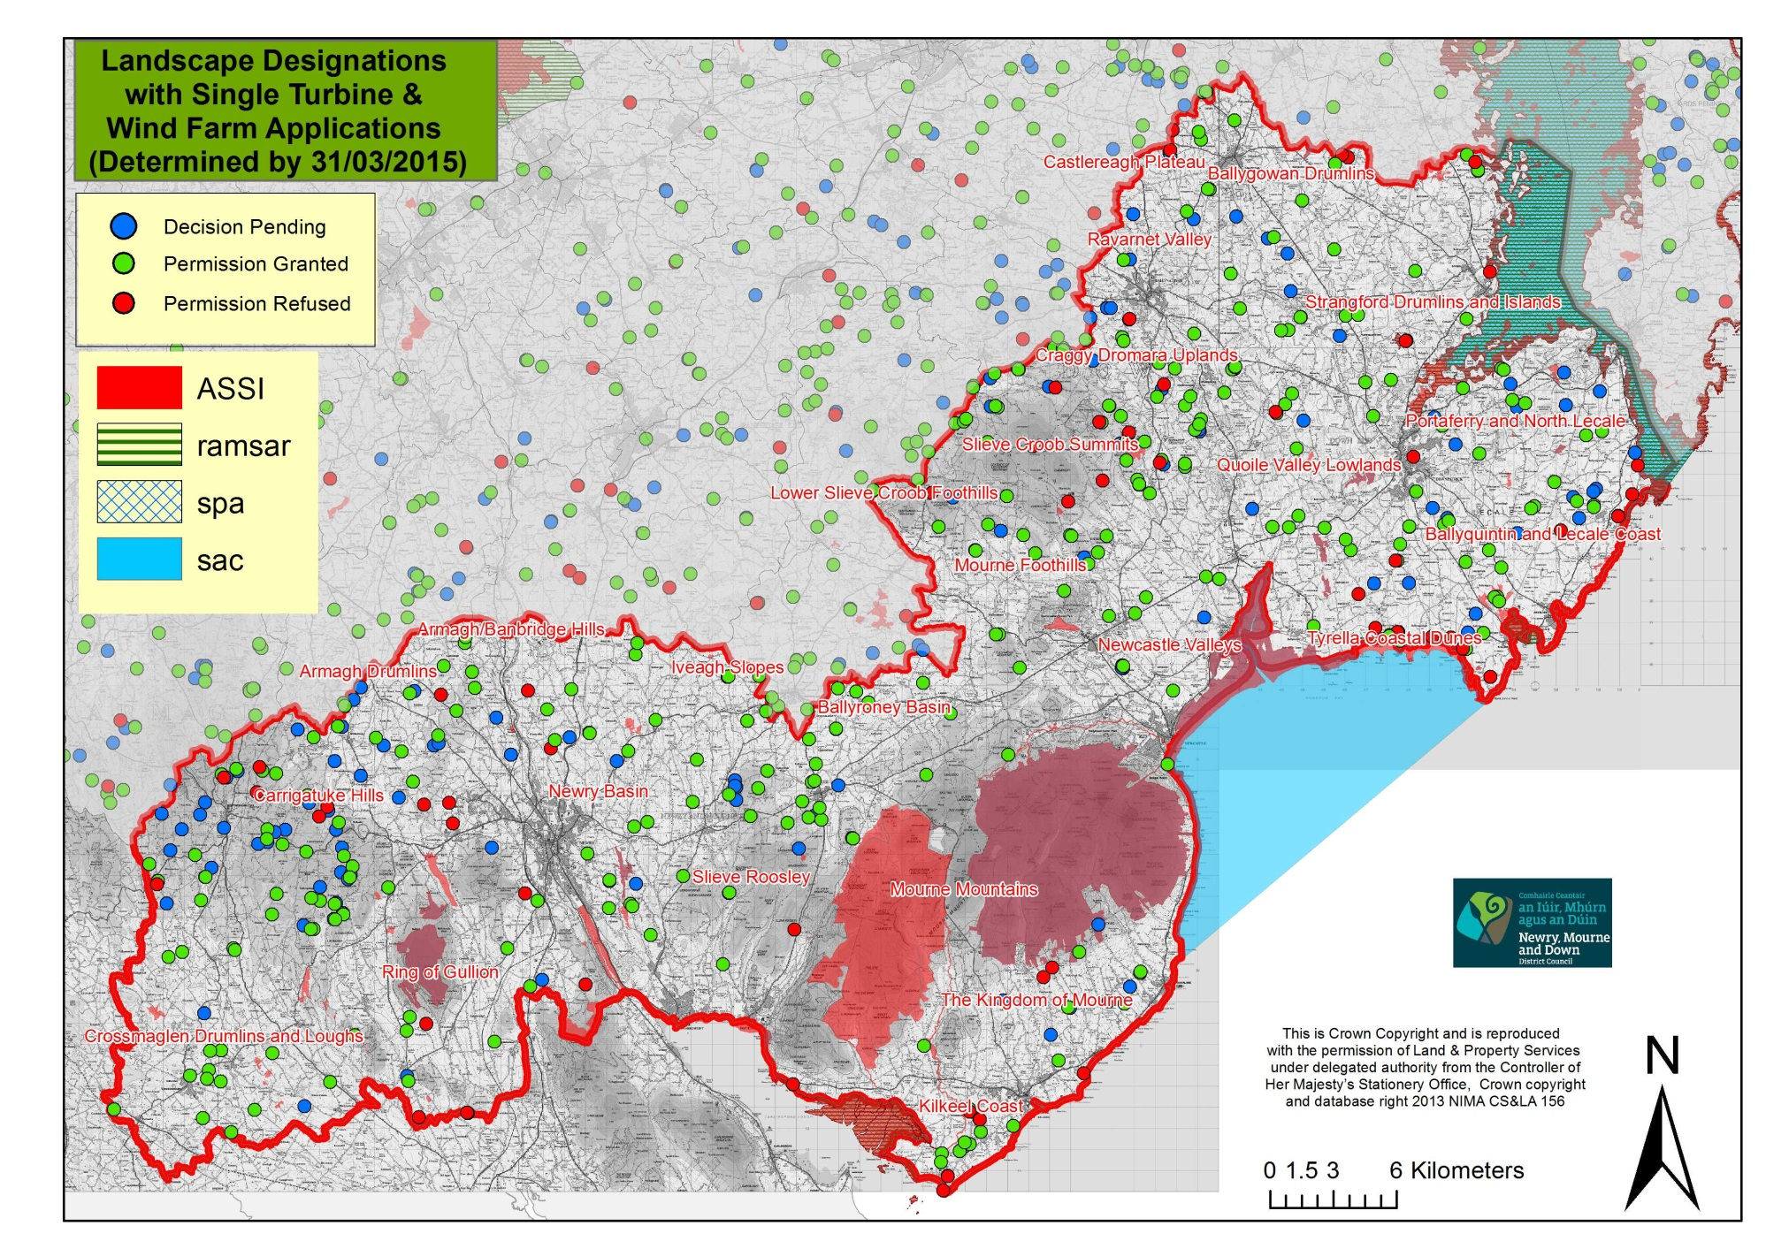

**Figure 6**

**8.0 Conclusions**

**8.1** It is evident that from the available statistics that the rate of rural housing approvals under PPS21 is notably reduced when compared to approvals under historical rural planning policies albeit with some areas of the District experiencing additional pressures to others. When assessing these figures it must also be taken into consideration the role that the economic recession resulted in a downturn in the number of applications submitted to the DOE.

**8.2** In formulating any new or revised policies, the new LDP must therefore reflect the differences in the landscape across the District to enable future development, allow rural communities to remain sustainable, offer protection to our valued landscapes. Policies within the LDP must also be consistent with both the RDS and SPPS in relation to providing the majority of all development towards our city, towns, villages and small settlements to ensure that the LDP is found to be ‘sound’ at the Public Examination.

**8.3** One of the key aims of the new LDP will therefore be to balance development while protecting the Districts most vulnerable landscapes. It is evident from the analysis carried out within this paper that with regard to one off houses in the countryside there is evidence that there is substantial pressure across lands sections of the District. This suggests that both PPS18 and PPS21 have not been wholly effective in maintaining and protecting the rural character of the District.

**8.4** As the analysis and statistics suggest there are areas within the District that are under more pressure than others. Figure 4 shows pockets of additional pressure in the southern section of The Mournes DEA, the rural southern section of the Newry DEA and the western section and south eastern portion of the Crotlieve DEA. It should also be noted that all other DEAs have areas of concentrated development which generally appear to correspond with the road networks within these areas. Given that certain areas within the District have sensitive and scenic landscapes which contains a high number of environmental designations it may therefore be appropriate to introduce additional protection in certain localities.

**8.5** It is also accepted that the cumulative impact of one off dwellings within other sections of the Districts landscape may have been offset by its greater capacity to absorb higher levels of development. This higher level of pressure reflects the strong vibrant rural community that exists in this District. This will be further considered as part of the LDP process.

**8.6** Whilst the number of decision relating to renewal energy projects have increased over recent years there has been a general downward trend in the number of wind energy applications being received. The reduction in this type of planning application may be linked to factors outside the remit of planning and in-particular the uncertainties regarding obtaining connections to the network infrastructure, operating incentives and the costs related to installing the appropriate technology.

**8.7** The process of planning and local government reform has provided an opportunity for a stronger local dimension to rural planning policy. The new LDP process has afforded Councils the responsibility of bringing forward bespoke policies that are more finely tailored to local circumstances in their area, in line with prevailing regional planning policy. This includes, managing growth to achieve sustainable development that meets the essential needs of a vibrant rural community, and facilitating the development necessary to achieve a sustainable rural economy.

**8.8** This paper will be taken into account in the consideration of strategy options and the formulation of countryside policies within the LDP.

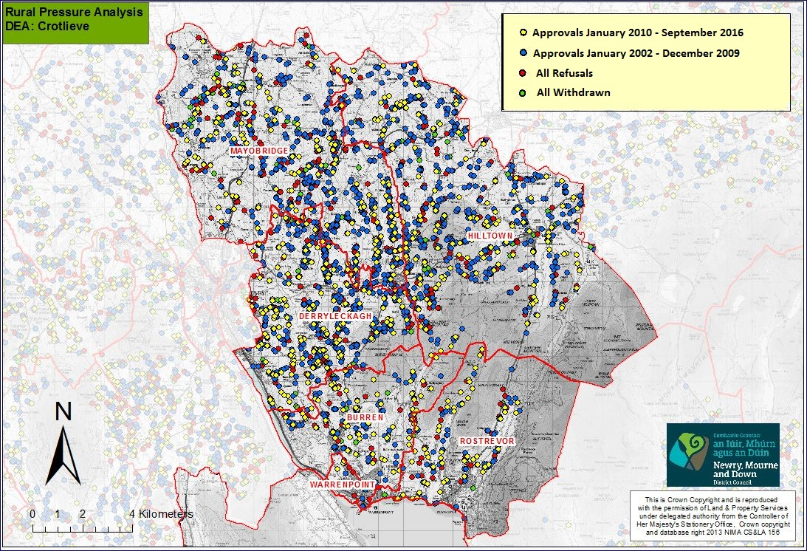

**Figure 7**

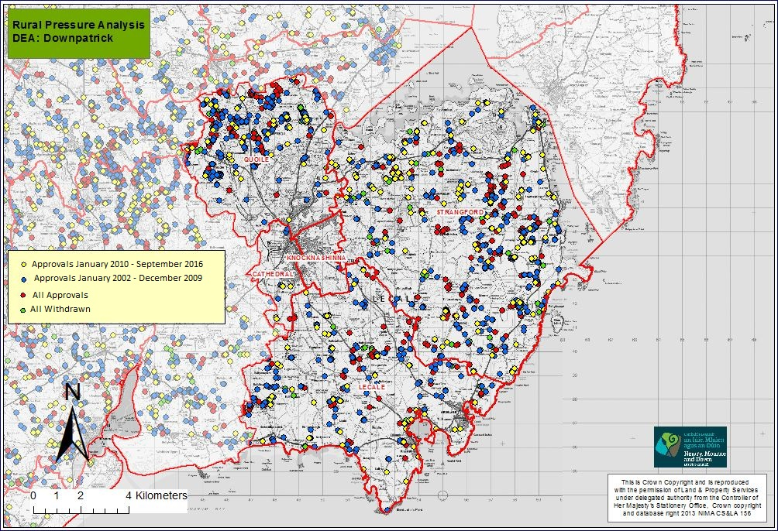

**Figure 8**

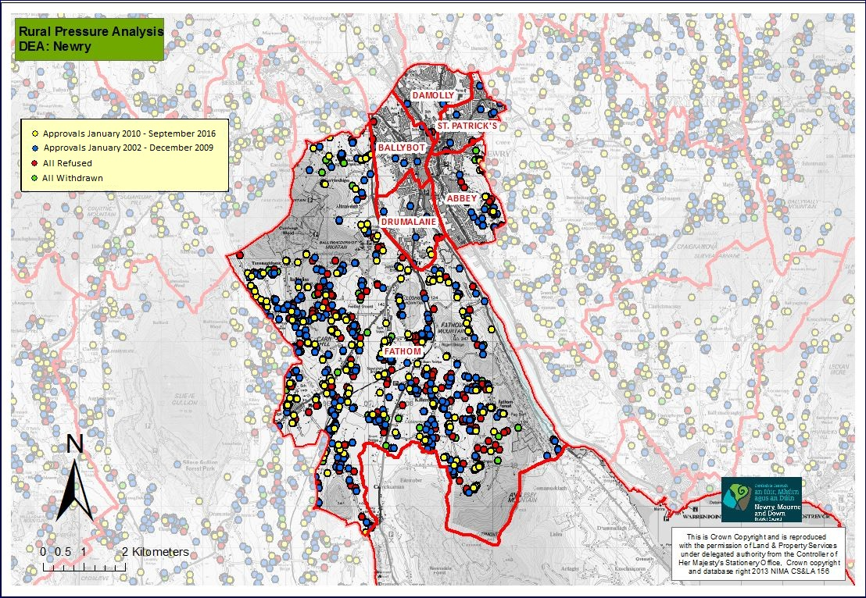

**Figure 9**

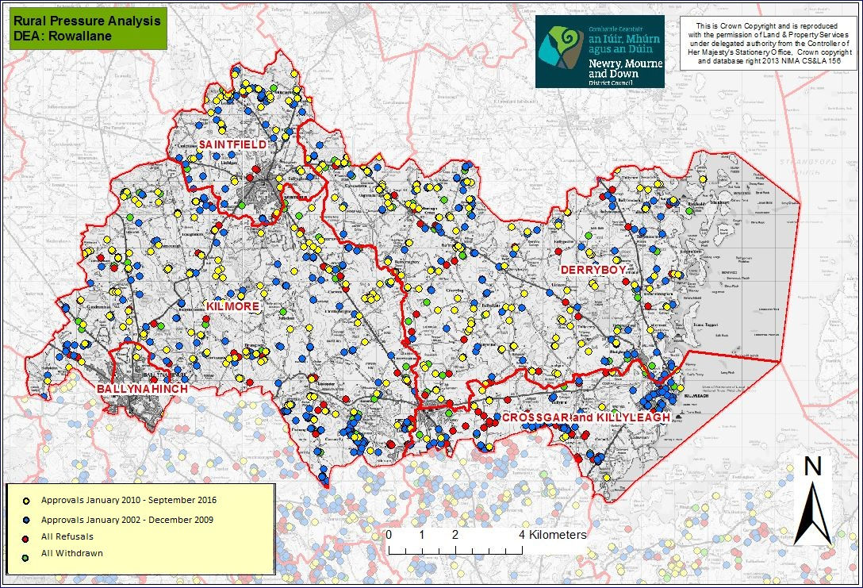

**Figure 10**

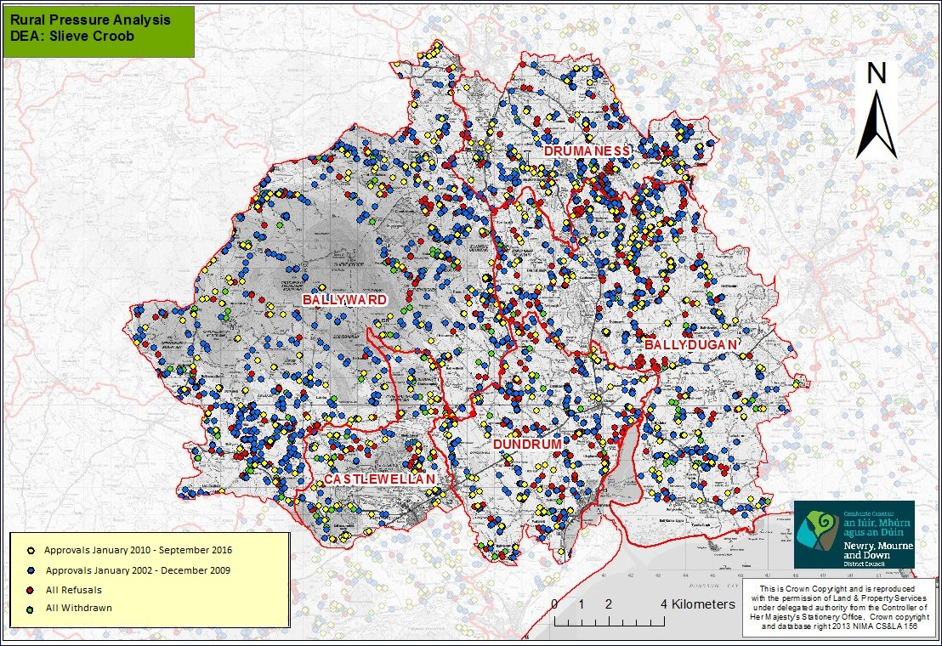

**Figure 11**

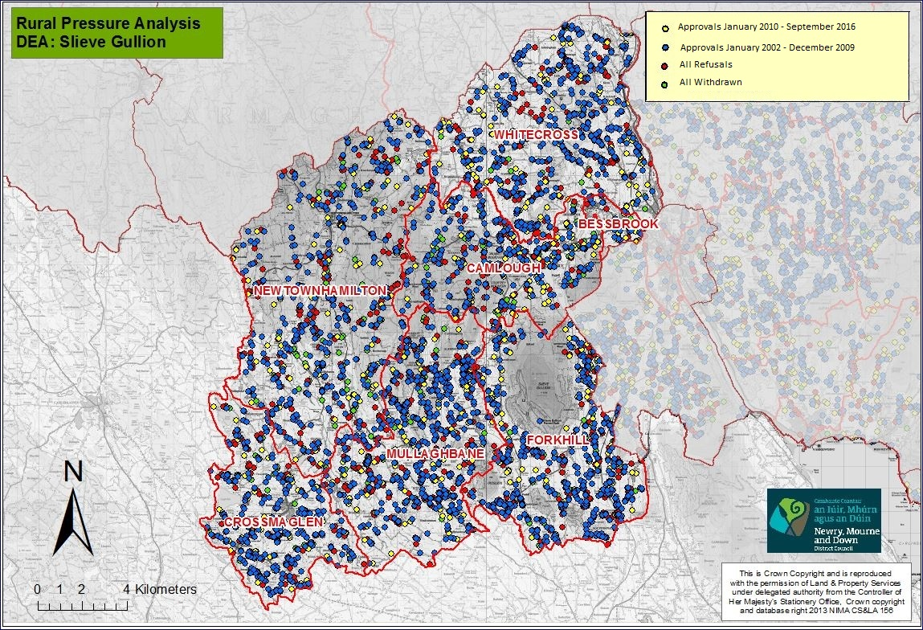

**Figure 12**

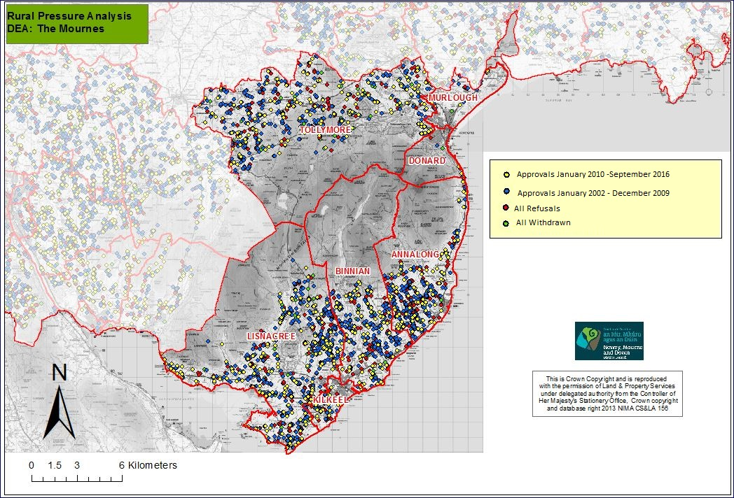

**Figure 13**

1. The four strands of the Countryside Assessment are: Environmental Assets Appraisal, Landscape Character Assessment, Development Pressure Analysis and Settlement Appraisal.
2. These designations do not correspond with the AONB boundaries of these designations