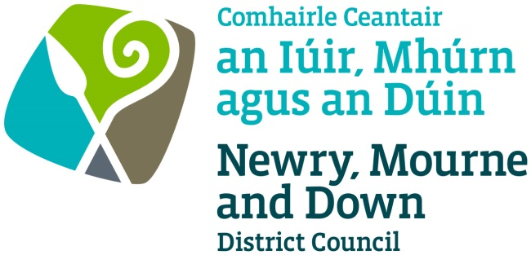

STREET TRADING ACT (NORTHERN IRELAND) 2001

APPLICATION FOR GRANT/RENEWAL/VARIATION OF A STREET TRADING LICENCE

Completed Application to be sent to one of the below offices:

Oifig Dhún Padraig  Downpatrick Office  Licensing Section  Enterprise, Regeneration and Tourism Department  Downshire Civic Centre  Downshire Estate  Ardglass Road  Downpatrick  BT30 6GQ | Oifig an Iúir  Newry Office  Licensing Section  Enterprise, Regeneration and Tourism Department  O’Hagan House  Monaghan Row  Newry  BT35 8DJ
For further details contact:
Telephone: 0300 013 2233
Email: licensing@nmandd.org
Website: www.newrymournedown.org

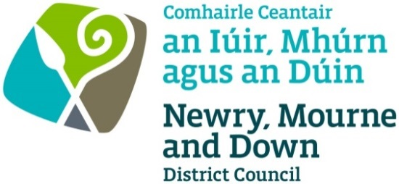
Ref: M/60/19/

Application for the Granting/Renewal/Variation of a Street Trading Licence

Please ✓Tick appropriate box

Application for Grant of a Stationary Street Trading Licence
Application for Grant of a Mobile Street Trading Licence
Application for Renewal/Variation of a Stationary Street Trading Licence
Application for Renewal/Variation of a Mobile Street Trading Licence
Application for a Temporary Street Trading Licence

** The application form must be completed in BLOCK LETTERS using BLACK INK **

Title: MR/MRS/MISS… Date of Birth: _____

Full Name: _______

Home Address: _______

Postcode: Telephone No: ______

Email: ________________________________________________________________________

Business Address (if different from above): _______

Description of articles to be sold: ______

Description of vehicle or stall: ______

Dimension of vehicle or stall: ______

(Photographs or drawings of stall/vehicles can be attached to application form.)

Registration number of vehicle or stall: ______

Do you own the vehicle or stall? YES/NO

If not, give the name and address of the owner: ______________________________________

Address at which the vehicle or stall is to be kept when not in use: ________________________

Address at which articles for sale will be stored: _______________________________________

Stationary or Temporary Street Trading Licence

Detail exact location of pitch: Hill Street, Newry

_____

_____

Please provide details of times of trading for each day:

DAY | TIME
Monday
Tuesday
Wednesday
Thursday
Friday
Saturday
Sunday | 17 March 2019 – 11.00am to 5.00pm

Mobile Street Trading Licence

Please provide details of times and areas of trading for each day. This is to include details of streets or housing estates where you will be trading that day.

DAY | TIMES | NAMES OF STREET OR AREAS WHERE TRADING IS TO BE CARRIED ON

Monday
Tuesday
Wednesday
Thursday
Friday
Saturday
Sunday

This Section Applies To Those Who Will Be Selling Food

Are you registered as a food premises: YES / NO

If yes, please provide details (i.e. name of Local Authority where registered, date of last inspection)

Will bottled gas be used: YES / NO

Will a generator be used for power: YES / NO

Have you had any food hygiene training: YES / NO

Have you previously held a Street Trading licence? Please provide details:
______________________ ______

_

Declaration and Signature

- In connection to this application for the grant, renewal or variation of a Stationary/Temporary/Mobile Trading Licence, if you provide information which you know to be false, you will be prosecuted for that offence. On conviction you are liable to a maximum fine of £1,000.
- Information provided as part of this application may be disclosed in response to a request under the Freedom of Information Act 2000 or the Environmental Information Regulations 2004.
- The Council to which you are submitting this application form, collects data for the purposes of the management and application of the Street Trading Act. The data may also be passed onto other related Government Agencies and to other Council Departments, to facilitate Statutory Requirements, Service Level Agreement of or similar purposes.
- Newry, Mourne and Down District Council collects the Data on this Form for the purpose of administering Street Trading under the Street Trading NI Act 2001. The Data Collected on this Form will be shared with the relevant Council Departments, the Police Service under the Data Protection Act 1998

The Council’s privacy notice can be accessed via our website www.newrymournedown.org/privacy-policy.

Ticking this box indicates that you have read and understood the above declaration.

I enclose herewith fee in amount of £ | Official Use Only
Print Full Name: | Date Received
Signature: | Receipt Number
Date: | £

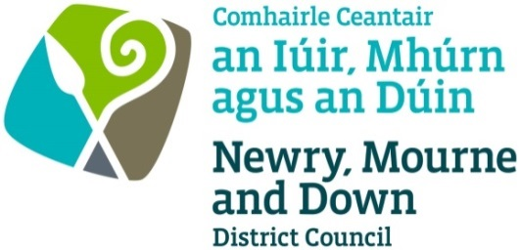

FORM OF CONSENT FOR CRIMINAL CONVICTIONS

Dear Applicant

Regarding your application/renewal/variation for a Street Trading Licence it is necessary for me to inquire if the Police have any record of convictions of a trading nature against you.
As such information can only be made available to me with the written consent of the person concerned, I would ask you to please complete and sign the form of consent below and return it to me with your application.

This office is covered under the Data Protection Act 1984 to hold and request this information.

Registration Number: ZA057622

FORM OF CONSENT

I, of

Date of Birth:

Hereby authorise the Chief Constable of the Police Service for Northern Ireland to make available to the Licensing Section, Newry, Mourne and Down District Council, O’Hagan House, Monaghan Row, Newry, BT35 8DJ or, Downshire Civic Centre, Downshire Estate, Ardglass Road, Downpatrick, BT30 6GQ details of any convictions of a trading nature against me during the last TEN YEARS.

Signed: ______

Date: ______

NEWRY, MOURNE AND DOWN DISTRICT COUNCIL

Documents to be submitted with application for a Street Trading Licence:

Completed Application Form and form of consent for criminal convictions.

- Confirmation from your Insurance Company of a current valid public liability insurance cover (games stall traders to ensure current public liability insurance cover).

- Hot Food, Ice Cream and any type of food traders confirm they are registered with Environmental Health Department under Food Safety Order Northern Ireland 1991.

- Identification of person proposing to trade (e.g. copy of driver’s licence/passport etc).

- Two passport type photographs of person proposing to trade.

- Photograph of the trading stall or unit when fully erected.

- All traders must provide the exact size of pitch with trailer or stall when erected, including tow bar must be given. All dimensions must be accurate.

- Fee for application of licence. Please make cheque(s) payable to:- ‘Newry, Mourne and Down District Council’.

All documentation may be submitted to us electronically by emailing them to licensing@nmandd.org although we may ask for the original of any scanned or emailed document if we feel we need to see the original.

- Use of generators are restricted. Please indicate if you require the use of a generator. Please note an Officer of the Council may refuse the use of any generator if deemed unsatisfactory.

Generator –
  - Must have correct guard around generator (traders that do not have correct protective guard around generator will be refused permission to trade on the day of trading)
  - Must have noise limiter
  - Must not emit fumes
  - Fuel must be kept in proper container in safe place
  - Co² fire extinguisher to be provided
  - Must be kept within the confines of the allocated street trading pitch
  - Photograph must be supplied (of generator)

- Banned goods – the following are not permitted: -
✗ - Any type of pellet guns
✗ - Any type of knives
✗ - Laser lights
✗ - Spray string and similar items
✗ - Spray paint and similar items
✗ - Stink bombs and similar items
✗ - Offensive articles e.g. t-shirts etc
NEWRY, MOURNE AND DOWN DISTRICT COUNCIL

CHARGES - STREET TRADING

EFFECTIVE FROM 1ST APRIL 2015

TYPE OF LICENCE | APPLICATION FEE  (Non-refundable)  £ | LICENCE FEE  (Including Application Fee)  £
Stationary Licence | £75.00 | £875
Mobile Licence | £75.00 | £300
Temporary Licence | £75.00 | £75 for first application  £45 for each subsequent application (maximum of four)  Increase fee for a double pitch to £120 - standard pitch size is 5m x 2m
Variation | £50.00 | n/a

