Food Hygiene Rating Scheme:  Request for a re-rating inspection | 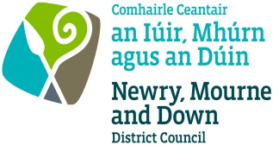 | 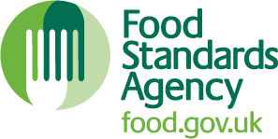

Notes for businesses:
- As the food business operator of the establishment you have a right to request at any time a re-visit for the purposes of re-rating under section 4 of the Food Hygiene Rating Act (Northern Ireland) 2016 provided that you have paid the £150 cost of the re rating inspection in accordance with section 4(7) of The Food Hygiene Rating Act (Northern Ireland) 2016 and the following conditions are met:-
- You must wait until the end of the 21 day appeal period before you apply for a re-rating inspection.
- Any appeal against the current food hygiene rating has been determined or abandoned:
- You must provide details of the improvements made to hygiene standards with your request, including supporting evidence where appropriate.
- The district council considers that you have provided sufficient evidence that the required improvements have been made.
- You must also be compliant with the Act. This means that you must display your current valid rating sticker. A re-rating inspection will not be carried out if you are found to be non-compliant and a £200 fixed penalty notice may be served for non-compliance.
- The district council officer will give you a ‘new’ food hygiene rating based on the level of compliance that is found at the time of the re-visit - you should be aware that your rating could go up, down or remain the same.
- The re-rating visit will take place within 3 months of the request being made and will usually be made without prior notification.

Business details
Food business operator/proprietor

Business name

Business addresses

Business tel. number |  | Business email

Inspection details
 | Date of inspection |  |  |  |  | Food hygiene rating given

Action taken
Please describe the remedial action you have taken with reference to the issues identified in the inspection letter/report provided to you by your district council with your score:
Compliance with food hygiene and safety procedures

Compliance with structural requirements

Confidence in management/control procedures

 | Please provide any other supplementary evidence (e.g. photographs, invoices, copies of relevant HACCP documentation etc.).
Signature
Name in capitals
Position |  |  |  |  |  |  |  |  | Date
Please now return this form and payment to: Newry, Mourne and Down District Council,
O’Hagan House, Monaghan Row, Newry, BT35 8DJ, or
Downshire Civic Centre, Downshire Estate, Ardglass Road, Downpatrick, BT30 6GQ

