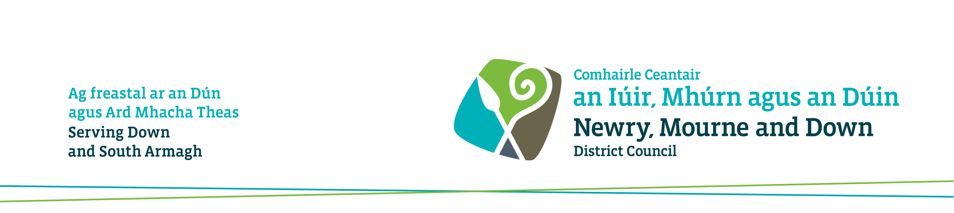

For admin use only
PT/

Receipt No:

Application to Conduct an Inspection for Fitness (Landlord Application)

The Private Tenancies (Northern Ireland) Order 2006
Article 33

Please use BLOCK LETTERS, in black ink, and send the form to:

Environmental Health
O’ Hagan House
Monaghan Row
Newry
BT35 8DJ
Environmental Health
Downshire Civic Centre
Ardglass Road
Downpatrick
BT30 6GQ
OR

The Council will send a copy of this application form to the tenant. Please see the attached notes.

*A fee of £50 must accompany this form. (If a reinspection is required a further fee of £100 will be incurred.)

Please make cheques payable to Newry, Mourne and Down District Council

- Address of dwelling-house
This can be a house or flat

- Name of tenant  Mr / Mrs / Ms | Tel No:
- Date the current tenancy commenced | (Day: / Month: / Year: )
- Name and address of landlord

Contact Tel Number

- Name and address of landlord’s agent (if any) – if no agent, state NONE

- Does the tenancy include property other than the dwelling-house?
6. Does the tenancy include property other than the dwelling-house?
For example, garage, or other separate buildings or land YES NO
If “YES”, give details

- Has a notice of refusal been issued in respect of this dwelling? (See note 6)
YES
NO
DON’T KNOW

- Description of dwelling house:

- Year of construction (Tick only one)

Pre 1945 1945 – 1956 Don’t know

- House type (Tick only one)

Terrace house Semi-detached house Detached house Flat in 2-storey block
Other flat or maisonette

- Rooms

No of reception / living rooms _____

No of double bedrooms (minimum floor area 9.3m²) _____

No of single bedrooms (minimum floor area 3.7m²) _____

- Heating (Tick one only)

Full central heating (i.e. radiators in all rooms)
Partial central heating (i.e. radiators in some rooms)

- Facilities (Insert “s” if shared with another household) (Tick all that apply – if not state N/A)

Fixed bath or shower Wash hand basin
Hot water supply WC inside
WC outside only Piped cold water supply
Kitchen sink

9. Is the property let furnished? (i.e. has the landlord or agent provided furnishings)

YES NO

10. Is the landlord responsible for repairs in accordance with Articles 7 and 9 of the Private Tenancies (Northern Ireland) Order 2006 (See note 7)

YES NO (If no, please attach tenancy agreement)

Signed: ___________________________ Landlord / Agent* (delete as appropriate)

Date: __________________________

(Please make sure to indicate, where necessary, whether the applicant is a Landlord / Agent).

NOTES (to be retained by applicant)

Fitness Inspections

(1) Article 36 of the Private Tenancies (Northern Ireland) Order 2006 states that a district council shall, if an application under Article 33 is made to it, inspect a dwelling-house let under a private tenancy, (certain dwelling-houses do not require a fitness inspection - see Note 3 below), with a view to deciding if it meets the fitness standard for human habitation. A dwelling-house can be a house or a flat.

Protected and statutory tenancies

(2) Protected and statutory tenancies are always subject to rent control. In the absence of a rent determination under the Private Tenancies (NI) Order 2006, the rent of a protected or statutory tenancy remains fixed at the level payable under the Rent (Northern Ireland) Order 1978.

The following dwelling-houses do not require a fitness inspection

(3) (a) a dwelling-house let under a tenancy which began before the commencement of the Private Tenancies (NI) Order 2006; or
(b) a dwelling-house which was built after 1 January 1945; or
(c) a dwelling-house where a renovation grant has been paid by the Housing Executive, but only for a period of 10 years from the date of the grant; or
(d) a dwelling-house where an HMO grant has been paid by the Housing Executive, but only for a period of 10 years from the date of the grant; or
(e) a dwelling-house which is a house in multiple occupation currently registered with the Housing Executive; or
(f) a dwelling-house formerly let under a protected or statutory tenancy where a regulated rent certificate has been issued, but only for a period of 10 years from the date of the certificate.
.
The fitness standard for human habitation

(4) The Council will issue a certificate of fitness if it is satisfied that the dwelling-house meets the fitness standard for human habitation as set out in Article 46 of the Housing (NI) Order 1981. A dwelling house meets this standard if:–
- it is structurally stable;
- it is free from serious disrepair;
- it is free from dampness prejudicial to the health of the occupants;
- it has adequate provision for lighting, heating and ventilation;
- it has an adequate piped supply of wholesome water;
- there are satisfactory facilities in the house for the preparation and cooking of food, including a sink with a satisfactory supply of hot and cold water;
- it has a suitably located water-closet for the exclusive use of the occupants;
- it has, for the exclusive use of the occupants (if any), a suitably located fixed bath or shower and wash-hand basin each of which is provided with a satisfactory supply of hot and cold water; and;
- it has an effective system for the draining of foul, waste and surface water.

If a certificate of fitness is issued

(5) In the case of protected and statutory tenancies, the Rent Officer for Northern Ireland will determine an appropriate rent, taking into account the fitness of the dwelling-house. In the case of all other tenancies, the rent for a tenancy which meets the fitness standard for human habitation is a matter for agreement between landlord and tenant.
If a notice of refusal is issued

(6) If the Council is not satisfied that the dwelling-house meets the fitness standard for human habitation it will give the landlord notice of its refusal of his application. A copy of this will be sent to the tenant (if any). This notice will state the reasons for refusal, and will also indicate the works which in the opinion of the Council will be necessary for the dwelling-house to meet the fitness standard for human habitation.

In all cases, tenancies will be subject to rent control. An appropriate rent will be set by the Rent Officer for Northern Ireland. This rent will be the maximum which can be charged until the dwelling is brought up to the fitness standard for human habitation and a certificate of fitness is issued by the district council.

Repairing obligations

(7) The Private Tenancies (NI) Order 2006 does not alter the repairing obligations of landlord and tenant where these are clearly set out in the tenancy agreement. However, where this is not the case, the Order imposes default terms. These are set out in Articles 7 to 11 of the Order but can be summarised as follows:

Landlord’s obligations
- Structural and exterior repairs (including gutters, drains etc, and external paintwork)
- Internal repairs other than those listed under tenant’s obligations
- Repair and maintenance of gas, water, electric, sanitation and heating installations
- Repair and maintenance of any fixtures, fitting and furnishings provided under the tenancy

Tenant’s obligations
- General care of the premises
- Repair of any damage caused by the tenant, his household or his visitors
- Internal decoration

