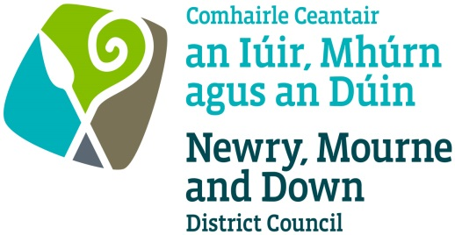

Scéim Sparánachta na Gaeilge 2019/2020
Irish Language Bursary Scheme 2019/2020

This form is also available in Irish
- Applicant details
Applicant’s Name:
Parent’s/Guardian’s name (if applicable):
Applicant’s Date of Birth:
Contact Details:  (if applicant is under 18,  please provide a parent’s  or guardian’s details) | Address:
 | Town:
 | County:
 | Postcode:
 | Email:
 | Mobile number:
 | Home number:

- Course details
Please give details of the course for which you are seeking a Newry, Mourne and Down District Council Irish Language Bursary

Name of Course:
Address:
Start date: | Finish Date:
Contact Details for Course (telephone and/or email):

Total Cost of Course: | Amount of funding sought:

- Course Benefits
Please describe how the course will help develop your language skills

- Re: Public Funding (please delete as appropriate)

I have / have not made an application seeking public funding towards attending the course
(eg Líofa bursary)

- Eligibility Criteria

Please confirm, by ticking each section, that you meet the eligibility criteria for the award of a Newry, Mourne and Down District Council Irish Language Bursary

I am a resident in the Newry, Mourne and Down District Council area | - yes | - no
I am registered to attend the course to improve my Irish language skills | - yes | - no
I have been awarded a scholarship/bursary from public funds to attend the course (eg Líofa bursary) | - yes | - no
I have requested an amount which does not exceed 50% of total fees for the course up to a maximum of £300 | - yes | - no
I confirm the course will start and finish within the current financial year under consideration (1 April – 31 March) | - yes | - no
I confirm I will complete the course and will provide proof of payment of course fees and attendance | - yes | - no

- Declaration
I confirm that the information I have provided is true and accurate to the best of my knowledge

Applicant’s Signature | Date
Signature of Parent/Guardian  (if applicable) | Date

Please return the application form to:
Irish Language Unit
Newry, Mourne and Down District Council
O’Hagan House
Monaghan Row
Newry
BT35 8DJ
Monitoring Form – Irish Language Bursary Scheme

For monitoring purposes, Council is seeking to identify the Section 75 characteristics of the successful Irish Language Bursary applicants, and we would appreciate if you would complete this form. (For applicants under 18 years of age the monitoring form should be completed by the nominated parent / guardian on behalf of the applicant).

The information will be removed on receipt and processed. It will be used for monitoring purposes only and not be attributed to any specific individual.

District Electoral Area where you are resident:

Crotlieve Downpatrick Newry Mournes Slieve Croob
Slieve Gullion Rowallane

Age: under 18 years 18–40 years 41– 60 years 60 years or over

Gender: Male Female Other

Community background:

I am a member of the Protestant community
I am a member of the Roman Catholic community
I am a member of neither the Protestant nor Roman Catholic communities

Disability:

The Disability Discrimination Act 1995 states that a person has a disability if s/he has a ‘physical or mental impairment which has a substantial or long-term adverse effect on
his/her ability to carry out normal day to day activities.’

Do you meet (or have you in the past, met) this definition? Yes No

Racial group / Ethnic origin:

White Chinese Indian Irish Traveller Pakistan Bangladeshi Black African
Black Caribbean Black other Mixed ethnic group

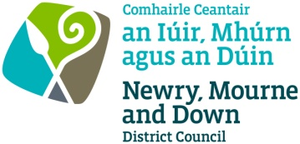

Newry, Mourne and Down District Council
Irish Language Bursary Scheme 2019/2020
Guidance for Applicants

Purpose of the Bursary Scheme

To assist individuals who have not been awarded a scholarship / bursary from public funds to improve Irish Language skills through providing scholarships or bursaries for Irish Language courses, including Gaeltacht colleges, intensive courses and third level courses starting and finishing within the current financial year under consideration (1 April – 31 March).

The bursary will cover course fees only.

Applicants are eligible to apply for 50% of total fees for the course up to a maximum of £300 in total.

Retrospective applications will not be considered and only one application per person per year is permitted.

The applicant must:

- be resident in the Newry, Mourne and Down District Council area;
- in the case of minors, have parental / guardian permission to attend the Irish Language course;
- be registered to attend an Irish Language course;
- not already have a scholarship from public funds (eg Líofa Bursary);
- complete the Irish Language course by attending for its duration;
- provide proof of full payment of fees and attendance at the Irish Language course

The application process

Application forms will be available to download from the Newry, Mourne and Down District Council website www.newrymournedown.org and hard copies will be available for collection from Council offices at Monaghan Row, Newry and Downshire Civic Centre, Downpatrick. This is a rolling scheme. All applicants will be required to supply accurate contact details to enable effective communication regarding the progress of their bursary application.

The Council will make the final decision on the allocation subject to applicants meeting the eligibility criteria. Successful applicants will be informed of the amount of their individual bursary, which will be awarded only upon successful completion of the course and having met the conditions of the letter of offer. While applicants are eligible to apply for 50% of total fees for the course up to a maximum of £300 in total, the amount of individual bursaries awarded will be dependent upon the level of funding available.

Newry, Mourne and Down District Council takes the confidentiality of personal data seriously and is committed to protecting your privacy. Our privacy notice explains how we collect, use and disclose information that you provide to Newry, Mourne and Down District Council. A copy of our privacy notice is available on request or via the following link: http://www.newrymournedown.org/media/uploads/privacynotice.pdf

1 Applicants will be deemed ineligible should they be successful in obtaining a scholarship / bursary from other public funds e.g. Líofa and must inform the Irish Language Unit if they are successful in obtaining same

