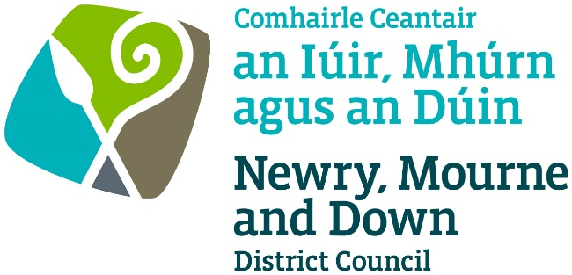

Licensing of Pavement Cafés Act
(Northern Ireland) 2014

APPLICATION FOR GRANT/RENEWAL/VARIATION OF A PAVEMENT CAFÉ LICENCE

Completed Application to be sent to one of the below offices:

Oifig Dhún Padraig  Downpatrick Office  Licensing Section  Enterprise, Regeneration and Tourism  Department  Downshire Civic Centre  Downshire Estate  Ardglass Road  Downpatrick  BT30 6GQ | Oifig an Iúir  Newry Office  Licensing Section  Enterprise, Regeneration and Tourism  Department  O’Hagan House  Monaghan Row  Newry  BT35 8DJ
For further information contact:
Tel: 0300 013 2233
Email: licensing@nmandd.org
www.newrymournedown.org

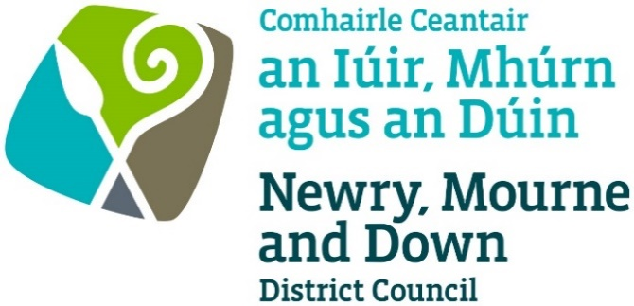

Ref:

Licensing of Pavement Cafés Act
(Northern Ireland) 2014

Section 1 of 5
I/We hereby make application to Newry, Mourne and Down District Council under the provisions of the Pavement Cafés Act (Northern Ireland) 2014 for the:

Application Type:
Please ✓Tick appropriate box
Application for Grant of a Pavement Café Licence
Application for Renewal of a Pavement Café Licence
Application for Variation of a Pavement Café Licence

Applicant Details

First name

Last name

Address

Postcode Date of Birth

Telephone number

Email

Designation: Owner/Director/Manager or otherwise state

Section 2 of 5
Premises Details
Name of premises/trading name

Type of Business

Address

Postcode

Section 3 of 5
Operating Details

Is alcohol to be consumed in the curtilage of the Pavement Café? Yes No

Are the premises licensed under the Licensing (NI) Order 1996? Yes No

Proposal Details

Total width of footpath _____________m

Is the area within 10 metres of a road junction: Yes No

Dimensions of café area:

Number of tables & chairs:

Barrier Height:

Barriers/Tap Rails Yes No

Section 4 of 5
Site Details (Refer to Pavement Cafés Guidance Document)

Provide an area Location Plan, Scale 1:1250, depicting location of Pavement Café and sufficient surrounding area with infrastructure.

Here Enclosed To Follow

Provide a proposed Site Plan, scale not less than 1:100, depicting street space occupied, size and type of barriers, number and type of tables and chairs, and any other pavement café furniture.

Here Enclosed To Follow

Where will the Pavement Café furniture be stores when it is not in use? (Ensure furniture is stored remote from designated fire escapes)

Section 5 of 5
Declaration and Signature

- I confirm that I wish to apply for a Pavement Café Licence for the development as described within this application.
- I confirm that that the information provided in this application is correct.
- I confirm that all furniture must be of a temporary nature that can be removed swiftly within 20 minutes at the end of the permitted period or when access to the area is required by any statutory body or in the event of an emergency.
- I confirm that I have placed the appropriate notice in a prominent place at or near the premises that it can easily be read by the public, and that the notice shall be displayed for 28 days from the date of this application.
- Information provided as part of this application may be disclosed in response to a request under the Freedom of Information Act 2000 or the Environmental Information Regulations 2004.
- The Council to which you are submitting this application form, collects data for the purposes of the management and application of the Pavement Café Act. The data may also be passed onto other related Government Agencies and to other Council Departments, to facilitate Statutory Requirements, Service Level Agreement of or similar purposes.
- Newry, Mourne and Down District Council collects the Data on this Form for the purpose of Administering Pavement Cafe Licensing under Licensing of Pavement Cafés Act (Northern Ireland) 2014
- The Data Collected on this Form will be shared with the relevant Council Departments, the Police Service of NI and the NI Fire and Rescue Service for the purposing of administering the licence under the Data Protection Act 1998

The Council’s privacy notice can be accessed via our website www.newrymournedown.org/privacy-policy

Ticking this box indicates that you have read and understood the above declaration.

Print Full Name | Official Use Only
Signature | Date Received
Date | Receipt No
 | (£)

NEWRY, MOURNE AND DOWN DISTRICT COUNCIL

Documents to be submitted with application for a Pavement Café Licence:

- Completed Application Form

- Confirmation from your Insurance Company that your premises has current valid public liability insurance cover.

- Location Plan to a scale of 1:1250 showing sufficient area around the proposed pavement café to enable consideration of all related issues.

- Site plan to a scale of not less than 1:100 showing access points, building lines, boundaries, kerbs, table and chair arrangement, bins, lighting, trees, other items.

- Details of the furniture including photographs/manufacturers details.

- Risk Assessments

- Planning permission, if appropriate

- Site Notice

- Fee for application of licence. Please make cheque(s) payable to:- ‘Newry, Mourne and Down District Council’.

All documentation may be submitted to us electronically by emailing them to licensing@nmandd.org although we may ask for the original of any scanned or emailed document if we feel we need to see the original.

NEWRY, MOURNE AND DOWN DISTRICT COUNCIL

Licensing of Pavement Cafes Act (Northern Ireland) 2014

PUBLIC NOTICE
APPLICATION FOR A PAVEMENT CAFÉ LICENCE

NOTICE IS HEREBY GIVEN THAT
(Name of applicant) ___________________________________________________
(Address of applicant) __________________________________________________
__________________________________________________________________________________________________________________________________________
has applied to Newry, Mourne and Down District Council for a Pavement Café Licence at
(Name and address of premises) _____________________________________________________________________
______________________________________________________________________________________________________________________

Any objection relating to the application should be made within 28 days of the date of
this Notice.
The objection should be addressed to Newry, Mourne and Down District Council,
Licensing Section, Enterprise, Regeneration and Tourism Department, Monaghan Row,
Newry, BT35 8DJ or Licensing Section, Enterprise, Regeneration and Tourism Department,
Downshire Civic Centre, Downshire Estate, Ardglass Road, Downpatrick, BT30 6GQ

Any objection must be in writing and must specify the grounds of the objection, the name and address of the person making it and must be signed by them or their agent.

It should be noted that where an objection is made after the 28 day time period referred to, but before a final decision is taken on the application, it is appropriate for the Council to consider it, if there is sufficient reason why the objection was not made within the stated time period.

(Applicant’s Signature) ______________________________ (Date) ____________

This site notice must be displayed for the whole of the period of 28 days in a prominent place at or near the premises so that it can be conveniently read by the public.

